To
- Dr. Manmohan Singh, Hon’ble Prime Minister of India.
- Mrs. Sonia Gandhi, Hon’ble Chairperson of UPA/President, Congress (I).
- Shri. Rahul Gandhi, Hon’ble MP/General Secretary, Congress (I).
- Hon’ble Minister of Communication and IT.
- Hon’ble Minister of State for Communication.

PUBLIC APPEAL

Firstly, the Government of India under your able leadership is congratulated for the land mark decision taken to revamp the national air carrier ‘AIR INDIA’. The decision to employ prominent and professionally well qualified COO in place of old brass is path-breaking in the history of public sector enterprises. It is a visionary decision and quite encouraging for the ailing public sectors enterprises like BSNL, MTNL, etc. This serves as a precedent for the top brass of the non-performing public sectors undertakings that government is proactive in the interest of the nation. But, this decision should not be restricted to AIR INDIA alone but also be extended to other ailing public sector enterprises like BSNL, MTNL, etc. Through whistle-blowing public awareness appeal by young executives of BSNL (AIGETOA) it come to know that BSNL, the public sector giant in Indian telecom industry, is currently going through the most critical time for its survival in the fierce competitive market conditions. It is battling with falling revenues, profits and market share mainly due to unabsorbed Group-A ITS officers. Currently BSNL is reeling under the operational losses and marginal financial profits are generated from huge bank reserves despite having largest telecom network and infrastructure in India. It is about a year that the Government favourably allotted 3G and Wi-Max spectrum ahead of private operators and still BSNL has not captured the first mover’s advantage. No wonder, BSNL is surely landing in similar situation like that of AIR INDIA, where if it happens, it will endanger Government’s initiative on e-governance, health care, primary education and public welfare in rural India, where BSNL is only service provider. In addition the Government has to bail out BSNL by providing more than 14000 crores per annum as the salary bill for the 3.2 lakhs employees. Instead of post-mortem, the Government of India can immediately call for similar action like AIR INDIA for the BSNL by replacing the incompetent management of BSNL with prominent and well qualified professionals for complete revamp of the telecom giant. It also protects the share holder’s wealth investments through IPO initiative of Government to disinvest BSNL in the market. In support of this the following information about the performance of BSNL in terms of revenue growth and profit is supplied.
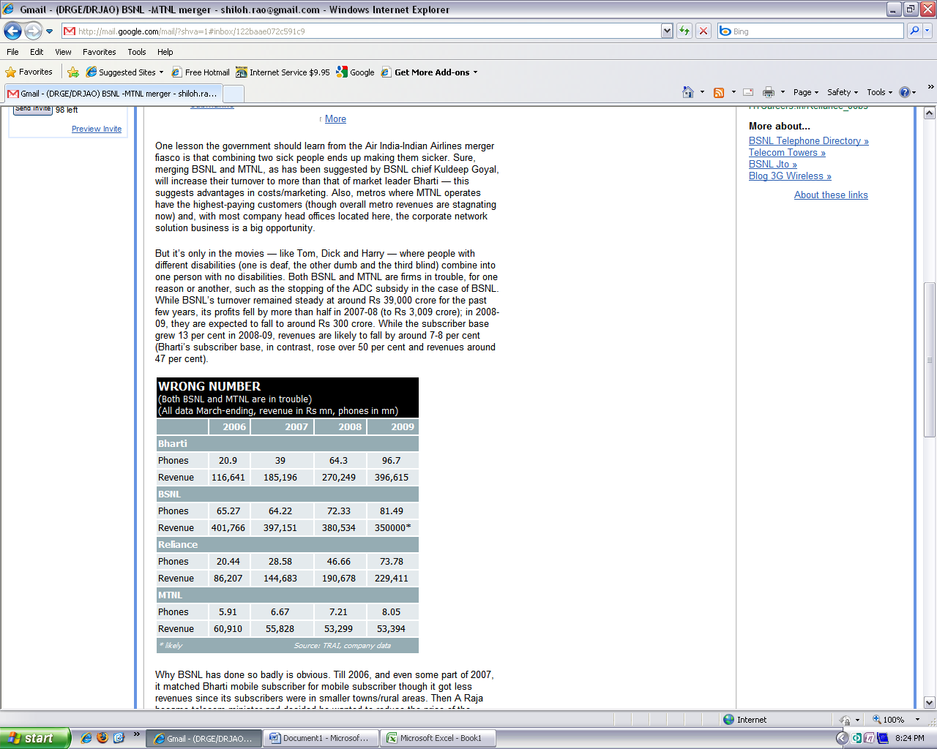 | 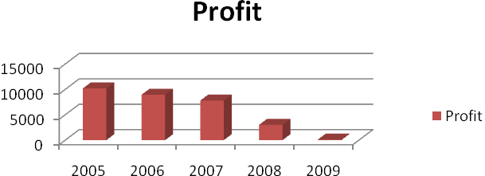

I, the undersigned fully convinced by the above facts and appeal to you honors kindly save the public company from the hands indolent management of BSNL by constituting fact finding committee headed by the judiciary to probe the nosedive loss and punish the higher officers of BSNL for causing innumerable loss to the nation. I also wish to inform you that I whole heartedly support the noble initiative of young executives of BSNL through their association named AIGETOA launched “OPERATION SACRIFICE” starting from 18th August 2009 at the Bharat Sanchar Bhawan, Harish Chandra Mathur Lane, Janpath, New Delhi. Remain with regards.
Yours faithfully
Signature:
Name:
Address:
Telephone number:

