East India Company with “BLACK ANGREZ (ITS)” has stood again and eating BSNL
Revolution through “Operation Sacrifice” of All India Graduate Engineer Telecom officers Association (AIGETOA): for upliftment of BSNL.
AIGETOA (an association of qualified engineers and account officers in BSNL) has started “Operation Sacrifice” against the ill policies of BSNL and anti-business activities of Guest deputed officers holding key policy making post in BSNL management. AIGETOA is fully committed to bring complete corporate culture for the upliftment of the Asia’s No-1 Public sector “BSNL”.
Through whistle-blowing public awareness appeal by young executives of BSNL (AIGETOA) all young executives are going to bring to the attention of the general public, media, judiciary, eminent personalities and political leaders of our nation about BSNL and its current situation which is undergoing most critical time for its survival in the fierce competitive market conditions. BSNL is battling with unexpected falling revenues, profits and market share mainly due to unabsorbed Group-A ITS officers holding all the policy making power but working as guest without any sense of belongingness to the company. Currently BSNL is reeling under the operational losses and marginal financial profits are generated from huge bank reserves despite having largest telecom network and infrastructure in India. It is about a year that the Government favourably allotted 3G and Wi-Max spectrum ahead of private operators and still BSNL has not captured nor exploited the first mover’s advantage. No wonder, BSNL is surely landing in similar situation like that of AIR INDIA, where if it happens, it will endanger Government’s initiative on e-governance, health care, primary education and public welfare in rural India, where BSNL is only service provider. In addition the Government has to bail out BSNL by providing more than 14000 crores per annum as the salary bill for the 3.2 lakhs employees in order to avoid the litmus test of life for the employees of BSNL.
The AIGETOA has started “Operation Sacrifice” since 13.07.2009 to expose the anti-business activities of Guest ITS officer dominated in BSNL management and bring the change in the sarkari BSNL work culture to complete corporate culture for tangible, reliable and assured customer service to regain its lost glory of BSNL.
BSNL witnessed 97% dip in profit in the financial year 2008-09. The profits have declined sharply from 8000 cr. to a meagre 105 cr. during the last 4 years in spite having amazing infrastructure, latest technology, more than 150 years history and work force of more than 3 lakhs young and experienced employees whereas private players have earned more and more profits during the same period with minimum resources so where lies the loophole? Because the management is in the hands of “BLACK ANGREZ (ITS) who are just eating BSNL like termites and will run away when this giant will fall.
Following comparison will explain the declination of BSNL hold in the telecom market share and it’s revenue.
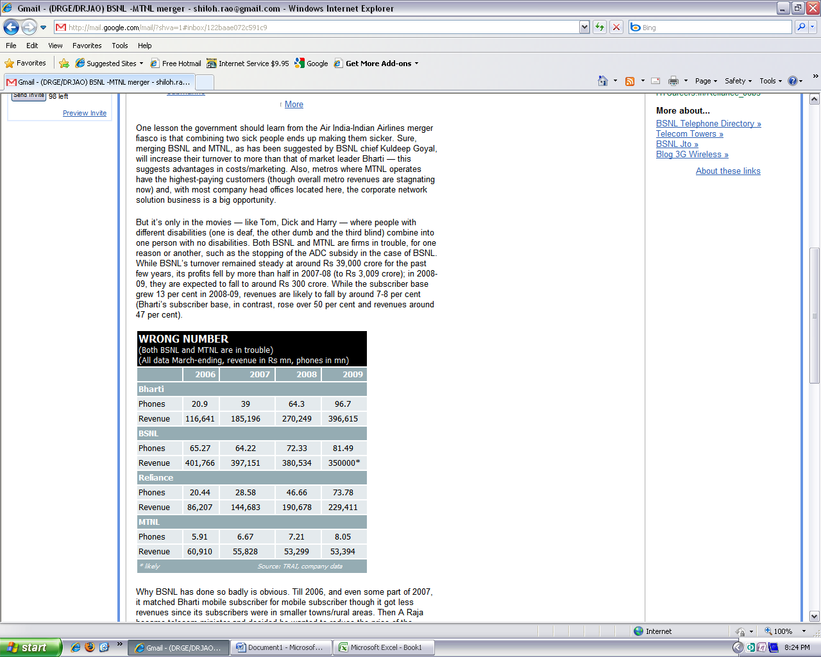 | 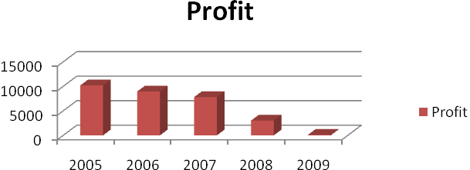

It is a pity to mention that BSNL even after passing more than 8 years, policy makers of this company are still working as guests (Deputed from Govt.) without any belongingness to the company, moreover it’s against the Department of Public Enterprises (DPE) guidelines. as per the DPE order deputation in any public sector should be not allowed more than 3 years. Through their muscle power and deceitfulness they are still continuing BSNL in same old monopolistic government culture and unwilling to adopt the contemporary corporate culture in BSNL fearing their vested interests and dilution of their bureaucratic grip on the organisation.
BSNL in order to meet its essential requirement of having qualified engineering graduates/accounts professionals to handle technical issues and surge ahead and dominate the telecommunication market recruited almost 10,000 qualified graduate engineers and account officers after its formation. They constitute as most competent work force out of 3 lakhs employees who are young and capable to handle the growing technology, competition and pressure to perform. But, due to the vested interest of bureaucratic policy makers who are unwilling to dilute their government legacies are not promoting the in-house talent and deliberately repudiate appropriate responsibilities. Every professional requires minimum educational qualification to practice his skills. It is very disappointing situation in BSNL, that an employee with lesser educational are leading and judging the performance of the employees with much higher educational qualification. Direct Recruited engineers/Accounts officers are legitimately demanding responsibilities with respect to their qualification so that their talent can be utilised for the well being of the company. But it is on part of the BSNL management, who is not ready to impart responsibilities according to qualifications as in other PSU’s practices and principles.
We young executives are more worried about our future as we have to serve for many years and if the same situation prevails in BSNL the day is not far when the company will run out of finances for paying the basic salary of the employees. However the major chunk DOT absorbed employees are covered under government pension their future safety and security. We are entirely dependent on long survival of BSNL for our bread and butter. Considering all these facts into mind AIGETOA has decided to go for comprehensive revolution in BSNL for upliftment through “Operation Sacrifice” and all the 10000 members of this association throughout India are ready to even give up their lives if the need arise for the complete transformation of BSNL.
At the beginning on 31st July 2009 we are holding half day demonstration in every nuke and corner of the country and protest against the ill motives and wrong policies of guest ITS officers. If board of directors of BSNL and concerned ministry of government of India still remain deaf and blind for the current situations, we have no options but rally all the 10000 members of our association to BSNL Head Quarter New Delhi on 18th August 2009 for mass indefinite protest followed by hunger strike till last breath.
“We appeal to all the public eminent, political leaders, media houses and conscitious citizens to support and help us to save the existence of your company BSNL”.

