ALL INDIA GRADUATE ENGINEER TELECOM OFFICERS ASSOCIATION
(An Association of Gr. Er. Telecom Officers of B.S.N.L./M.T.N.L.)
Regd. Office: Office No. 4 & 5, Near Sethi Hospital, Bawal Chowk, Rewari-123401 (Haryana)
Website: www.aigetoachq.org
President General Secretary
N. Shilohu Rao S. K. Saini
No. 36,II Street, Kamraj Nagar 283-L, Model Town,
Villivakkam, Chennai-600049 (TN) Rewari-123401 (Hr.)
Mobile: +91-9444442255 Mobile: +91-9416010099

Ref No: CHQ/AIGETOA/140 Dated. 21/07/08

Urgent
To
The CMD BSNL,
Bharat Sanchar Bhawan,
New Delhi

Sub:- Immediate kind intervention on MP Telecom Circle issues raised by AIGETOA-reg

Sir

Our Circle body of AIGETOA MP Telecom Circle has taken initiative to safeguard the interests of organization to make it “Corruption Free”. Our circle body has written to circle management many times to solve the issues related to Circle Store Scam, EPF issue, malpractice in transfers & Officiating SDE promotions. On 30th Oct, 2007, news came in leading newspapers of MP about the Circle Store Scam in which two trucks with unauthorized store were being transported and it was caught red handed by media and several officers of BSNL. Almost 9 months have been passed but no action has been taken by circle administration rather the accuseds were transferred to the places of their choice. The CGM MP Sh. R.K.P. Hinduja has not taken any strong step to investigate the matter properly and thus indicated that BSNL management will not take any action if some further frauds occur in BSNL. CGM MP always given irresponsible statements about Malpractice done in transfers & Officiating SDE Promotions and EPF issue that Sh. Prabhash Singh (GM Admin) and Sh. G. P.Verma (GM Finance) are not in his control and members can go for agitation against concerned GMs. Along with many written communications done by our local body and a series of meetings held between AIGETOA MP & Circle Management, no solution has come out as circle administration is protecting the culprits.
I also requested Director-HRD vide our letter no. CHQ/AIGETOA/139, dated 15/07/08 to intervene in this regard. We also submitted the evidences of corruptions and malfunctioning to DDG SR Sh. Shakeel Ahmad on 18/07/08 for the subject matter as above. But till date we have not got any response.
Today, our members of MP telecom circle are protesting opposite CGM Office at Bhopal and they are very agitated about the irresponsible behavior of circle management. Therefore, I request your goodself to intervene in this regard and instruct CGM MP to take necessary action to solve the genuine issues of members of AIGETOA MP so as to maintain industrial harmony and let us start working together to make BSNL corruption free.
Thanking you
With regards
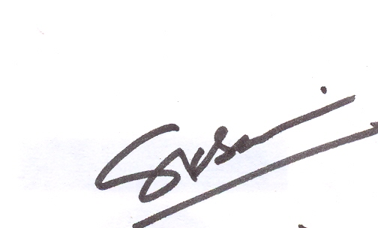
(S.K.Saini)

Copy to:- The Director-HRD, BSNL CO, New Delhi for kind inf. pls.

