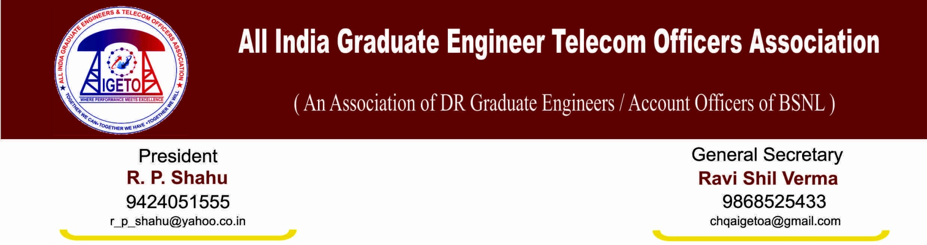
No: GS/AIGETOA/23 Dated: 18’ Dec 13

To

Sh. R K Upadhyay
CMD, BSNL
Corporate office, New Delhi.

Subject: Request for agenda meeting in the Chairmanship of CMD on long pending HR issues and non-compliances of record of discussion held between this association and BSNL management on 8th Aug-2013.
Reference: Record of discussion held between this association and BSNL management on 8th Aug-2013 vide SR letter No. 31-4/SR/2013

Respected Sir,
We want to draw your kind attention towards the various long pending HR issues in respect of direct recruit executives and agreement reached followed by the long agitation in terms of record of discussion mentioned under reference on the following points:

- Finalization of standard pay scale of JTO equivalent (E2) and SDE equivalent (E3) with additional increments to New Recruited executives to maintain the pay parity
- Introduction of 30% Superannuation benefit to the Direct Recruits
- Stop external DGM/MT recruitment hence scrap the RR and implementation of CPSE hierarchy based on stringent performance and qualification as of top leading CPSEs
- Resolution of EPF anomalies in respect of direct recruits
- Maintain uniformity in first time bound up-gradation i.e. four years in respect of all executives

It is understood that management side has take certain view and decisions on the issues raised by AIGETOA. However, the view which is emerging out is not in line with the agreement reached vide the letter mentioned under reference and management side has taken a unilateral view on all the issues without consulting us. It can be clearly inferred that after passage of more than four months, all our issues have been put on to the stage zero again from where we have started.
Further, this association has yet not been allotted any formal agenda meeting which also was committed at the time of calling of the August agitation. We are of definitive view that having a one-to-one discussion with the HR team and Association representatives under your presence will enable the management to take an informed and well deliberated decision. It will take only a single day’s effort but the same will prevent ours as well management side’s endeavors to resolve things in amicable and mutually agreed way from going waste.
In view of the above, we request your good-self to take a final call on the issues by awarding formal meeting to this association under your chairmanship. This association still believes that we will be delivered justice timely under your able leadership and keep our selves ready for the final verdict.

Yours faithfully,

(Ravi Shil Verma)
Copy to:
- Sh. A.N. Rai, Director (HR) BSNL
- GM (SR), BSNL CO
- GM (C&M) , BSNL CO

