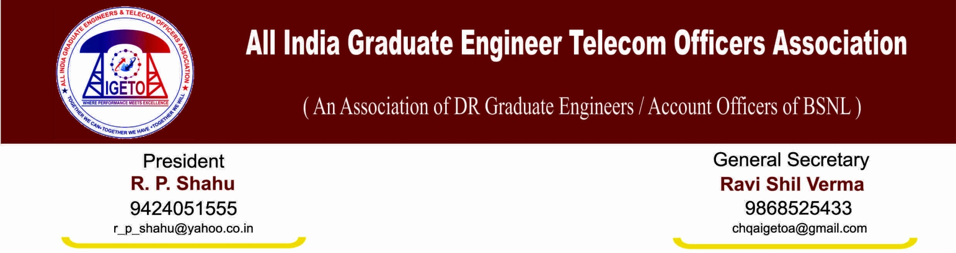
No: GS/AIGETOA/22 Dated: 09’ Dec 13

To
Sh. R K Upadhyay
CMD, BSNL
Corporate office, New Delhi.

Subject: Regarding conducting the future LDCEs from JTO to SDE (T) with single and common paper.

Dear Sir,
This is in reference to this association letter dated 17th July 2012 wherein we have requested to conduct the future LDCEs with a single and common paper to all. In this regard, we would like to once again submit the following advantages if management goes ahead with this concept:

- It is a fact that executives passed with particular specialization paper are not necessarily being posted in that particular field and syllabus of specialization paper is already covered in general paper. Moreover moderation of the specialization paper for different field is not possible to maintain at same level i.e. in some fields it may be easy and in some fields it may be tough which may result in not having a level playing field for the applicants appearing from different specializations. This fact can be verified from the results of earlier LDCEs where substantial difference in passing ratio may be noticed across different specializations. Further, some switches and technologies have become obsolete presently. To conduct exams for such switches and doesn’t doesn’t find any relevance today.

- Apart from the above, it is very much cumbersome and time taking in view of the departmental process of conducting LDCE with number of specialization papers which ultimately results in extra financial burden for the company in preparing multiple sets of different – different specialization streams and also introduces significant delay in the LDCE process. Further, all these papers are to be printed in bilingual mode which is a very time taking and cumbersome process. Introducing a single paper will remove this difficulty.

- Further, in today’s scenario, it is very difficult to find paper setters for so many number of specialization papers. It will be easy to find paper setters for one common paper.

- Further, TTA to JTO and some other LICEs are also being conducted with one common paper only which has resulted into quick conduction of exams. Therefore, we don’t find any demerit in doing away with concept of multiple papers. Further, if at all needed, we suggest that number of questions can be increased.

- We are very much sure that our recruitment cell is capable enough to adapt with the change in process and it is our firm belief that with single paper, they shall be able to conduct the exam in the month of March 2014 which will be a huge benefit to the young and deserving executives of BSNL.

In the light of above facts, there doesn’t appear any need to conduct separate specialization papers in LDCE. Therefore, this association humbly requests your kind to kindly direct the authority to process the next LDCE with single and common paper to the entire applicants.

Yours faithfully,

(Ravi Shil Verma)
Copy to:
- Sh. A.N. Rai, Director (HR) BSNL for kind information and necessary action please.
- Sr. GM (Recruitment) for kind information and necessary action please.

