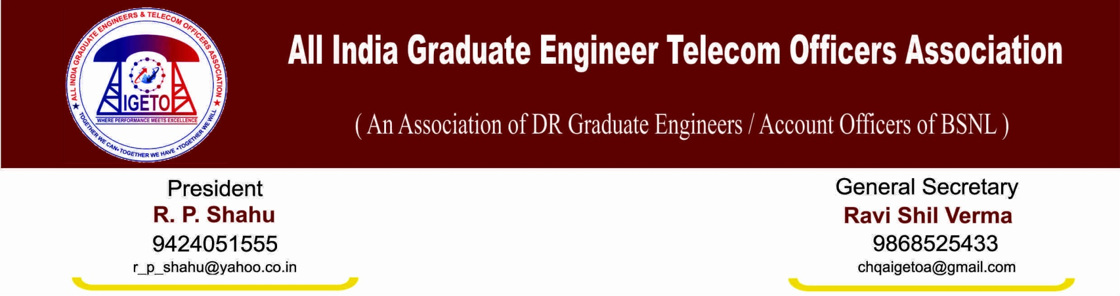
No: GS/AIGETOA/21 Dated: 09’ Dec 13
To,
Shri R.K. Upadhyay
Chairman and Management Director
BSNL, New Delhi

Subject: Extending the benefit of notional date of promotion with consequential benefits like increment on promotion, fixation of pay, counting of experience for further promotions, annual increments etc. to the candidates qualified against 33% LDCE quota for SDE (T).
Respected Sir,
This is to bring to your kind notice that candidates qualified for the grade of SDE (T) through LDCE held on 4th March-2012 against 33% quota are not being provided even one increment on promotion quoting the provision of EPP although they are well eligible for notional date of promotion with all consequential benefits like counting of experience for further promotions, annual increments etc from the date after six months of LDCE was initially announced. This association hereby submits following points on the subject mentioned above for your kind consideration:
- That, promotion to the grade of SDE (T) is made through two different modes i.e. 67% through Seniority cum fitness and 33% through LDCE. Both mode of promotion should be executed every year against the vacancies with eligible candidates.
- That, LDCE for SDE (T) for the vacancy years 2006-2007 to 2009-2010 was due in year 2008, 2009 and 2010 respectively but same was notified vide Pers cell vide no.5.2/2009-DE dated 18.03.2010 to be held on 04/07/2010 including all the vacancies of four years.
- That, the competitive examination against 33% LDCE quota was initially announced to be held on 04/07/2010 and postponed from time to time and finally held on 04/03/2012. However, the result of the examination was declared on 2nd July-2013 and the promotion orders were issued accordingly on 4th July-2013. About 2700 candidates passed the said LDCE held for the vacancy years 2006-2007 to 2009-2010. The delay in conducting LDCE was purely on either administrative or legal ground and candidates have nothing to do with that.
- That, as candidates qualified for the given vacancy years i.e 2006-2007 to 2009-2010 are well eligible for appearing in the examination hence promotion in the year 2008, 2009, and 2010 respectively but due to administrative and/or legal delay, final promotion could happen only in year-2013. By this time candidates had already got their financial upgradation to E3 pay scale hence as per the provision of EPP field units are denying even one increment on promotion through LDCE.

- That, if the management would have conducted the LDCE and promotion on due time in year 2008, 2009 and 2010 respectively, all the qualified candidates would have got one additional increment on the date of promotion with added benefit of regular service in the SDE grade and other monetary benefits. Delay in conducting LDCE purely on administrative/legal grounds is causing tri loss to the candidates i.e. loss of increment, loss of regular service and loss of arrear benefits which is completely against the natural justice.
- That, there is chances of major anomaly if the candidates who are promoted to the grade of SDE (T) for vacancy year 2008-2009, 2009-10 and their financial up-gradation to E3 grade is due after promotion order of LDCE, they will get one increment on the date of promotion and one additional increment on the date of financial up-gradation to E3 hence will draw more salary than the candidates who is promoted to the grade of SDE (T) for the vacancy year 2006-2007.
- That, promotion through other mode i.e. seniority cum fitness for the same vacancy years are already executed in year 2009 and BSNL has already extended the seniority to the candidates qualified through LDCE quota on the basis of vacancy years for fixation of inter-se-seniority
- That, in similar cases various courts of law have already delivered judgment of extending notional date of promotion after six months from the date LDCE is announced. As LDCE for SDE (T) was due in year 2007, 2008, 2009, and 2010 for vacancy year 2006-2007, 2007-2008, 2008-2009 and 2009-2010 respectively and examination including vacancies of all the four years was initially notified on 18/03/2010 vide Pers cell vide no.5.2/2009-DE dated 18.03.2010.
In view of the facts submitted as above, your good self is requested to kindly bestow the justice by extending the notional date of promotion after six months from the date LDCE was initially announced i.e. from 18.09.2010 with consequential benefits like increment on promotion, fixation of pay, counting of experience for further promotions, annual increments etc to all the qualified candidates. The similar notional benefits should also be extended to the candidates declared qualified in the last LDCE held in the year 2007.
With Best regards

Ravi Shil Verma
GS, AIGETOA

Copy to:
- Director (HR) for kind information please.
- Sr. GM (Pers) for kind information please.

