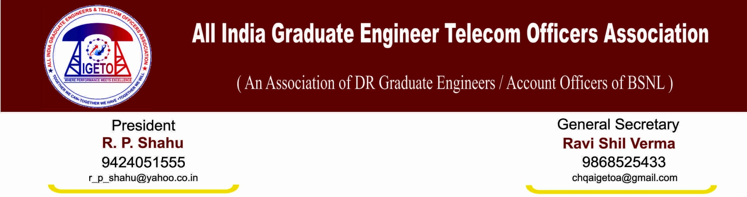
No: GS/AIGETOA/20 Dated: 09’ Dec 13
To,
Shri R.K. Upadhyay
Chairman and Management Director
BSNL, New Delhi

Subject: Recently issued promotion orders of JTOs to SDEs against 67% seniority-cum-fitness quota, request for enquiry into the reasons behind retention of these candidates as in the recently issued promotion orders against LDCE quota acute shortage was cited at some circles.
Respected Sir,
I would like to draw your kind attention towards the recent promotion and posting order issued to the grade of SDE (T) vide No.2-15/2011-Pers-II-Pt.II dated 29/11/2013 (Enclosed herewith) in respect of left out JTOs of DPC-2011 against 67% seniority cum fitness quota. It may be seen that in the aforesaid order, everyone has been retained in their present circle.
It may be recalled that just few months before promotion and posting orders were issued to the grade of SDE(T) against 33% of LDCE quota wherein mass displacement was done (up to 95%) from some of the circle like AP, KTK, MH, MP and Orissa. The reasons given were that there is acute shortage in some circles which administration needs to bring at Par. Despite representation of the candidates on critical grounds and strong recommendations by Circle Heads, retention of most of the candidates were not considered with the reason best known to the authorities and finally some of them were even refused their long waited promotion due to constraints at their end.
It is regrettable to state that just a couple of months later, another promotion order is issued in the same grade through seniority cum fitness quota and all the candidates are retained in their existing circles which includes AP, KTK, MH, MP also where the mass displacement was done few months ago. Seeing this order, the minds of many of our direct recruits are perplexed with a thought that how come the administration has been able to overcome the shortage of various circles in such a very short span of time.
Many thoughts are occurring in our minds as our apprehension expressed at the time or promotion orders of LDCE quota that the same shortage will not be hindrance when promotion orders of seniority-cum-fitness shall be issued has now become true. The reasons need to be explored behind this dual policy. We fear that this may be deliberate attempt of certain authorities to favor a particular group for reasons best known to them.

The above act of the authorities is highly discriminative and indicative of something irregular in the matter of transfer and posting of executives. Being a responsible association, we cannot remain mute spectator under such scenario and neither can we draw our own conclusions without knowing the exact facts. In view of this we request your good-self to kindly institute an enquiry into the various promotion orders issued between July-2013 to till date at all levels including the LDCE as well seniority quota to ensure that no wrong doing has been done. By doing this, if some justified reasons are there, we can inform our members so that unnecessary heart burn can be avoided. However, if there is any vested interest involved at any level, we request your good-self to kindly take suitable and stern action against them.
With Best regards

Ravi Shil Verma
GS, AIGETOA

Copy to:
- Director (HR) for kind information please.
- Sr. GM (Pers) for kind information please.

