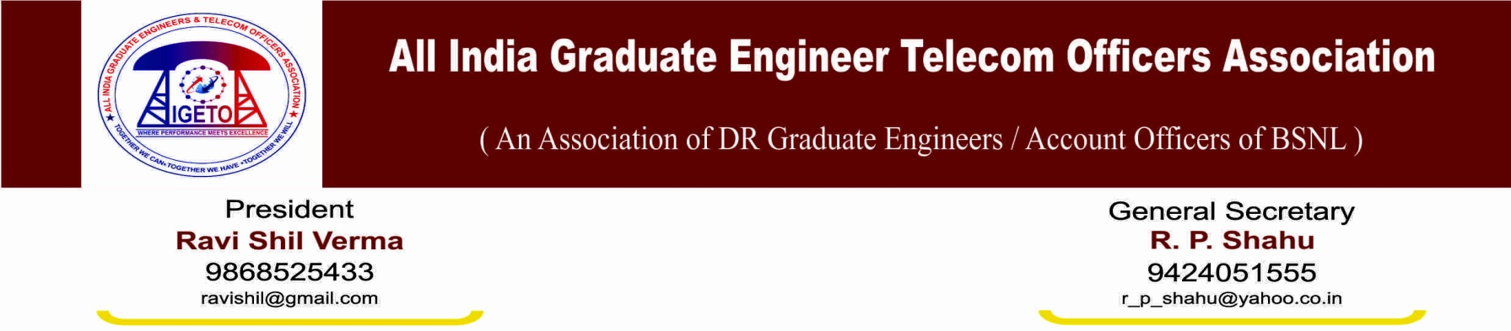
No. GS/AIGETOA/83 Dated 03.11.2014

To
Sh. A.N. Rai
The Chairman & Managing Director, BSNL
Bharat Sanchar Bhavan
Janpath, New Delhi

Subject: Regarding autocratic and repressive instruction issued by Circle Office Bhopal in respect of payment of salary which was deducted without following the prevailing rules/guidelines in this regard.
Reference: SR-19-1/Union/AIGETOA/2014-15/06 dated 16.10.2014

Respected Sir,
Your kind and high attention is invited towards the autocratic and repressive instruction mentioned under reference issued by Circle Office Bhopal wherein several terms & conditions are forced for refund of salary which was deducted randomly against the provision of the company. In this regard I hereby submit following facts for your kind consideration and necessary action.

- That, it is needless to mention that salary deduction in the month of Aug-13, Sep-13 and Feb-14 is done purely on random basis by lowering basic pay without following the prevailing rules and guidelines. In some case salary is deducted even against the sanctioned leave. There is no any departmental proceeding and order passed by competent authority in respect of salary deduction as per the provision of CCS leave rule/BSNL CDA Rule and concern executives have not been given chance of being heard even no intimation is given which is against the basic principle of natural justice.
- That, every concern executives have represented in writing to the authority against such wrong doing but no action is taken in field units to render justice. This association has taken up this matter strongly to the Circle Management but it is regret to mention that instead of resolving the issue on merit, Sr. GM (Admin) Sh Prakash Ballal has adopted cheep tactic of lodging counterfeit FIR, suspensions, show cause notices, memorandums, Charge Sheets against the representatives and victims so that every voice against such wrong doing can be crushed.
- That, despite of such unkind act of Sr. GM (Admin) MP Sh Prakash Ballal, this association has kept on raising voice at different forum and now Circle Office has issued complete autocratic and repressive instruction to SSA heads by putting several terms & conditions like unconditional regret, performance status, vigilance status and undertaking for not participating in future agitations etc. for refund of salary so deducted. It is worth here to mention that deduction and payment of basic wage of employees in CPSEs are governed by the rules and guidelines laid down by the Government of India through various authorities like DPE, DOP&T, CCS leave Rules etc. Circle Administration, Circle Head has no such authority to put terms and conditions based on their whims and fancies.
- That, on the matter of salary refund under subject Circle Administration can only decide the matter on merit whether salary deduction was done as per the procedure laid down by the company and hence refund is justified or not. They can only decide the matter on merit whether salary is to be refunded or not just by regularizing the leave available in the account of concern employees. If salary deduction is done without following the departmental procedure, interest on salary deduction must also be paid and disciplinary action against responsible officers must be initiated. Circle Administration has no such power to put any terms and conditions like unconditional regret, performance, vigilance status, undertaking for not participating in agitational activity etc. for payment of salary which is complete overstepping of jurisdiction just to satisfy the false ego and to crush the genuine voice against wrong doing of higher authority.
- That, this is not only act of CGM and GM (Admin) of MP Telecom circle where they have overstepped their jurisdiction but there are several other dictatorial instruction to employees of this circle as given below:
- Forcing executives to purchase smart phones from their own salary so that official communication can be made through WhatsApp.
- Forcing employees to purchase Jumper and Drop wire from their salary for providing telephone and broadband connection.
- Issuing instruction in writing to employees for donating salary to increase revenue of MP Telecom Circle to improve the performance of circle in their tenure so that they can improve their APAR and qualify the interview for their career enhancement.
- Threatening employees to have normal delivery of baby without hospitalization else they will not pay medical reimbursement.
- Charging fine of Rs 500 to 1000 without any receipt from the employees who became late in office. Coming late in office is misconduct and must be dealt with BSNL CDA Rule. There is no provision in BSNL CDA Rule to charge fine against such misconduct. Charging fine from employees is nothing but bribe to allow them for late coming.
- Filling counterfeit FIR, suspension without sufficient reason in violation to CVC guidelines, show cause notice, charge sheets, and transfer etc. against the association leaders who dare to raise voice against their wrong deeds.

Such autocratic and repressive act of CGM Sh N K Yadav and GM (Admin) Sh Prakash Ballal of MP Telecom Circle have badly affected the employees-employer relationship and likely to build industrial unrest. Considering the facts submitted above your kind intervention is highly solicited by instructing the CGM (MP) to immediate withdraw the repressive instruction mentioned under reference and decide the issue purely on merit as per the prevailing rules and guidelines of the company.
It is also requested to kindly institute suitable inquiry against CGM Sh N K Yadav and GM (Admin) Sh Prakash Ballal of MP Telecom Circle against their doctorial instruction as mentioned above in Point No-5.
We hope your kind and sincere intervention in this regard.
Sincerely Yours

(R P Shahu)
General Secretary

Enclosure: as mentioned under reference

