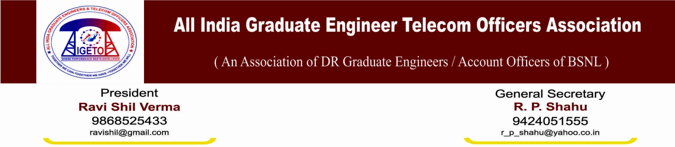
No. GS/AIGETOA/82 Dated 03.11.2014
To
Sh. A.N. Rai
The Chairman & Managing Director, BSNL
Bharat Sanchar Bhavan
Janpath, New Delhi

Subject: Regarding no reply even after passing of more than six months against clarification asked by Sr. GM (HR/Admin) of MP Telecom Circle from GM (SR), BSNL CO.
Reference: letter of Sr.G.M. (Admin/HR) MP Telecom Circle vide letter no 19/SR/Union/AIGETOA dated 14.03.14
Respected Sir,
Under the undue pressure of CGM and GM (Admin) of Madhya Pradesh Telecom Circle, DDOs have deducted huge and random salary in the month of Aug-13, Sep-13 and Feb-14 without following rules/guidelines and even the basic principle of natural justice. Executives in MP Telecom circle have represented in writing and followed all the amiable path individually as well as through association platform but remain unheard for long time. Unrest among victims have increased up to the highest level and finally protested in mass before the office of GM (Admin) from 10th to 13th March-14. Level of unrest can be imagined from the facts that police FIR was launched against the victims and police arrest was made. Apart from that police case, many representatives have been served show cause notice, charge sheets and even suspended for more than two months.
In the situation mentioned above, Sr. G.M. (Admin) MP Sh Prakash Ballal have sought clarification one from EPFO and another from GM (SR), BSNL CO on 13-03-2014. It is really ridicules and disgraceful to learn that EPFO considering the situation has issued clarification on very next day i.e. on 14th March-14 but SR Cell of our own company could not issue the clarification even after passing of more than six months. Because of this insensible, passiveness and complete ignorant attitude of SR Cell of BSNL CO matter could not been decided on merit and still there is atmosphere of huge unrest.
Your good self is requested to kindly instruct the SR Cell of BSNL to immediately issue point wise reply of the letter written by Sr. G.M. (Admin/HR) of M.P. Telecom Circle as mentioned under reference so that matter can be decided on merit else responsibilities lies to them for any industrial unrest and unfortunate incident.
Sincerely Yours

(R P Shahu)
General Secretary

Enclosure: as mentioned under reference
Copy to:
G.M. (SR), BSNL CO for kind information and necessary action please.

