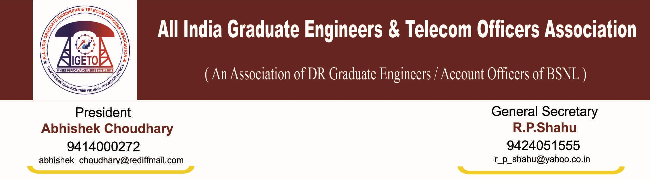
No: CHQ/AIGETOA/438 Dated: 6th Aug- 2013

To,
The CMD
BSNL, New Delhi
Subject: Intimation for peaceful mass hunger strike and demonstration in the premises of BSNL Corporate office, Harish Chandra Mathur Lane, Janpath New Delhi w.e.f. 12/08/2013 till meet out our demands.
Dear Sir,
In reference to our notice vide CHQ/AIGETOA/428 dated 12th July-2013 vide which we had submitted our demands and agitational program. It is regret to mention that, despite passing of more than 15 days of our active agitation wherein thousands of executives are sitting on mass Dharna at Jantar-Mantar New Delhi since 29th July-2013 BSNL management has so far not called even for formal meeting to the representatives of this association.
In continuation to that this is to inform you that AIGETOA has decided to intensify this agitational program and will held peaceful mass hunger strike in the premises of BSNL Corporate office, Harish Chandra Mathur Lane, Janpath New Delhi w.e.f. 12/08/2013 till meet out our demands.
You are kindly requested to instruct the concern department for providing necessary facilities in this regard during the hunger strike.
This is for your kind information and necessary action please.

(R P SHAHU)
General Secretary
Mobile-094240-51555
Copy to:
- Shri Kapil Sibal, Hon’ble MoC, GoI.
- Dr. Kruparani Killi , Hon’ble MoS for communications, GoI
- Sh. Milind Deora , Hon’ble MoS for communications, GoI
- Shri Shri M F Farooqui, Secretary DOT
- The Director (HR), BSNL CO New Delhi.
- The Sr. G.M (Admin), BSNL CO New Delhi
- The Sr. G.M. (SR) BSNL CO New Delhi
Copy for information and necessary action please:
1. The Commissioner of Police (Hq.), New Delhi
2. The Officer-In-Charge, Police Station, Barakhambha Road, New Delhi

