ALL INDIA GRADUATE ENGINEER TELECOM OFFICERS ASSOCIATION
(An Association of Gr. Er. Telecom Officers of B.S.N.L./M.T.N.L.)
Regd. Office: Office No. 4 & 5, Near Sethi Hospital, Bawal Chowk, Rewari-123401 (Haryana)
Website: www.aigetoachq.org
President General Secretary
N. Shilohu Rao S. K. Saini
No. 36,II Street, Kamraj Nagar 283-L, Model Town,
Villivakkam, Chennai-600049 (TN) Rewari-123401 (Hr.)
Mobile: +91-9444442255 Mobile: +91-9416010099

Ref No: CHQ/AIGETOA/141 Dated. 25/07/08

To
Shri Kuldeep Goyal
CMD BSNL
BSNL Corporate Office, New Delhi

Subject: Result of LDCE of TES Group-B and transfer and posting -regarding
Sir,
I would like to congratulate you that more then 800 DRGE-JTO have passed the LDCE of TES Group-B while they were not much devoted towards the examination and have not taken any extra leave for preparation. We were and we are still opposing to take the LDCE of qualified engineer from Group –B to Group-B. In the ongoing process of posting of these successful candidates I would like to draw your kind attention on the following points to avoid any hardship to the executives:
- Many of DRGE-JTOs are already having their first posting at other than their Home circle; this is only with DRGE-JTOs. All such employees have already applied for inter circle transfer under Para-38 as JTO. So you are kindly requested to consider their posting as per their request.
- Few months back 113 SDEs were transferred to hard tenure circle on the basis of longest stay whose transfer orders have been cancelled recently just before the LDCE result which created a lot of confusion among our members whether SDEs are not required at hard tenure circle or management is thinking to replace them with successful candidates of LDCE. I would like to request your goodself before posting to the successful candidates of LDCE out of circle, all the transfers based on the longest stay list must be executed in the cadre of SDE as many of SDEs in the list of longest stay, have been staying much more then tenure defined by the corporate transfer policy.
- I would also like to draw your kind attention towards the marking system of the examination for the common post from different stream. If the competition is being held for the common post among the candidates having different stream the marking is always based on Scaling System to judge the easiness or toughness of the subject. As second paper of LDCE was taken with different streams and questions of some streams were very easy to attain the passing marks and some were equally tough. Format of questions of the entire streams were also not same like 5ESS was having 100% objective questions in the second paper. After promotion any candidate can be posted to any stream so it is not possible to judge actual talent of employees without Scaling System. There may be various candidates who have scored very good marks in first (common) paper but failed in second paper due to the toughness of the paper so it will be high injustice to judge their actual talent with simple marking system. In view of this I request your goodself that Percentile should be given in place of percent to decide the cut off marks in second paper. In second paper of “access network” question number 3 was highly confusing and was not as per standard format. As per the standard format serial number should not be changed for the questions having “OR” option which can be seen in the same paper of “Satellite communication” question number 4. Many have not attempted for 10 marks due to this confusion and paper became of only 90 marks. So it should be clarified from the examination cell regarding the format of question paper and bonus marks should be given for any mistake.
So I request your goodself to look into the above submissions positively and we are fully hopeful to get justice under your able leadership.
With regards
Sincerely yours
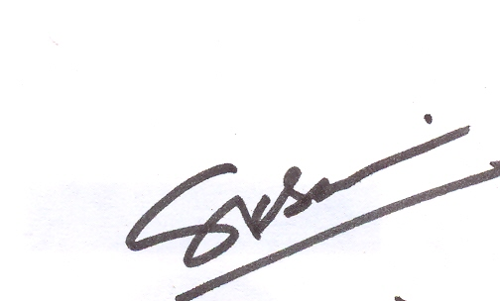
(S. K.Saini)

Copy to :- 1. Sh. Gopal Das, Director-HRD, BSNL CO, New Delhi for kind inf. pls

