“OPERATION SACRIFICE”
For upliftment of BSNL
By All India Graduate Engineer Telecom Officers’ Association (AIGETOA)
Website: www.aigetoachq.org Email: chqaigetoa@gmail.com
___________________________________________________________________________
Appeal to save BSNL (A Public Asset of Nation)

To
Shri Gurudas Kamat
Hon’ble Minister of State for Communication
Sanchar Bhavan, 20, Ashoka Road,
New Delhi-110001

Honourable Sir,
We, the young executives of BSNL, wish to invite your kind attention towards BSNL, a public sector enterprise in telecom sector carved out of Department of Telecommunications (DOT) Government of India in the year 2000. The telecom giant, who had glorious past with 12000 Crores profit 5 years back, is now going through disgraceful and critical present for its survival in the fierce competitive market conditions. The saturation of lucrative revenue earning in urban and lack contemporary management practice and corporate governance in BSNL has led its condition more pathetic and contemptible. Currently BSNL is reeling under the operational losses, and marginal financial profits are generated only from the huge bank reserves. Despite having largest telecom network and infrastructure in India, BSNL is unable to compete with private players. It is about a year that the Government has favourably allotted 3G and Wi-Max spectrum to BSNL in ahead of other private operators and BSNL is still to capture or exploit the first mover’s advantage. It is not to wonder that BSNL is surely landing in a situation similar to that of AIR INDIA, where if it happens will peril the Government’s initiative on e-governance, health care, primary education and public welfare especially in rural India, where BSNL is only service provider. In addition the Government will have to shell out approximately 14000 crores per annum again from the tax payers’ pocket for salary bill of nearly 3.2 lakhs employees of BSNL.
BSNL witnessed 97% dip in its profit over the period of 5 years. Following comparison depicts as to where BSNL lie in the telecom market despite having vast telecom infrastructure, more than 150 years of history and work force of about 3.2 lakhs employees.
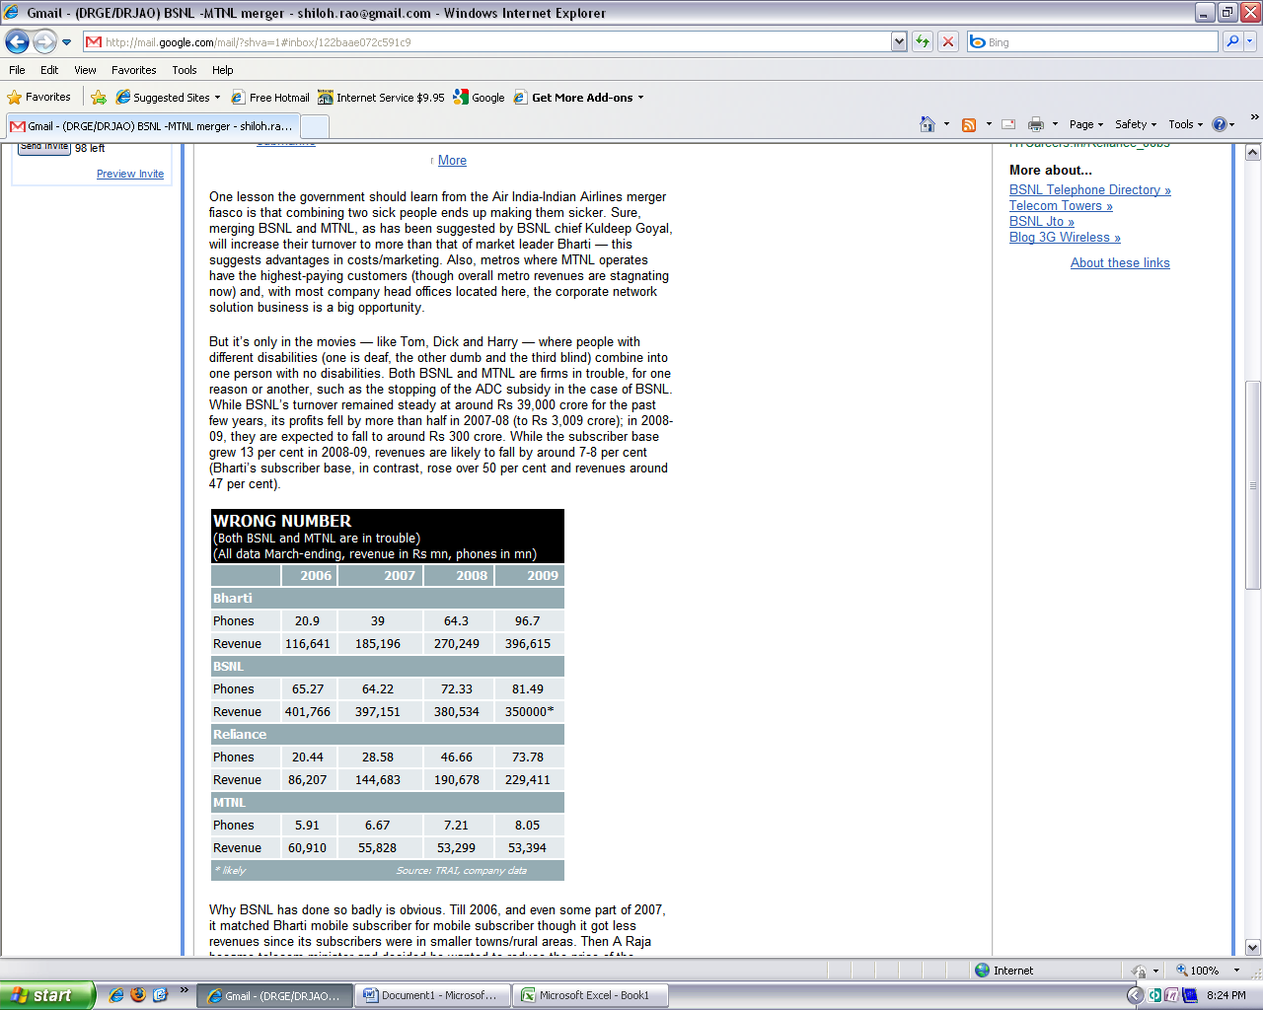 | 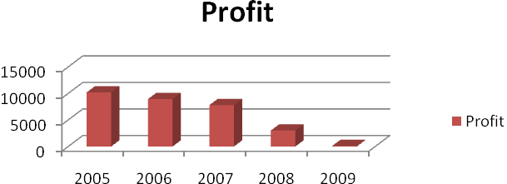
It is a pity to mention that even after 9 years of inception, the policy makers of this company are still working as guests (on deputation from Government) without any responsibility, accountability and belongingness to it. Moreover, the continuation of unabsorbed ITS officers in BSNL on deputation is not in lines with the instructions/guiding policies of the Department of Public Enterprises (DPE), which states that the deputation of Government Servant to any public sector undertaking should be not allowed for more than 3 years. They are still running BSNL in same old monopolistic government culture and not unwilling to adopt the contemporary corporate culture in BSNL fearing dilution of their vested interests and bureaucratic grip on the organisation. The awkward situation has ultimately led to the failure of public delivery system in BSNL.
It irony in the BSNL that the post of Divisional Engineers, Assistant General Manager, Deputy general managers are occupied by the officers with 10th, 12th, ITI, Diploma, BA, etc. All of them become officers in the DOT era because of the powerful trade unions. The bureaucrats upgraded them to the post of officers without having any regard to job requirement and rules/norms specified by the DOPT. According to our survey out of 54000 executives only 12000 executives are only academically qualified as engineers and accounts officers.
Recently the visionless BSNL management formulated its management service rules where it has enabled all un-qualified and under-qualified to become Divisional Engineer, Assistant General Manager, Deputy General Manager and General Manager, etc. Telecom service, being technology intensive industry, requires professionally qualified engineers and managers at middle and senior level posts. Whereas, BSNL management on the other side is unique one to have no regard for educational and professional qualifications of its executives, thereby promoting un-qualified and under-qualified people and ignoring the qualified and professionally competent workforce. This is one among the other reasons for which BSNL is incurring financial losses and losing market share in heavily technology driven sector such mobile. Stagnated growth of mobile customers is the clear indicator of poor network planning, poor system maintenance and neglected customer care by the un-qualified and under-qualified engineers working as Divisional Engineer, Assistant General Manager and Deputy General Manager.
BSNL in order to meet its man power requirement has recruited about 10000 qualified engineering graduates/accounts professionals to handle neo technical area after its formation. They constitute as most competent, talented and performing work force out of 3.2 lakhs employees. But, due to the vested interest of bureaucratic policy makers who are unwilling to dilute their government legacies are not promoting the in-house talent and deliberately repudiate responsibilities. Every professional requires minimum educational qualification to practise and hone his skills. It is very disappointing that in BSNL an employee with lesser educational qualification is having more promotional avenues than the qualified professionals. BSNL recruited Engineers / Accounts Officers are legitimately demanding responsibilities with respect to their qualification so that their talent can be utilised for the well being of the company and people at large. But it is on part of the BSNL management, who is not ready to impart responsibilities according to qualifications as in other PSU’s practices and principles.
We young executives are more worried about the future as they have to serve for many years and if the present scenario continues in BSNL the day is not far that it will be even hard to receive the basic salary of the employees. Considering all these facts into mind AIGETOA has decided to go for comprehensive revolution in BSNL through “Operation Sacrifice” and all the 10000 members of this association throughout India are ready to sacrifice themselves for the complete transformation of BSNL.
Our Association (AIGETOA) has started “Operation Sacrifice” from 13/07/2009 to expose the anti-business activities of Guest ITS officer and visionless management and to transform the sarkari work culture into complete corporate culture for tangible, reliable and assured customer service to regain its lost glory of BSNL.
At the beginning on 31st July 2009 we are holding half day demonstration in every nook and corner of the country and protest against the ill motives and wrong policies of guest ITS officers. If BSNL board and concerned ministry of government still remain deaf and blind for the current situations, we have no options but rally all the 10000 members of our association will BSNL Head Quarter New Delhi on 18th August 2009 for mass indefinite protest followed by hunger strike till last breath.
We request the Government of India: -
- To settle the ITS absorption issue since the continuation of ITS officers in BSNL without getting absorbed is detrimental to the organisation and the society as large.
- To constitute independent Fact-finding Committee to enquire into causes for nosedive losses and reprimand the BSNL management by lifting corporate veil so as to repair the loss caused by irresponsible BSNL management and guest ITS officers
- Kindly intervene to prevent BSNL from becoming another Air India, which is recently been bailed out by the Government, save the public asset of the nation from the incompetent management of BSNL.
- To investigate the working of BSNL under various provisions of Companies Act 1956.

I, the undersigned fully convinced by the above facts and appeal to your honour to kindly save the public company from the hands of indolent BSNL management.
Remain with regards.

Yours faithfully,
Signature:
Name:
Designation:
Address:

