“Operation Sacrifice” to save BSNL
All India Graduate Engineer Telecom Officers Association (AIGETOA)
(An Association of young Engineers & Account Officers of BSNL)

Appeal to all the public eminent, political leaders, media houses and conscious citizens of India

Dear Sir/Madam,
We the young executives with BE/B.Tech/CA/MBA qualifications recruited by BSNL after its formation are committed to give world class quality services to our esteemed customers at competitive price. We are proficient to take up the external challenges (from private operators) but it is hard to take up the internal challenges due to existing corruption, sarkari work culture and anti business policies of bureaucrats (Deputed ITS) dominated BSNL management without your support.

Earlier Department of Telecommunication (DOT) was monopoly telecom operator in India but after coming into the effect of “New Telecom Policy 1999” many private operators was allowed to enter into the most challenging and demanding telecom field. Indian Government converted DOT into BSNL (PSU) in Oct. 2000 wherein all the setup and work culture had to change according to the Public Sector. But it is unfortunate that nothing has been changed in the name of culture and setup even after passing more than 8 years but it became worse with time due to bureaucrats policy makers in BSNL.

At the time of conversion, BSNL already had more than 3 Lakhs of employees (executives & non-executives) but most of them were not trained in corporate culture and with the rapid invention and advancement in telecom technology many of them lack of technical competence and educational qualification. In order to meet its essential requirement in new technology like mobile, broadband, 3-G services etc. BSNL recruited almost 10,000 qualified engineering graduates/accounts professionals to handle technical issues and surge ahead and dominate the telecommunication market. Currently we constitute as most competent work force out of 3 lakhs employees who are young and capable to handle the growing technology, competition and pressure to perform. But, due to the vested interest of bureaucratic policy makers who are unwilling to dilute their government legacies are deliberately repudiate appropriate responsibilities and posted them under non-technical executives having qualification of merely 10th, 12th ITI, Diploma, BA/BCom etc.

We young executives are more worried about the survival of BSNL as we have to serve for many years and if the same situation prevails in BSNL the day is not far that it will be even hard to receive the basic salary of the employees. Considering all these facts into mind AIGETOA has started “Operation Sacrifice” since 13.07.2009 to expose the anti-business activities of Guest ITS officer who dominate in BSNL management and bring the change in the sarkari BSNL work culture to complete corporate culture for tangible, reliable and assured customer service to regain its lost glory of BSNL. All the 10000 members of this association throughout India will be gathering at BSNL corporate office New Delhi on 18th August 2009 for the indefinite protest against the bureaucrat policy makers and ready to even give up their lives if the need arise for the complete transformation of BSNL.

BSNL AT A GLANCE

- BSNL having huge infrastructure and more than 150 years experience unlike other operators who are recently entered in to telecom field.
- Providing comprehensive service in every area of telecom field like basic telephony, wireless telephony, internet, etc. unlike other operators who are providing some specific service. Service area is throughout the country except Delhi and Bombay unlike other operators who are restricted to some states.
- Having huge work force of more than 3 lakhs executives and non executives.

Despite of all these things BSNL profit declined from Rs. 8000 Crores to 574 Crores during last four years. BSNL witnessed 97% dip in profit in last two financial years. Following comparison will explain the declination of BSNL hold in the telecom market share, revenue and profit despite having amazing infrastructure, more than 150 years history and work force of more than 3 lakhs employees.
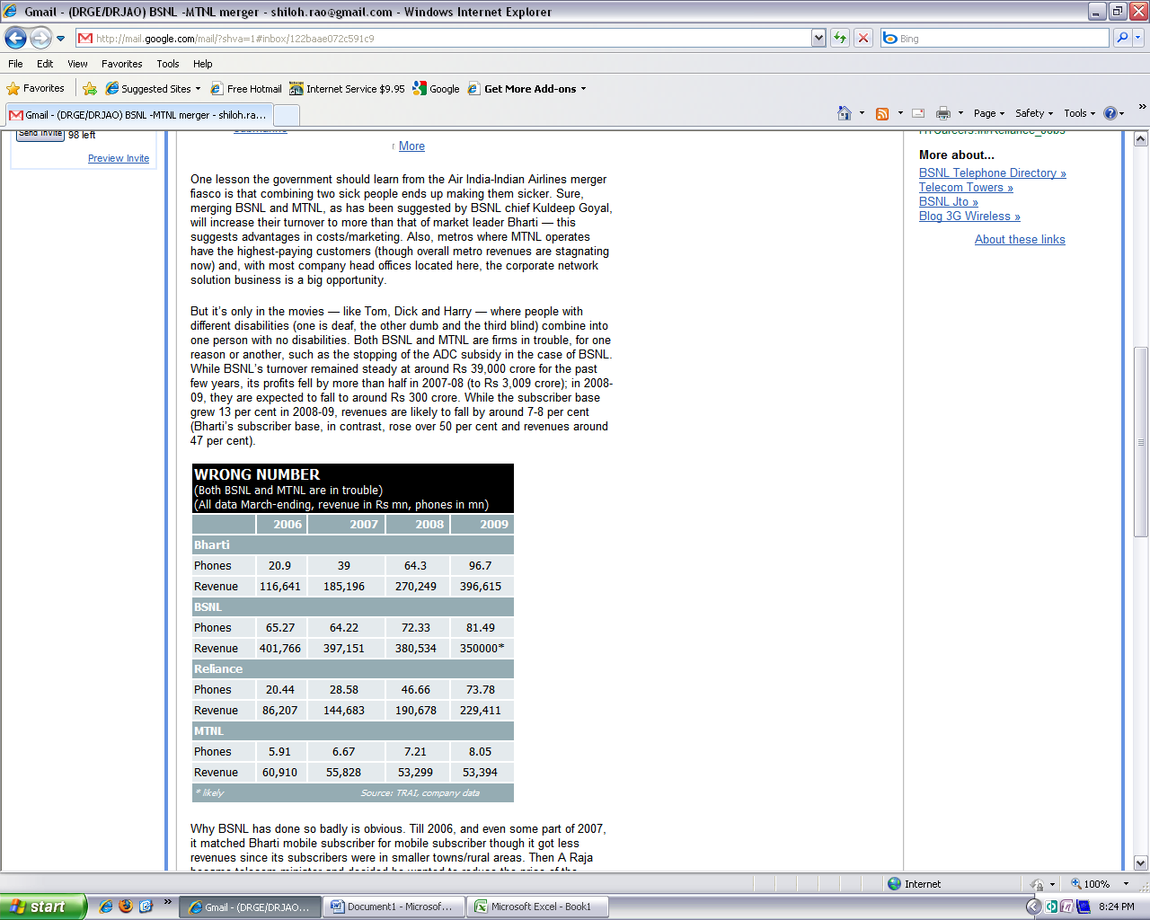 | 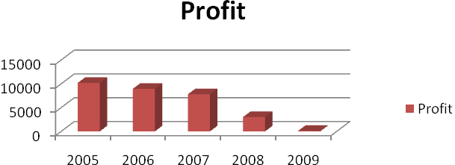
REASONS
- Deputed Government officers in the rank CGM, PGM, GM who constitute the just below board level and heads several circles and occupy several key portfolios in BSNL corporate office. No Accountability for their decisions, profits and losses.
- Lack of job satisfaction and belongingness among different cadres, No job enhancement and enrichment for every employee especially young executives and non- executives due to poor or rather no HR policy.
- Deputed officers are making haphazard recruitment polices and not promoting internal talents fearing loosing grip in the organizational hierarchy.
- Old monopolistic government work (Sarkari) culture, no focus on performance and delightful customer service. No recognition for the performance of the employees.

“We appeal to all the public eminent, political leaders, media houses and conscious citizens to support and help us to save the glory of BSNL an organization built upon taxes paid from your hard earnings (Public Money)”.

