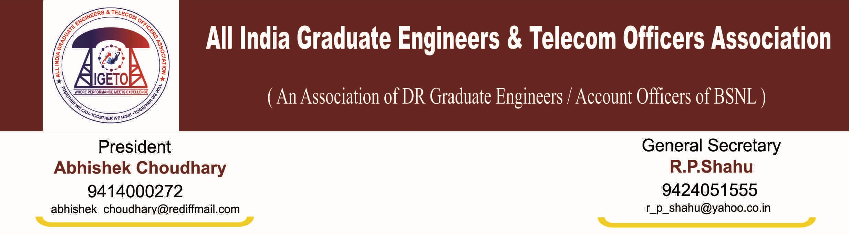
No: CHQ/AIGETOA/427 Dated: 9th July- 2013

To,
The Sr. G.M. (Pers)
BSNL CO, New Delhi

Subject: Request for modification in posting order issued through LDCE for SDE (T) held on 4th March-2013 in some specific cases.
Dear Sir,
At the outset, on behalf of this association I extend once again the profound gratitude for issuing posting order of LDCE passed candidates in such a short time after declaration of result. This association has already highlighted some specific cases before your goodself cases which are not considered while issuing posting order of LDCE passed candidates. We are herby submitting the list of the candidates seeking modification in posting order on following ground.
- Consideration of lady officers in retaining them in parent circle or in their choice of circle.
While issuing posting order lady officers are not considered in retaining them in their parent or choice of circle hence it is requested to consider them to retain in their parent circle or in their choice of circle on sympathetic ground and guidelines issued by GOI. List of such affected lady officers is attached herewith and Marked as Annexure-1.
- Consideration of physically handicapped candidates in retaining them in parent circle or in their choice of circle.
While issuing posting orders physically handicapped candidates are not considered in retaining them in their parent circle hence it is requested to consider them to retain in their parent circle or in their choice of circle on sympathetic ground and guidelines issued by GOI. List of such affected officers is attached herewith and Marked as Annexure-2.
- Consideration of couple and working spouse cases.
While issuing posting order couple and working spouse cases are not considered hence it is requested to kindly consider the same on sympathetic ground as per guideline issued by Government of India. List of such affected officers is attached herewith and Marked as Annexure-3
- Considerations of modification in transfer of those who have already worked are still working in out of their parent circle since their recruitment.
This association also received some representations from members of this association who have either already worked and recently transferred to their parent circle under rule-8 in JTO cadre or yet working out of their parent circle since their recruitment as JTO. Most of such cases are already considered while issuing posting order of LDCE passed candidates yet some candidates remain unconsidered. List of such affected officers is attached herewith and Marked as Annexure-4.
- Correction in account of wrong circle entry (working circles ore posting circle) in posting order:
This association received representations from some members against whom working circle showing wrong in the posting order hence either their posting has been done wrongly or they are not being relieved by the working circle in spite their posting circle is right. This association request for correction in the working circle and posting order as requested by the candidates. List of such affected officers is attached herewith and Marked as Annexure-5
This association is very much hopeful that your kind will consider our above genuine submission and take favorable action as early as possible so that promotion of such candidates does not suffer.

Thanking you,

(R P SHAHU)

General Secretary
Copy to:
- The CMD, BSNL BSNL CO New Delhi.
- The Director (HR), BSNL CO New Delhi.
- Sr. G.M. (SR) BSNL CO New Delhi

