No. GS/AIGETOA/37 Dated: 11/02/2014
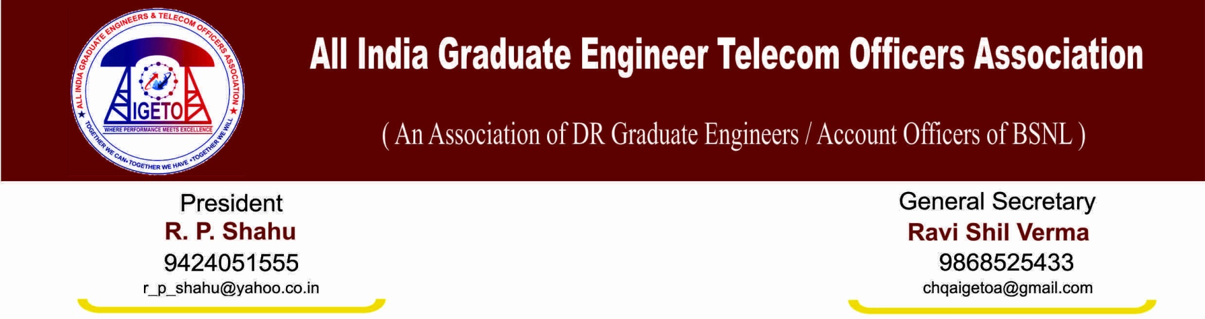
To
The CMD
BSNL, New Delhi
Subject: Regarding ongoing protest from 3rd Feb-2014 against breach of trust and non-resolution of very basic issues in respect of direct recruited executives.
Respected Sir,
This association vide its letter No GS/AIGETOA/27 dated 13th Jan-2014 has served notice for indefinite hunger fast from 3rd Feb-2014 against the breach of trust and non-resolution of very basic issues in respect of direct recruited executives of BSNL.
In response to our notice, a meeting was held on 31st Jan-2014 under the chairmanship of your good self, some discussion did take place but no final resolution had come out. Sir, your good self has desired for submission of the facts in support of wrong doing in past and in implementation of 2nd PRC which are affecting the pay, career and social security of direct recruits. You have assured us to take corrective actions within time of 7 days of submission of our inputs against any such wrong doings.
Followed by above meeting and your assurance to take corrective action this association had differed indefinite hunger fast. It is regret to mention that this assurance has once again ended without any concrete action which has further dented our confidence and trust.
Now, this is to notify that this association has decided that our All India President Sh R P Shahu along with some other volunteers will sit on indefinite hunger fast from 12/02/2014 at Jantar Mantar New Delhi. All other members will abstain from offices from 12/02/2014 and will reach at Jantar Mantar for mass protest.
Sincerely your’s

Ravi Shil Verma
General Secretary
Copy to: G.M. (SR), BSNL CO New Delhi.

