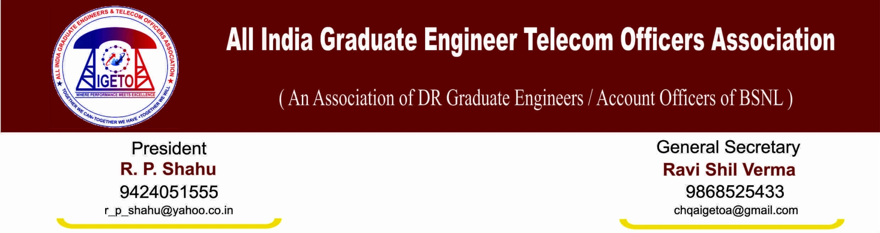
No: GS/AIGETOA/36 Dated: 5th Feb’2014

Notice for emergency meeting of CS/CWC/CHQ

In view of our ongoing protest against breach of trust and non-resolution of very basic issues in respect of direct recruited executives of BSNL, It is to notify that emergency meeting of All CS/CWC/CHQ is called on 7th Feb-2014 (Friday) from 10:00 am onwards at New Delhi.
Friends, as you know we have reached to the points where no option left except fight for right and dignity hence Presence of the all the representatives from every part of the country is mandatory.
In the said meeting we all have to take cumulative decision how to intensify our ongoing agitation if issues are no resolved up to our satisfaction.
It is further requested to not book the return ticket till our agitation is going on.

S/d
Ravi Shil Verma
GS, AIGETOA

