**GS/AIGETOA/38 21st February 2014**

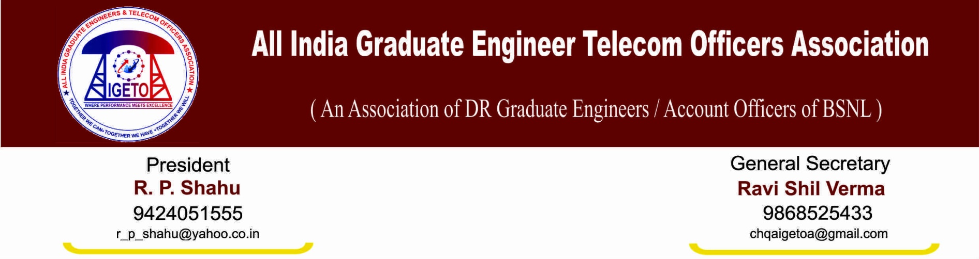**To**

**The CMD**

Bharat Sanchar Nigam Limited

New Delhi

**Subject**: **Deferment of ongoing agitation, regarding.**

***Respected Sir,***

In view of the discussions and assurances given to this association to resolve the issues in a positive and sympathetic manner in the meeting held on 20th Feb-2014 under the chairmanship of Director (HR) and the subsequent appeal by SR cell for calling off the ongoing agitation, this association has decided to the defer the ongoing agitation for now. We believe on the words & spirit of the commitment expressed by the management in the discussion that these issues will be resolved in a positive atmosphere by the management in a timely manner:

* We believe that Higher Level Committee formed for Pay scale/Pay parity and Superannuation issue will look into the various order issued by GoI/DPE and submissions by this association. Issue will be resolved on merit within one month of time as assured**.**
* We believe that the Committee formed for implementation of CPSE cadre hierarchy in BSNL will issue its draft proposal within one or two days’ time.
* We believe that the EPF contribution for training period will be looked compassionately and management will find the way to withdraw its’ appeal in the court on merit.
* We believe that the Uniform first time bound upgradation in four years will be resolved on positive note and court case on this issue will be analyzed and management will look into possibility of withdrawing its’ appeal in the court on merit.
* We believe that management will take the issues raised by AIGETOA in a positive way and resolve them in timely, sympathetic and compassionate way.

We once again reaffirm our commitment to work for the welfare and growth of the BSNL in future and on this note we defer the ongoing agitation.

**Your’s faithfully**

**Sd/-**

**(Ravishil Verma)**

**General Secretary**