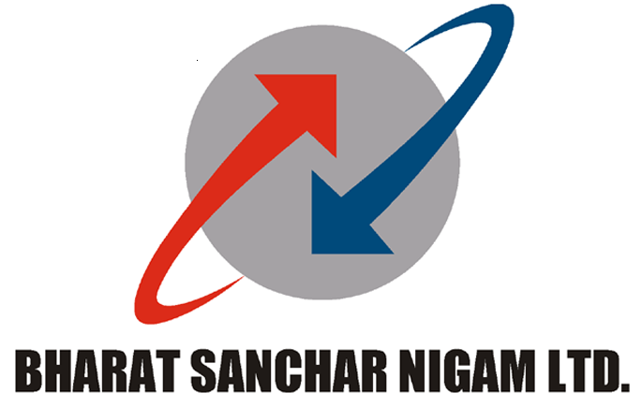BHARAT SANCHAR NIGAM LIMITED
(A GOVERNMENT OF INDIA ENTERPRISE)
SR Cell, Corporate Office
8th Floor, Bharat Sanchar Bhawan,
Harish Chander Mathur Lane,
Janpath, New Delhi-110 001

F. No. BSNL/7-1/SR/2014 Dated, the 31st January, 2014
To
The General Secretary,
AIGETOA,
New Delhi.

Sub: Notice for indefinite hunger fast from 3rd February, 2014 – regarding

This has reference to the discussions you had with CMD, BSNL this morning. A copy of the ‘Record of discussions’ of the meeting held is enclosed herewith.

2. In view of the meeting held, you are requested to withdraw your proposed agitational programme.

Yours faithfully,

(Satish Wadhwa)
DGM (SR), BSNL C.O.
Encl: As above.

BHARAT SANCHAR NIGAM LIMITED
(A GOVERNMENT OF INDIA ENTERPRISE)
SR Cell, Corporate Office
8th Floor, Bharat Sanchar Bhawan,
Harish Chander Mathur Lane,
Janpath, New Delhi-110 001

F. No. BSNL/7-1/SR/2014 Dated, the 31st January, 2014
Record of discussions of the meeting held on 31st January, 2014under the chairmanship of CMD, BSNL with the representatives of AIGETOA

A meeting was held on 31st January, 2014 under the chairmanship of CMD, BSNL with the representatives of AIGETOA and the following issues were discussed. A copy of the compilation of current status on various issues was also handed over to the Association representatives.
Issue No. 1 Finalisation of standard pay scale as directed by DPE followed by 2nd PRC i.e. E2 for JTO equivalent and E3 for SDE equivalent with additional increment to executives recruited on or after 1.1.2007 to maintain the parity between executives recruited before 1.1.2007
The AIGETOA representatives pointed out that due to erroneous implementation of 2nd PRC in respect of DR JTOs/JAOs, they are facing considerable loss in their salary as compared to their salary in the pre-revised pay scales and the same needs to be rectified. In response, the CMD advised them to justify their contention in writing, within a week’s time.
The management side shall examine afresh the issue/inputs and rectify the mistake, if any or give them a suitable reply otherwise. This process will also be completed within a week’s time after getting inputs from the Association.
Issue No. 2 Implementation of 30% superannuation benefits in respect of DR executives as directed by DPE followed by 2nd PRC
The management side informed that the Committee, taking into consideration the current financial position of the Company, has given a recommendation of contribution to the extent of 2% of Basic + DA towards Superannuation Fund for direct recruit employees, after taking inputs from all the unions and associations. Thereafter, the Committee also held deliberations on 15th January, 2014 with the representatives of all the unions and associations. The union leaders have unanimously demanded 12% contribution towards Superannuation Fund.

CMD, BSNL directed that the recommendations of the Committee as well as the inputs received from various unions and associations be submitted for consideration of the competent authority, within a week’s time by the concerned Cell.

Issue No. 3 Stop external DGM/MT recruitment, hence scrap the RR, same must be recruited within among internal executives and implement time bound functional promotion instead of financial upgradation on the basis for stringent performance and qualification as of top leading CPSEs to fill the gap at middle level executives
In response to the demand of the association for stopping external DGM/MT recruitment, the management side pointed out that for smooth running of the Company, direct recruitment is made wherever it is felt imperative. In this process, the internal candidates also get an opportunity to compete with outside candidates. As such, the demand for stoppage of DGM/MT recruitment cannot be agreed to.
On the issue of CPSU hierarchy, it was informed that the designated Committee has held consultations with the stake holders and shall be in a position to share the draft Policy with all concerned within 15 days’ time.
Issue No.4 Resolution of EPF anomalies in respect of direct recruits
It was clarified by the management side that EPF Cell is functioning in the Corporate Office under GM (CA) and the relevant issues, if any, can be taken up with this Cell. However, the CMD, BSNL directed that the details about the existence/functioning of EPF Cell may be re-iterated for information of all concerned. Further, as regards the issue of EPF contribution during the training period, it was informed that the issue is sub-judice.
Issue No. 5 Immediate cancellation of mass displacement executed in posting order issued in promotion against LDCE (33% quota) for SDE (T) held on 4th March, 2012 from some circle like AP, Orissa, Punjab, Maharashtra, MP and KTK. Execute the longest stay list to maintain the shortfall of SDEs in some Circles
It was informed that a large number of requests from the various circles have been considered for retention on various grounds such as spouse, Physical handicapped, medical, age bar, female etc. In total, approx. 450 requests have been considered for retention on various grounds which are mostly from AP, OR, PB, MP, MH circle.

The CMD, BSNL directed that there should be no discrimination amongst the employees in this regard and the provisions of existing Transfer Policy should be adhered to.

Issue No.6 Maintain uniformity in first time bound upgradation i.e. four years in respect of all executives
The Association pointed out that one batch, i.e. of 2001 year has been at a disadvantage and got the financial upgradation only after six years whereas others got the benefit in time and a Court order is already there which has not been implemented.

The CMD, BSNL advised the Association to submit a copy of the same for examination, within a week’s time for any due compliance.

(Satish Wadhwa)
DGM (SR), BSNL C.O.
To
All concerned

