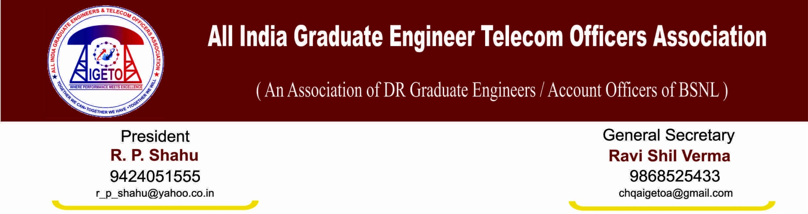
No: GS/AIGETOA/29 Dated: 23rd Jan’2014

To,
Shri Prahalad Rai
General Secretary
AIBSNLEA

Dear Sir
We are in receipt of your letter dated 15th January 2014 wherein you have assured and reiterated your wholehearted support for the success of the agitation. We are also gladdened by the positive words used in your letter:

“What is important is the settlement of these vitalissues and not through which Association or Forum it is achieved, and we sincerely want that.”

Sir, we also have the similar belief and are focussed on the results irrespective of who does it or where it is got done. Your encouraging words will go a long way in promoting the interests of the much neglected DR fraternity of BSNL.
With the similar view and confidence of your support, we have requested SNEA also to launch the agitation under either their banner or a combined United Forum banner and have ensured them that we shall be part of anything launched on that platform on these issues.
Thanks once again for the encouragement and the positive words from your side.

With Warm regards
Sd/-
Ravi Shil Verma
General Secretary

