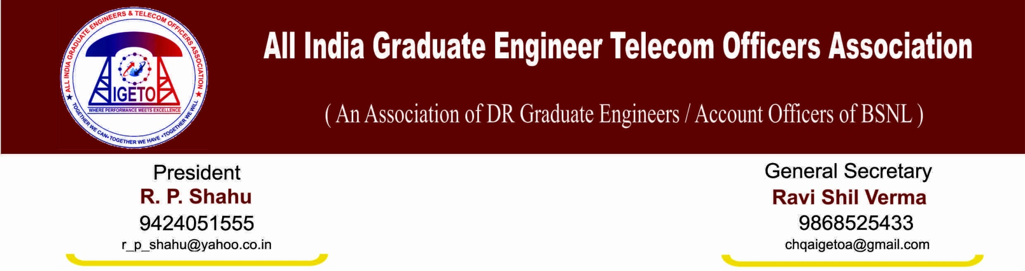
No: GS/AIGETOA/28 Dated: 23rd Jan’2014

To,
Shri K Sebastin
General Secretary
SNEA (India)

Dear Sir,
This is in reference to your letter dated 10th January 2014 wherein you have advised us that Joint Struggle is the only option and that an isolated struggle will not resolve the issue. We do believe that the words expressed by you do carry the weight it deserves.
Sir, it is a known fact that BSNL management has been ignoring the legitimate demands of direct recruits from the beginning and has been undermining the strength of executives every now and then. We all including AIGETOA, SNEA and AIBSNLEA has been struggling for the rights of the executives and in the process have several time launched agitational actions. Thereafter, management has been giving us written assurances to all of us either individually or at the platform of United forum. However, all those promises have been broken especially on the matters relating to the Direct recruits. Every time management has breached our trust.
Going by your letter, we also believe in whatever you have said. With utmost honesty and humility, I would like to inform you that continuous ignorance has forced us to take this extreme step and we have committed ourselves to this path.
However, this is to convey that if either United Forum or even SNEA individually serves the notice for organizational action on the following issues on the basis of various agreements made to AIGETOA, AIBSNLEA, SNEA or United forum, we ensure our 100% support and physical participation into this struggle:
- Finalization of standard pay scale of JTO equivalent (E2) and SDE equivalent (E3) with additional increments to New Recruited executives to maintain pay parity with executives recruited just before 1.12007.
- Introduction of 30% Superannuation benefit to the Direct Recruits of BSNL as per the recommendation of 2nd PRC
- Stop external DGM/MT recruitment
- Implementation of contemporary CPSU Hierarchy
- Resolution of EPF anomalies in respect of direct recruits
- Maintain uniformity in first time bound up-gradation i.e. four years in respect of all executives
Sir, these issues have been the most important issues for our survival especially the issue no.1 and 2 which are linked to our future and family security and there cannot be any compromises on that. In view of this, it is our humble appeal to you to either join our struggle or serve a notice from United Forum on these issues or even SNEA individually. On behalf of AIGETOA, I assure you hundred per cent support and physical participation of my members. AIBSNLEA has already extended its unconditional support.
Further, as the next general elections can be notified any time, we request you to do the needful urgently and immediately so that the agitation can start well before February 15th 2013.
I hope you will take cognizance of the facts given by us and decide accordingly. Herein we would also like to emphasize that we are only interested in getting the above issues resolved irrespective of how and where it gets resolved. We sincerely hope that together we will.

With Best regards
Sd/-

Ravi Shil Verma
General Secretary

