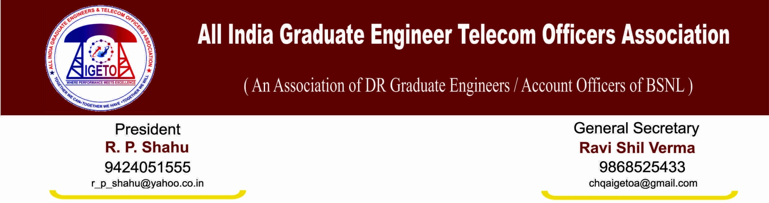
No: GS/AIGETOA/3 Dated: 4th Oct’ 13
To,
The CMD
Bharat Sanchar Nigam Limited
New Delhi.
Sub: Seeking meeting with concern authorities under the chairmanship of your good self to discuss various issues agreed to be resolved in a time bound manner, regarding.
Ref: - 1. Record of the negotiation meeting held between representatives of AIGETOA and
BSNL Management in respect of various issues on dated 08/08/2013.
2. AIGETOA letter no. CHQ/AIGETOA/451 dated 2nd September 2013.
Respected Sir,
Your benign attention is invited towards the record of the meeting mentioned under reference and this association letter dated 2nd September 2013 vide which we have submitted the brief feedback on the seven issues.
We are very hopeful that under your guidance, issues must be progressing towards resolution as agreed in the meeting between management and the association representatives on 8th August 2013.
However, as agreed in the meeting, AIGETOA is yet to give a formal presentation to the HR team under your chairmanship, despite repeated pursuance with the concerned sections dealing with the case. Further, despite passage of almost two months, no visibility is there on the issues and in the meanwhile two major clauses of the agreement reached on 8th August has been violated resulting into huge de-motivation and wondering amongst our members whether HR managers of BSNL are having any respect for the words committed by highest authority in BSNL i.e. CMD. The details of the violations are as stated below:

- Stop external DGM/MT recruitment, hence scrap the RR, same must be recruited within among internal executives and implement the time bound functional promotion instead financial up gradation on the basis for stringent performance and qualification as of top leading CPSEs to fill the gap at middle level executives:

Resolution agreed by Management: Committee formed for the CPSU hierarchy shall be requested to submit its recommendations expeditiously. The issue raised herein by AIGETOA for MT recruitment would be examined afresh and resolved within two month’s time.
Status: Till date there is no visibility on the recommendations of the committee formed for the implementation of the CPSU hierarchy despite of repeated follow-ups and request for meeting from association side. The recommendations were to be submitted before going ahead with the MT recruitment and DGM recruitment, that did not happen and DGM examination has been notified to be held on 20th October.

Further, till date no inputs by AIGETOA has been examined by the concerned section dealing with the MT RR and neither are they having any plans to do so nor has the association been called for any meetings. In between there are murmurs that 25% of the STS posts (i.e. 1235 posts) are being diverted to Seniority cum fitness quota. This gives us enough reasons to wonder why this association was not taken into confidence while arriving at any such decision as normally if decision pertaining to benefits of direct recruits are being taken, view of all the associations are being called for. We completely fail to understand why these posts are being diverted to seniority quota and why not they are being converted into year wise LDCE quota for SDE/AO to DE/CAO exams which would have been the most apt way in the current scenario where these posts would have gone to young and meritorious candidates. We take strong objection to this unilateral decision without considering the interests of the young executives of BSNL.
Sir. Ideally CPSU hierarchy is the solution to all the HR problems which BSNL is facing today but instead of focusing on that, HR managers of BSNL are moving ahead with the earlier programs even without giving us a chance to voice our opinion. Therefore, in view of the above, it is once again requested to scrap the DGM recruitment as well as MT RRs immediately and start the deliberations on the formulation of CPSU hierarchy mechanism, revision in BSNMS RR/ BSNL MTRR taking the collective interests of all the groups in BSNL in mind.

- Immediate cancellation of mass displacement executed in posting order issued in promotion against LDCE (33% quota) for SDE (T) held on 4th March-2012 from some circle like AP, Orissa, Punjab. Maharashtra, MP and KTK. Execute the longest stay list to maintain the shortfall of SDEs in some circles.
Resolution: The recommendations of the circle heads particularly from those circles where large number of executives have been transferred out would be considered as well.
Status: No such requests from AP, MH, MP, KTK circles were considered where a large number of executives were transferred out. CGMs kept on writing letters while HR wing kept on ignoring these letters on one pretext or another. Finally CGMs were made to sign those letters personally and then also their recommendations were not considered except one or few which has basically demeaned the authority of CGMs also, the credibility of the association is a far fling thing. Though transfer posting was a very small issue but yet the resolution taken in the meeting was violated and

in fact in the process, basically the authority and respect for letters from CGMs was also compromised.

Further in addition to these violations, the status on other issues like Finalization of standard pay scales, Pay Parity issue of batches recruited after 2007, Implementation of 30% Superannuation benefit, Resolution of EPF anomalies, uniformity in first time bound up-gradation have not yet seen the light of the day and nor any progress is being envisaged in this regard. Till date we have not been called up for any of the meeting to explain our views or feedback as committed in the agreement dated 08.08.2013.
Sir, we are of the firm opinion that only your kind can come up to the rescue of this most important group of the company. Already there has been a very long agitation by this group and any further ignorance and violation of the clauses will result into huge unrest and de-motivation amongst the direct recruits.
Sir, we request for your kind intervention in this regard as despite of your instructions, HR wing has not come up with resolution of any of the issue. The timeline committed for many of the issues were two months but nothing has happened till date. We feel that as agreed earlier, a presentation from association side to the HR managers under the chairmanship of your kind will give us a chance to present our view and inputs on the issues and their resolution immediately.
Therefore, in view of the above, we request your good self to kindly allot us a time slot for a meeting under your kind chairmanship with representatives of this association and the concerned authorities so that the issues can be discussed in detail and resolved.
We firmly believe that your intervention will help the matters to be resolved in amicable way and unnecessary stand-off can be avoided.
Thanking You
Sincerely yours
Sd/-
(Ravi Shil Verma) General Secretary
Copy to:
- Director (HR)/Director (Finance) for kind information please.
- Sr. G.M. (SR), BSNL CO for kind information please.

