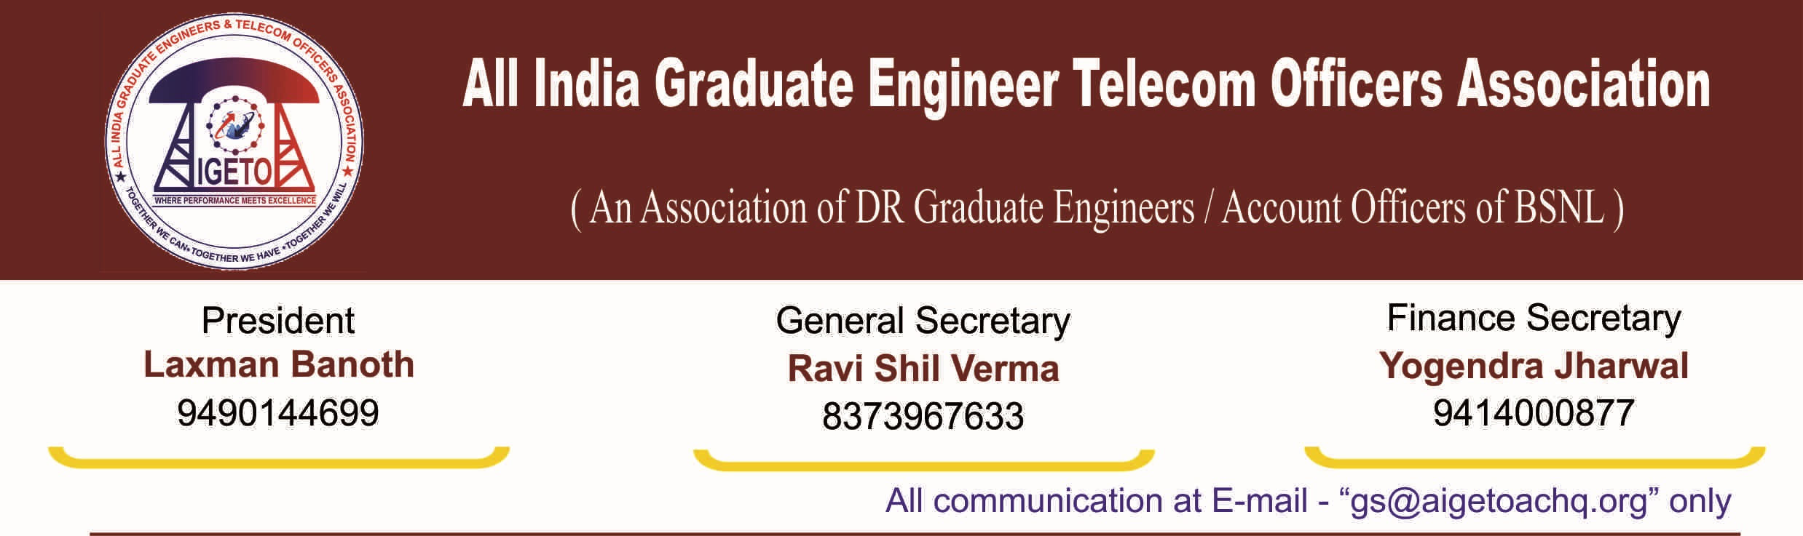
No. GS/AIGETOA/2016/9 (ii) Dated 22.07.2016

UNDERTAKING

I, Ravi Shil Verma, S/o of Sri Sushil Bhushan Prasad and General Secretary of “All India Graduate Engineer Telecom Officers Association (AIGETOA)” hereby give my undertaking that in case any provisions in the constitution of my association are at variance with the BSNL Recognition Rules, 2014 shall be amended/modified the same in consonance with the Recognition Rules, 2014 except Rule-5(2) of the said rule within a period of six months from the date of submission of the undertaking failing which action as per Recognition Rules will follow. This undertaking has been given without prejudice to the rights of the association wherein it has represented for a separate recognition and formal representation for the association representing exclusively the third category of executives i.e. direct recruits executives recruited after inception of BSNL.

[RAVI SHIL VERMA]
General Secretary, AIGETOA

