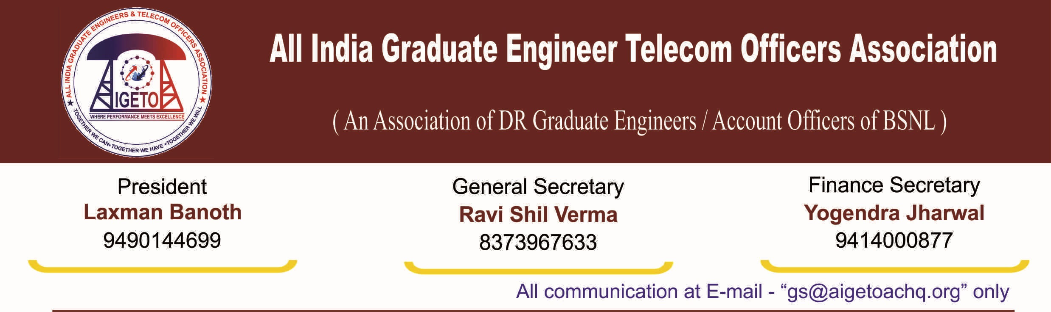
No. GS/AIGETOA/2016/9 (i) Dated 22.07.2016 UNDERTAKING
I, Ravi Shil Verma, S/o of Sri Sushil Bhushan Prasad and General Secretary of “All India Graduate Engineer Telecom Officers Association (AIGETOA)”, which is registered under Societies Act at Rewari, Haryana bearing Registration No HR/019/2016/02138, affirms our intention to participate in the Membership Verification Process of Bharat Sanchar Nigam Limited (Recognition of Executives’ Association) Rules, 2014 notified vide No. BSNL/5-1/SR/2016 dated 25/5/2016 of GM (SR), BSNL CO, New Delhi and further extended by No. BSNL/5-1/SR/2016 dt 23/6/2016 of GM (SR), BSNL CO, New Delhi.
I hereby give my undertaking that the provisions of the BSNL (Recognition of Executives’ Association) Rules, 2014 are acceptable to my association except Rule-5(2) of the BSNL Rules, 2014 notified through L. No. BSNL/31-2/SR/2009 dt 6/1/2014 by DGM (SR), BSNL CO, New Delhi on the following grounds, circulars and representations and exceptions:
- That, we are distinct category of executives i.e. “BSNL Recruited Executives”, whose service conditions are entirely different than BSNL Absorbed Executives.
- That, we got the right to form a Serving Association from distinct category of Government servants having common interest issued through notification by Central Services (Recognition of Service Associations) Rules, 1993 issued by Ministry of Personnel, Public Grievances & Pension (Department of Personnel & Training) vide No. 2/10/80/-JCA dt 5th November 1993.
- That, AIGETOA has been formed for the BSNL Recruited Executives, who are a distinct category of Government servants in BSNL having common interest and common service conditions as described under Para-5(c) of DoPT notification No. 2/10/80/-JCA dt 5th November 1993. Hence AIGETOA can’t open the membership for other categories.
- That, we have already represented to the BSNL Management for recognition of separate service association of BSNL recruited executives vide L. No. GS/AIGETOA/2016/7 dated 12/7/2016, GS/AIGETOA/60 dated 15.07.2014 & CHQ/AIGETOA/448 dated 29th August 2013 to protect our interest and the rights available under the constitution of India for my distinct category and distinct service conditions.
- That, this association is representing the issues of third category of executives since last 11 years. Recognition of Executives’ Association) Rules, 2014 are unilateral without proper categorization of employees. This arbitrary clause is intended to dilute this association and there by denying a platform of Direct Recruited executives having different service conditions in BSNL.
- That, this undertaking has been given without prejudice to the rights of the association wherein it has represented for a separate recognition and formal representation for the association representing exclusively the third category of executives i.e. direct recruits executives recruited after inception of BSNL.

[RAVISHIL VERMA]
General Secretary
eral Secretary, AIGETOA

