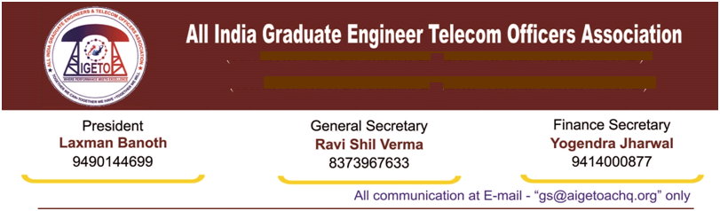
No. GS/AIGETOA/2017/20 Dated: 08-06-2017

To
The Director (HR),
BSNL Board,
Bharat Sanchar Bhawan,
Janpath, New Delhi-110001

Respected Madam,

Sub: - Request to issue Pre Basic training orders to LICE JE to JTO batch for the
vacancy year 2015-16 - Regd.

With reference to the above cited subject, it is to bring to your kind notice that around 2000 JEs were qualified in recent JTO LICE for the Vacancy Year 2015-16 which was conducted on 11-12-2016. Results were also declared on 03-04-2017. These JEs are waiting for their training orders since then. The delay in sending them to training may leads to demotivation in qualified JEs and also it may leads to possibility of discrepancies in their career up gradation in executive cadre. To avoid further discrepancies in their career progression, it would be better to start the Training as early as possible. Also it is worth mention that, these JEs are well qualified, and would be an asset for the department if they are trained early and induced into the field.

Hence in this connection we request you to instruct the concern to spare various RTTCs at the earliest and to issue the training orders at the earliest possible date.

In anticipation of kind and favorable orders
Thanking you madam

With Warm Regards

(Ravi Shil Verma)
GS-AIGETOA
Copy to:-
The PGM (Pers.), BSNL CO – For kind information and necessary action pls.

