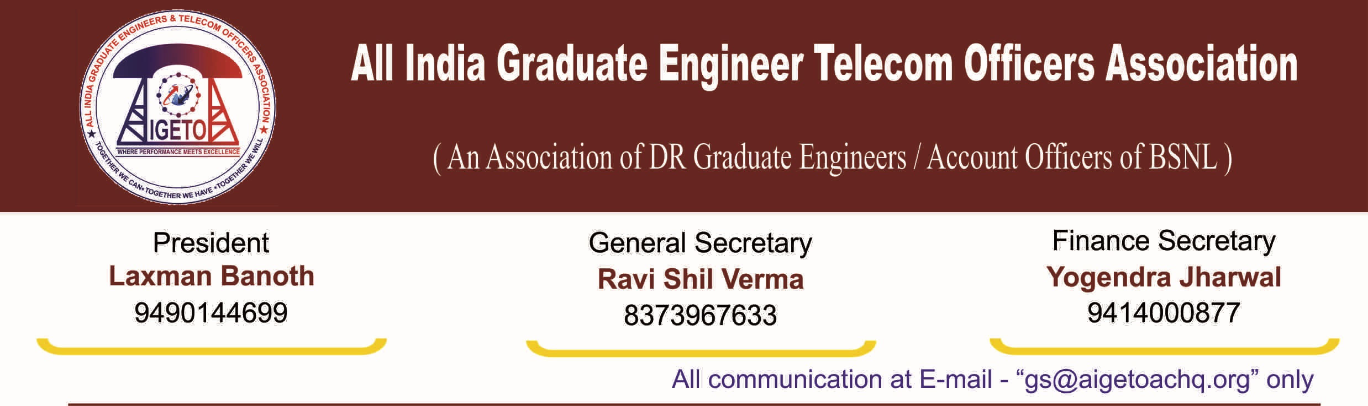
No. GS/AIGETOA/2017 Dated 25.05.2017

NOTICE FOR CENTRAL HEADQUARTER EXECUTIVE COMMITTEE MEET OF AIGETOA

As per provisions of the constitution of AIGETOA and subsequent discussion/decisions among CHQ, Emergency Central Headquarter Executive Committee Meet of AIGETOA CHQ is hereby notified to be held on 31st May’2017 at New Delhi. The meeting will be held as per the following schedule:
- AIGETOA Central HQ Executive Committee Meet:

Date & Time : 31st May’2017 (Wednesday) from 10:00 to 19:00 Hrs
Venue : New Delhi [Details will be informed through Group Mail/Website]

Agenda of the Meeting:
- Issue of vindictive action against Sri Ravi Shil Verma, GS-AIGETOA, Resolution/Action Plan.
- Review the progress of ongoing agitation program under Joint Forum for HR issues.
- Extension of Standard Pay Scale of E2-E3 for JTO-SDE equivalent, Promotion from JTO to SDE under DPC & LDCE Quota, Pay loss issue of post 2K7 batches, 30% Superannuation Benefits to BSNL Recruits wef 01-01-2007, Scrapping of MT/DR-DGM RR and other HR issues – Status, Discussion & Resolution.
- Deliberation on CPSU Proposal of BSNL in lieu of Khan Committee Recommendation – Discussion, Resolution & Action Plan.
- Organizational matters of the Association - Discussion, Resolution & Action Plan on;
- Compliance of mandatory provision of Audit from each Circle to the CHQ.
- Compliance of the supply of mandatory details of members to the Society Registrar.
- Organization strengthening and review of the progress of Circles.
- Reimbursement of circle quota fund and other organizational matters.
- Review of future partnership & strategic alliance for growth & resolution of issues.
- Status & discussion on the ongoing legal recourse on various issues by AIGETOA.
- Any other agenda item as opinioned by the house under permission of the chair.

[Ravi Shil Verma]
General Secretary
Copy to:
- The District Registrar Firms and Society, Faridabad, Haryana for kind information.
- The Sr GM(SR), BSNL HQ, New Delhi for kind information please.
- Sri Laxman Banoth, AIP/AIGETOA with a request to preside over the meeting.
- All CHQ Members to make it convenient to attend the meeting as per schedule.

