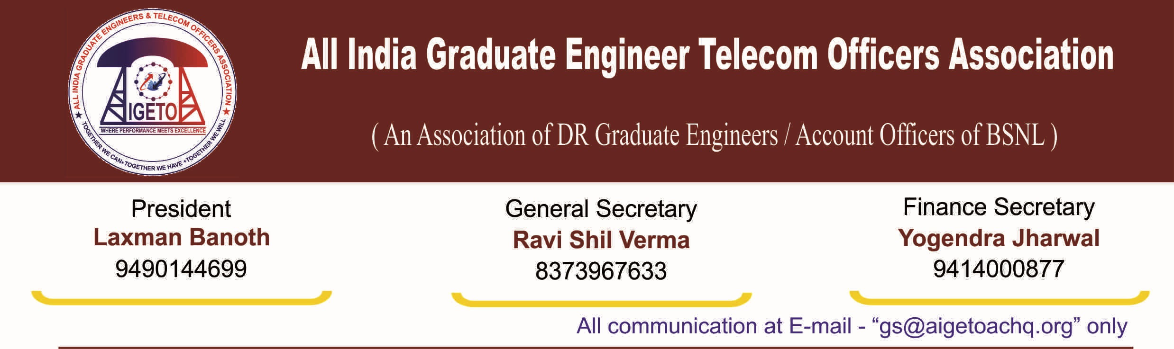
No. GS/AIGETOA/2016/9 Dated 22.07.2016

To,
The GM (SR)
BSNL Corporate Office,
New Delhi-110001

Subject: Recognition of majority representative Association of serving Executive employees in BSNL – Holding of 1st membership verification – Submission of application-Regarding.

Reference: Your office Letter No. BSNL/5-1/SR/2016 dated 25/5/2016 and 23/6/2016

Dear Sir,

In reference with the above subject/reference, it is submitted that we are intended to participate in the aforesaid membership verification process without prejudice to the rights of the association wherein it has represented for a separate recognition and formal representation for the association representing exclusively the third category of executives’ i.e. direct recruits executives recruited after inception of BSNL. We once again emphasize that proceeding ahead with the referendum process without considering the request of this association for a separate recognition and formal representation to the third category of Executives i.e. Direct Recruits is violation of the Government of India guidelines on the extant issue for which this association has been representing from time to time. AIGETOA is representing DR executives of BSNL since last 11 years along with other executive associations. Knowing very well about this association and its basic membership, introduction of clause no. 5(2) in Recognition of Executives’ Association) Rules, 2014 is unilateral and biased attitude of BSNL management without proper categorization of employees. This arbitrary clause is intended to dilute the participation of this association, which is representing the executives Directly Recruited by BSNL who form a separate group of executives having different service conditions in BSNL. We are yet to hear anything from SR cell on our representation in this regard.
However, as required, we are submitting following documents/ undertaking in respect of AIGETOA for kind consideration on the matter please:

S. No. | Name of the Document | Annexure No
1. | Certified copy of the Memorandum of Association | Annexure - A
2. | Certified copy of constitution/by-laws of the Association | Annexure - B
3. | Copy of Registration Certificate | Annexure - C
4. | Names/contact details of the Office Bearers of the Association | Annexure - D
5. | Estimated membership of the Association | Annexure - E
6. | Undertaking from the General Secretary regarding acceptance of the provisions of BSNL (Recognition of Executives’ Association) Rules, 2014 | Annexure - F
7. | Undertaking regarding amendment/modification in the constitution of the Association in case of variance with the Recognition Rules, 2014. | Annexure - G

With Regards
Encl. As above
Yours Sincerely

[RAVI SHIL VERMA]
General Secretary

