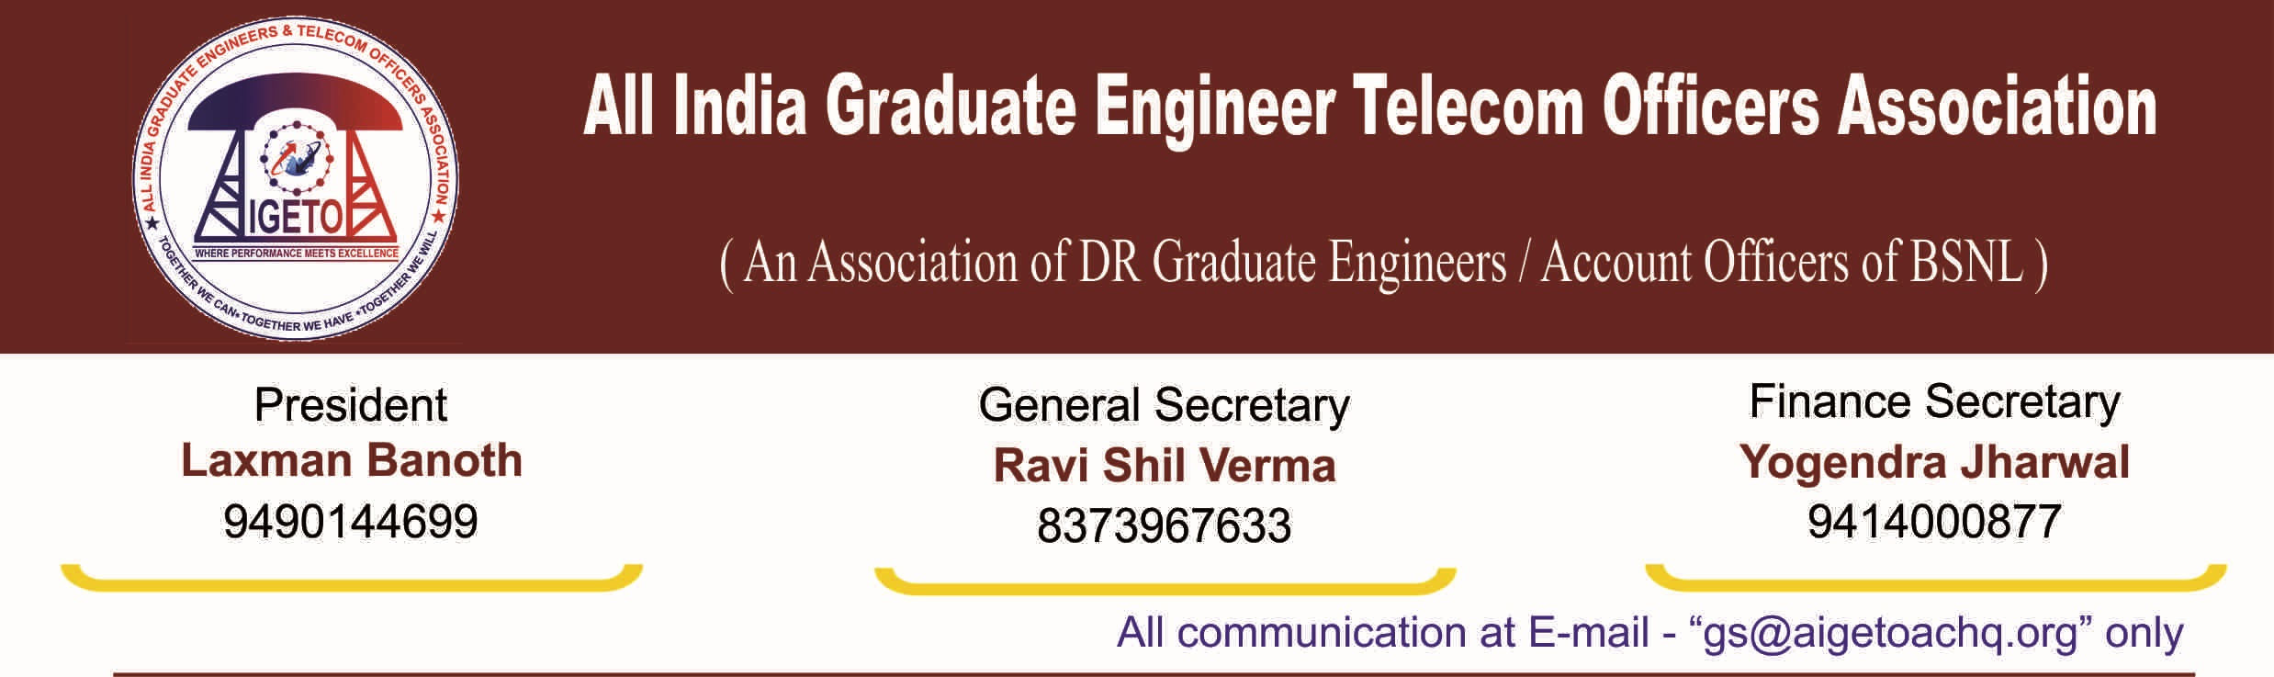
No. GS/AIGETOA/2016/8 Dated 21.07.2016
To,
Sr. GM (Pers)
Bharat Sanchar Bhawan,
B.S.N.L, New Delhi.
Subject: Regarding non submission of reply by BSNL in LDCE court case at CAT, Chandigarh.
Respected Sir,
This is in reference to the notification of the LDCE for promotion from JTO (T) to SDE (T) vide notification number 24-1/2014-Rectt. dated 13th November 2014. The examination was scheduled to be conducted on 15th February 2015. However BSNL HQ vide their letter number 24-1/2014-Rectt. dated 13/02/2015 informed that the said examination has been deferred till further orders due to multiple Court verdicts resulting into contradictions and administrative constraints there to. The said exam was re-notified for vacancy year 2010-11 vide letter no:-24-1/2014-Rectt Dated 20/04/2015 and exam was conducted on 21st June 2015. After conduction of exam result declaration was stayed by various court cases.
These court cases were filed in various Central Administrative Tribunals. BSNL filed transfer petitions to all cases in PCAT Delhi. PCAT Delhi vide interim order no:-P.T/185/2015 Dated:-22/4/2016 made CAT Chandigarh case, the lead case and directed for the matter to be disposed off expeditiously, preferably within three months. Thereafter CAT, Chandigarh delivered interim order to declare result of this aforesaid LDCE exam and to complete further formalities without actually issuing promotion order. Subsequently result was declared on date 21/5/16.
Sir, in this context, it has come to our notice that that Lawyer from BSNL side was not present in last hearing held on 08-07-2016. It appears that the due importance is not being given to such an important matter by Legal cell of BSNL Punjab Circle. The applicants have filed the amendment in final stage of hearing and Hon’ble Judge has allowed to include the amendment. It has also come to our notice that BSNL is yet to file the reply on the Amendment. For favorable outcome from CAT Chandigarh on next hearing dated 28-07-2016, it will be very urgent to file the reply on the amendment by BSNL. Punjab Legal cell has also not filed proper reply to Hon’ble court despite instructions by corporate office which will result in to further delay. This unnecessary delay is causing severe injustice to LDCE passed candidates who are waiting for their first promotion orders.
Therefore, your good self is requested to direct BSNL Punjab legal cell to file timely and proper reply in court and ensure that the BSNL Lawyer appears in time and regularly at the court hearings for early decision on the case. The next hearing is scheduled on 28th July 2016.
As intimated above, CAT, Chandigarh case is lead case and judgment of Chandigarh CAT may suffice for issuance of the promotion orders. However, still, if BSNL feels that any clarity is required on the matter, the clarification may be sought well in time to avoid any delay on that account. With Regards

[RAVI SHIL VERMA]
General Secretary
Copy To:- Dir (HR) ,Bharat Sanchar Nigam Limited, New Delhi.

