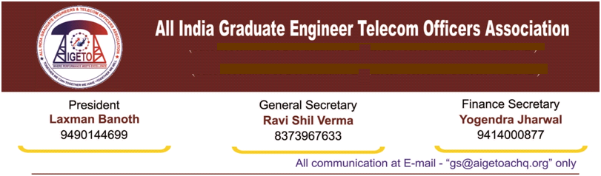

**No. GS/AIGETOA/2017/8 Dated 07.03.2017**

To

Smt. Sujata T Ray

Director (HR)

Bharat Sanchar Nigam Limited

New Delhi – 110001

**Sub: - Amendment to BSNL “TA/DA rule 2002” and letter No. 7-6/2006-EF/Vol.II(pt.) dated 08.09.2010 – Reg.**

Ref:- EF Section File NO. 1-15/2016 PAT (BSNL) Dated 15.02.2017

Respected Madam,

I would like to draw your kind attention on the revision in the Hotel entitlement and DA rates for the executives on tour wherein the rates have been enhanced by BSNL vide letter cited under reference. However, on going through the enclosure to the letter cited under reference, it is seen that enhancement of Hotel entitlement and DA was made for the executives under the pay range of JAG and above scale officers. It is understood that it is applicable for the executives drawing pay scale of E5 and above.

In this regard, following is submitted:

1. There are other set of executives in BSNL who are placed below the scale of JAG. These executives are visiting frequently from one place to another on official duties and maintaining the whole network. In other words, these executives are carrying forward the actual maintenance work in the field units and are moving outside the places of their postings.
2. These Executives are getting a very meager amount for Hotel & DA during official visit. The amount is so less that it is very difficult to search hotels by the executives visiting to various towns/cities in India on BSNL prescribed rates. Similarly the DA rates are also very less and the same is not suffice to the daily needs of the executives on tour.

Contd on Page 2

In view of the above, it is requested to make amendments in the **“TA/DA rules 2002” for enhancing the Hotel entitlement as well as Daily Allowance to the executives placed below JAG level in proportion to the enhancement done in case of JAG level vide letter under reference.**

With Regards

Ravi Shil Verma

GS, AIGETOA

Copy to:

1. PGM (Establishment), BSNL CO.
2. GM (EF), BSNL CO.