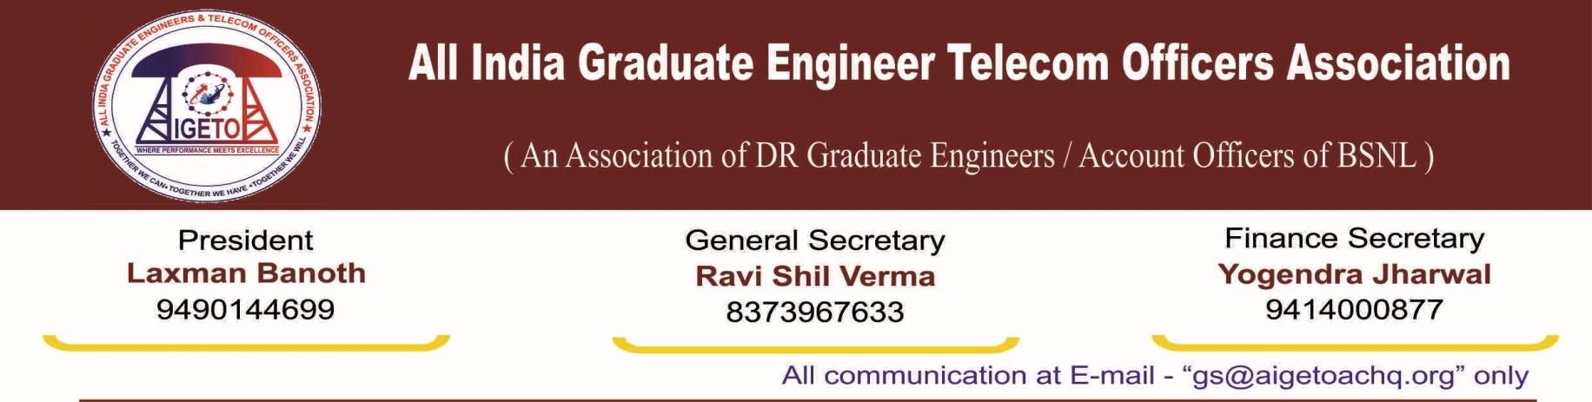

**No. GS/AIGETOA/2018/7 Dated 03.05.2018**

To,

**Smt. Sujata Ray,**

**Director (HR),**

**Bharat Sanchar Nigam Limited**

**Janpath, New Delhi**

**Sub: Loss of seniority to executives who have successfully passed the JTO to SDE LDCE exams conducted by the department from time to time due to delay in conducting of examination, Reg.**

**Respected Madam,**

We want to draw your kind attention towards the loss of seniority to executives who have successfully passed the JTO to SDE LDCE exams conducted by the department from time to time. The examinations were conducted in accordance with the then prevailing RRs and the LDCE passed executives were to be accommodated in a certain vacancy year in the prescribed quota for such officers. They appeared in the competitive exam in order to ensure that they have better promotional prospects and thus can reach to the higher strata considering the LDCE mode as a fast track mechanism for promotions. However, in past, these examinations were not conducted timely and fighting of seniority among two groups of Executives started as a result. At several occasions, it has been observed that BSNL has not fought the court cases proactively which resulted in BSNL being not able to defend its own RRs. It is highly unfortunate that Executives selected for specific vacancies year are not getting the seniority in corresponding vacancy year due to non-proactive handling of court cases. BSNL has not been able to protect the seniority of the LDCE passed officers which has been assigned by the department only. If you critically examine all such cases, the LDCEans have suffered tremendously on account of time and money, leading to sagging morale and ultimately losing out on various promotional aspects and losing out on various promotional aspects.

**The JTOs who have passed the LDCE conducted in the year 2015 are yet to get their first promotion even after a lapse of about three year.** Their frustration has reached to its height and they are still looking towards the management for an early solution. **LDCE for SDE (T) against 33% quota for the vacancy year 2006-07 was due in year 2007-08. The examination was finally held on 04/03/2012. The final result promotion orders were issued subsequently on 04/07/2013 onwards.** Despite the fact that this delay was purely on either administrative or legal grounds, the candidates suffered for no fault of theirs. **Due to this delay in conducting of examination, declaration of result and issuance of promotion order, the benefits of one increment on functional promotion to SDE (T) through LDCE was denied to many executives.** ***The LDCE passed executives as per 1996 RRs are also into courts. It is utterly surprising that these RRs have not been adequately protected by the management in the court of law. In spite of these officers getting an interim order in their favour, department has not acted positively in the direction and are finding one alibi or other by denying them their due seniority.*** Herein again, it will be worthwhile to mention that instead of holding the promotions, BSNL should issue the orders and seniority of the candidates can be fixed after clarity on the matter is achieved through court.

**Recently, On 12th December 2017, Hon’ble Supreme Court Passed an order related to 147 group of officers by upholding Hon’ble Ernakulam High court Judgment.** Though, in the judgment, at several places including the opening para, Hon’ble HC has referred the RR-1981 as amended in 1986 as the Rule under which combined qualifying- cum- competitive exams were conducted in the year 2000 and 2003, yet in para 47, the Hon’ble HC referred *5 years regular service* eligibility condition while explaining Rota provisions in cases when a single exam is conducted for several vacancy years as “*Junior Engineers who have completed 5 years of regular service in the grade on the 1st January of the year in which the examination is held”*.

It is understood that BSNL as an employer is contemplating to implement the judgment word by word without getting into the spirit of judgment by bringing down their seniority and demoting these officers. The whole judgment should have been invariably read with the 1981 RRs and the subsequent amendments. This is another example where BSNL has not been able to protect their seniority allotted by DOT/BSNL at one point of time.

The decision on reverting the 147 executives should be taken by going in accordance with the amended recruitment rules. As stated earlier the 5 years regular service stated in the judgment is a term used by the Hon’ble Court as an example to explain the Rota provision of the Rectt rule and not the eligibility condition for appearing in the examination. **The judgment needs to be implemented as per the requisite RR as any hurried implementation may invite reviewing of all promotions carried out after the year 1986 (year when 1981 RRs were amended) upto the promoted officers as per qualifying/competitive examination held in year 2000/2003. This may result into filing of Hundreds of court cases which may result into halting the whole process of promotion affecting the others who are even not related to this judgment. It is wrongly presumed that implementation of Hon’ble High Court’s order will settle this issue once for all instead it may result into further implications. This facts necessitates a thorough study of the Judgement before implementing it and if needed clarity on the above should be obtained from the Hon’ble Court.**

These 147 group of officers were assigned seniority by DOT 10-12 years back and were subsequently promoted by BSNL and have also reached upto the rank of DGMs. There is an inherent feeling in these officers that they are orphans as neither BSNL nor DOT management is ready to own them and are turning a blind eye to their problems. BSNL should not remain insensitive to their pain, disgrace and suffering.

At a point when promotions in BSNL have become a rare commodity, reverting these officers in hurried manner will give an impression that BSNL is not willing to protect its own RR. The onus of BSNL’s inability to promote and demote people cannot be put on to the employees as it is obviously the responsibility of BSNL and its management to look out for the paths of promotion. The focus of management should be on promoting more and more people and not on demoting the already promoted people.

In view of the above, we most humbly request your good self to protect the seniority and promotion given to these “147” group of officers as per requisite Recruitment Rules as it is the sacrosanct rule and have priority above all orders, directions etc. Implementing the judgment as per RR will give a direct message that management protects its employees up to the last extent. If the Judgment is not clear with respect to RR, then BSNL have all resources to seek clarity from the hon’ble court itself. We have full confidence in the ability of management and are hopeful that the due justice will be meted out to these officers.

AIGETOA as an association does not want a situation where all the promotions are marred into litigations. **In the last few days, we have seen a ray of hope in BSNL’s recent actions with regard to ensuring the pending promotions and we don’t want a situation where a new dimension is added to the already marred promotions scenario of BSNL.** This is the reason, we are requesting for an extensive and comprehensive study of the Judgment before implementing it and if any iota of doubt is there with regard to protecting the sanctity of the RRs, BSNL must go for a review, seeking clarifications from the hon’ble court itself instead of complicating the matter further.

With Regards

Yours sincerely,

(Ravi Shil Verma)

General Secretary

Copy to:

1. Shri Anupam Shrivastava Ji for kind information please.
2. GM (Pers), BSNL CO