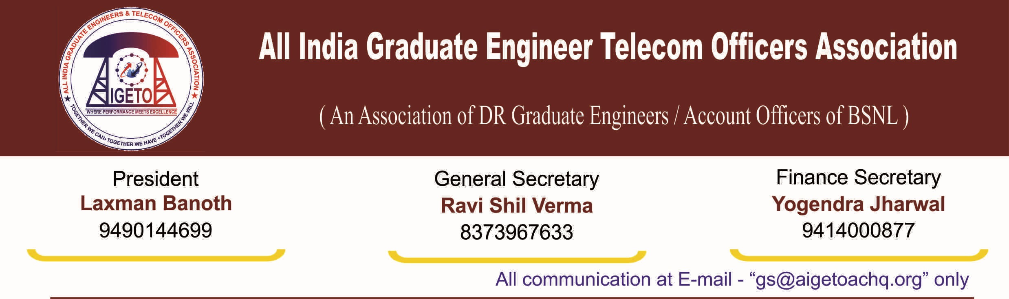
No. GS/AIGETOA/2016/7 Dated 12.07.2016
To,

The Director (HR)
BSNL CO, New Delhi

Subject: Regarding Recognition of majority representatives Association of serving Executive employees in BSNL- Holding 1st membership verification-calling up of applications regarding.

Reference:
- Notification of “Recognition of executives’ association Rule-2014” vide SR Cell Letter No. BSNL/31-2/SR/2009 dated 6th Jan-14
- Notice issued by SR Cell vide letter No. BSNL/5-1/SR/2014 (1) dated 16th june-2014
- Amendment published vide letter no. BSNL/9-1/SR/2014 dated 25 May 2016.
- Notice of calling for application vide letter no. BSNL/5-1/SR/2016 dated 25th May 2016.
- SR Cell letter number no. BSNL/5-/SR/2016 dated 23.06.2016
- AIGETOA Letter no. CHQ/AIGETOA/448 dated 29th August 2013 (Copy attached)
- AIGETOA letter no. GS/AIGETOA/60 dated 15.07.2014 (Copy Attached)

Respected Sir,

SR Cell of BSNL CO has finalized the “Recognition of executives’ association Rule-2014” vide letter mentioned under reference-1 by completely ignoring the feedback/comment of this association on the issue submitted vide it’s letter No. CHQ/AIGETOA/448 dated 29th Aug-2013 and finally issued notice for membership verification vide letter mentioned under reference-2.
Sir, your goodself is well aware of the fact that DPE has not prescribed any rules and guidelines in respect of Recognition of Executives Association in CPSEs. CENTRAL CIVIL SERVICES (RECOGNITION OF SERVICE ASSOCIATIONS) RULES, 1993 issued by MINISTRY OF PERSONNEL, PUBLIC GRIEVANCES & PENSIONS (Department of Personnel & Training) (Copy attached herewith) is the only guiding rules in this Regard. Para-5 (c) of which clearly states that Membership of the Service Association has been restricted to a distinct category of Government servants having common interest, all such Government servants’ being eligible for member-ship of the Service Association.

Unlike other CPSE, BSNL is having three distinct categories of employees in executive’s category i.e.
1)-ITS Group-A officers absorbed in BSNL,
2)-Group-B officers absorbed in BSNL and
3)- Executives who have been directly recruited by BSNL.

First two categories of executives were recruited in government setup before formation of BSNL hence absorbed with certain terms and conditions maintaining their initial service condition but third category of executives are directly recruited after formation of BSNL hence their service conditions are different then first two categories of executives e.g. retiral benefits, EPF.

Apart from retiral benefits, mode of recruitment and qualification are also different then similarly placed absorbed executives hence their career aspirations and avenues are also not only different but contradictory too. Moreover, directly recruited executives are also in minority at present. BSNL management has already extended separate and formal representation to the association of first category of executives and being in majority, Association of second category of executives will get their formal representation through this membership verification process but third category of executives will be left without any formal representation of their genuine grievances.
The grievances and issues pertaining to the direct recruit executives to whom this association represents differ in many ways including recruitment method, qualifications, job security, future security and retirement benefits, etc. with respect to absorbed executives. For example, the absorbed officers have different terms and conditions as compared to the BSNL recruited executives with regard to superannuation benefits like Pension, EPF/GPF, Gratuity Funds, etc.
The veracity of the above can also be verified by the fact that certain issues which pertained to only BSNL recruited Executives like issues related to EPF, Superannuation Benefits, Performance Oriented Promotion Policy have been raised, precipitated and highlighted by this association only which was formed to protect the interests and rights of the executives recruited by BSNL. Failure to represent the issues in a proper way results into loss not only for the executives but also the department. The classic example of the above problem is EPF, which still exists for BSNL recruited executives. BSNL has to pay big amount as penalty for the EPF anomalies. This is the result of failure of existing BSNL absorbed officers associations to represent the issues of BSNL recruited executives.
In view of the above circumstances, you are kindly requested to make provision to extend formal representation to the association of third category of executives also i.e. Executives who have been directly recruited by BSNL so that their genuine grievances shall not remain unheard.

AIGETOA is the only association having the provision of membership for exclusively direct recruited executives recruited after formation of BSNL hence Para 5(2) of the notification mentioned under referece-1 is not agreeable to this association. This association has decided to not to alter its constitution and not to give any undertaking in this regard. We demand separate recognition and formal representation for the association representing exclusively the third category of executives i.e. direct recruits executives recruited after inception of BSNL. This will enable all the three categories of executives to voice their opinions and grievances without any constraints and without any scope for unfairness or bias. As per current rules, BSNL has enabled it for only the first two categories of the executive mixing the third with the second which will suppress the interests and welfare of the executives who have been recruited by BSNL.
The above issues has already been raised vide AIGETOA letters under reference, but till date this genuine and valid demand has not been considered despite modifications and amendments of the referendum rules ( Letters under Reference) have been issued by BSNL to consider the demand raised by other associations.
We once again submit that Bharat Sanchar Nigam Limited (Recognition of Executives’ Association) Rules, 2014 are in absolute confrontation to CCS (RSA) rules 1993 which entails separate recognition to association representing different set of executives.
We once again request you to kindly do the needful for recognition and formal representation of an association representing exclusively the third category of executives i.e. direct recruits executives recruited after inception of BSNL. We once again emphasize that the issues regarding different category of executives may only be efficiently resolved by participative approach of associations exclusively representing that category with management.
This association is having high hope that this genuine demand will be considered.

Faithfully your’s

[Ravi Shil Verma]
General Secretary
Copy to:
- CMD BSNL for kind information with a request to intervene in the matter.
- GM (SR) for kind information and necessary action.
- GS, AIBSNLEA and GS, SNEA seeking support on the above.

