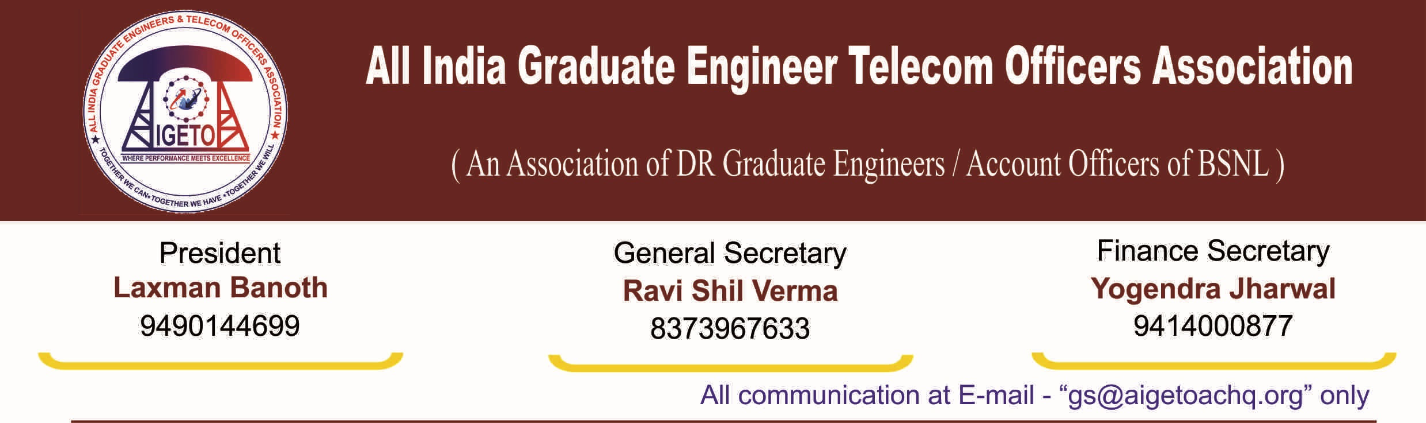

No. GS/AIGETOA/2016/5 Dated 27.06.2016

To
The Director (HR)
Bharat Sanchar Nigam Limited
1, H.C Mathur Lane, Janpath
New Delhi 110001

Subject: Direct recruitment of JTO (Telecom) for the year 2015-2016 from open market considering all the pending Rule-8 cases

Respected Madam,

With reference to the subject cited above and, this association’s request, vide letter no. AIGETOA letter No. GS/AIGETOA/149 Dated 09.05.2016 for the consideration of pending JTO (T) Rule-8 cases by direct JTO (Telecom) recruitment, the following is submitted once again:

1. Despite this critical issue being taken up continuously by our association and regular request and directives from corporate office for release of these officers, field units have shown their inability to release these JTO praying for transfer under R-8 sighting acute shortage of officers in this cadre.

2. This is to inform you that, many DR JTOs particularly in tenure circles are waiting since long for their transfer to their home circle after completion of five years of service, and due to huge delay in consideration of their cases, it has already created frustration among this young work force of the company. In many cases even after completion of ten years, the Rule-8 transfer is not being considered and this has created huge unrest amongst the executives.

3. It is also to inform you that, recently BSNL management conducted LICE for the promotion of TTA to JTO (T) in all most all the circles, and result of which is expected very soon.

4. Further, in the joint meeting held with AIGETOA and AIBSNLEA, it was agreed that instructions shall be conveyed to all the circles to clear the long pending cases through local arrangements also.

5. As DR JTO (T) recruitment and joining will take approximately one year time, and many DR JTOs especially of tenure circles are waiting for their transfer to their home circle after since very long, it is requested to instruct all the Circle heads to consider all these pending Rule -8 cases just after declaration of TTA to JTO (LICE) result in true spirit to motivate these young HR work force of BSNL.

6. Additionally, we request your kind self to increase the vacancies in Hard Tenure/Shortfall Circles further by exact number of Rule 8 cases pending so that shortfall does not occur even after recruitment. Since recruitment is long drawn process, Direct JTO (T) recruitment may be immediately notified so that affected executives may get relief sooner.

Sincerely yours

Sd/-

(Ravi Shil Verma)
General Secretary
Copy to:
- CMD, BSNL for kind information please.
- GM (Estt.), BSNL for kind information and necessary action please

