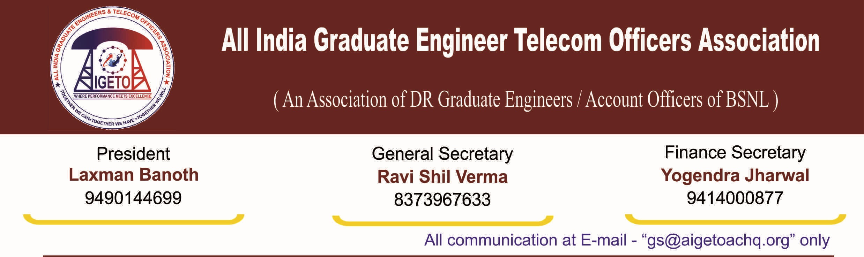
No. GS/AIGETOA/2016/4 Dated 27.06.2016
To,
The GM(Pers) ,
BSNL Corporate Office ,
Bharat Sanchar Bhavan, Harish Chandra Mathur Lane,
Janpath New Delhi - 110001

Subject:- Request to initiate collection of VC ( Vigilance Clearance through ERP ) and Circle Options for promotion & posting as SDE(T) under JTO(T) to SDE(T) LDCE of Vacancy Year 2010-11.

Respected Sir,
As you are already aware that LDCE for promotion from JTO (T) to SDE (T) for Vacancy year 2010-2011 was conducted on dated June 21, 2015 thereafter result of LDCE exam for vacancy year 2010-11 was declared on dated May 21,2016 , pursuant to vacation of stay on declaration of result by CAT –Chandigarh.
Further Hon’ble CAT Chandigarh in its interim direction dated 18.05.2016 has allowed BSNL to take further consequential steps which may necessary for issuing of promotion. Collection of Vigilance Clearance is time consuming activity. Therefore to avoid the procedural delay after the court proceedings are over, it is requested to initiate the process of collection of Vigilance Clearance for eligible LDCE candidates for SDE (T) promotion immediately.
It would also be pertinent to mention that, incidentally same process for collection of Vigilance Clearance for JTO(T) to SDE(T) promotion under seniority quota is being exercised presently , given the fact that seniority quota promotion from JTO(T) to SDE(T) is also stayed by The Court of Law ( Latest letter 2-15/2012 Pers-II-Pt.1 dated 21.06.216 was issued by AGM(Pers-II) BSNL Corporate Office , in this regard ) .It is therefore quite expected that such a process should also be initiated for LDCE Channel also , to keep all formalities for SDE (T) promotion.
Moreover I would also like to use this opportunity to bring your kind notice about another aspect that relevant to SDE (T) promotion through LDCE. Successful candidates will be allotted a Circle on promotion as SDE (T) and subsequently there might be requests from many successful candidates to change/retain their Circle of posting. LDCE Online Portal (http://www.ldceonline.bsnl.co.in/) may be utilized to collect three choices of Circle for posting as SDE (T) and accommodate those choices as far as feasible while allotting Circles. This will not only help reduce significantly such separate representation from candidates but also would be useful for considering the JTO (T)’s who have earlier registered for Rule-8 transfer to other Circles.

Eventually, I am highly optimistic that both processes (a) collection of Choices for Circle (b) Collection of Vigilance Clearance through ERP as per letter no:- 500-51/2016/ERP/Pers-I Dated:-1/6/16 would be initiated soon to possibly reduce the time to issue JTO (T) to SDE (T) promotion order for LDCE Channel.

With Best Regards

Sd/-
Ravi Shil Verma
GS, AIGETOA

Copy to:
Director (HR) BSNL CO, Delhi For kind information please.

