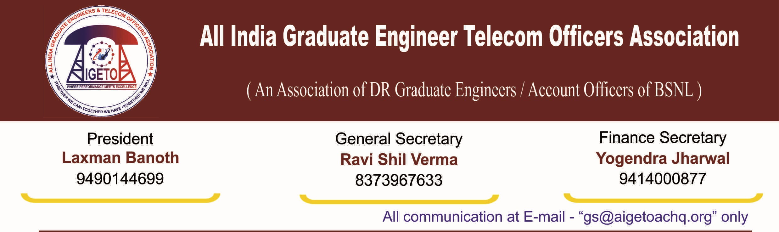
No. GS/AIGETOA/2016/3 Dated 27.06.2016
To
The Director (HR)
Bharat Sanchar Nigam Limited
1, H.C Mathur Lane, Janpath
New Delhi 110001

Subject: Proposal for the implementation of Group corporate term Insurance policy for Direct Recruit Employees of BSNL
Respected Madam,
We would like to draw your kind attention to the unfortunate fact that, the DR Executives those who have been recruited by BSNL after formation of BSNL on 1st October 2000, have long been deprived of their basic minimum pay, Promotion and Retirement benefit as per CPSU norms. There is no defined post-retirement benefit & family pension like that of existing departmental employees, moreover the alternative superannuation fund as proposed in the 2nd PRC for post-retirement benefit & family pension are not implemented. This association is trying its best for the implementation of Superannuation fund for these DR Executives as proposed in the 2nd PRC for post- retirement benefit.
In recent past many DR employees’ families have suffered the untimely demise of their breadwinner. This has put them under great financial stress not to mention the mental agony. Many have been very badly affected & unable to cope of with their family expenditure and children education just after their sudden demise. This situation is further aggravated due to non-availability of any post-retirement benefit & family pension for them unlike that of existing departmental employees.
A recent case in point is the demise of our DR AGM Sri B P Marndi of KGP. We are proud to say that more than 1500 AIGETOA members willfully contributed financially to help the bereaved family. Hon’ble CMD BSNL had himself handed over this amount to his family in one of our association programs at Kolkata on August 2015.
This heart wrenching episode was the force behind the thought of securing the families of such DR Employees. In this regard, recently this association met with different Corporate Banks & Life Insurance Corporations, searching for some solution which could provide meaningful relief to these bereaved families. After thorough discussions with them, it has been suggested there should be Group corporate Term Insurance family policy for DR executives, which we feel will definitely help the employee’s family in case of any unforeseen incident. The annual premium for a term insurance of 10 lacs is estimated to be around Rs. 1500/- per Annum. The Death Relief Scheme in line with other PSUs can also be implemented in BSNL.
Hence it is once again requested for immediate implementation of superannuation fund as proposed in the 2nd PRC for post-retirement benefit & family pension. The modalities of implementation of Death Relief Scheme in BSNL can also be thought about in addition as being done in other leading PSUs. Additionally, we request your kind self to implement the Group corporate Term Insurance family policy in consultation with corporate life Insurance company to extend some basic minimum support to the family of DR executives in case of any unforeseen incident.
Seeking your initiative in the necessary and noble cause.

Sincerely yours
Sd/-
(Ravi Shil Verma)
General Secretary
Copy to:
- CMD, BSNL for kind information please.
- GM(Estt.), BSNL for kind information and necessary action please.

