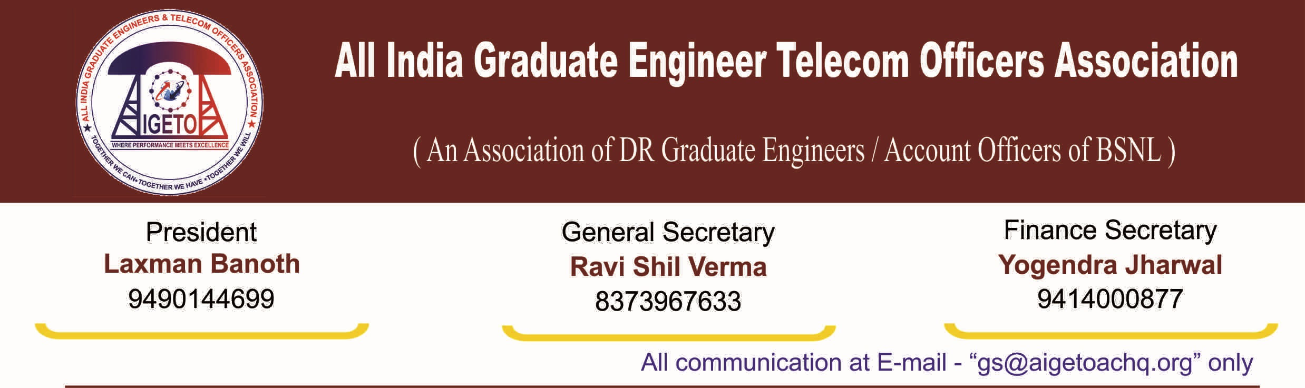
No. GS/AIGETOA/2016/2 Dated 27.06.2016
To

GM (SR)
BSNL CO, New Delhi

Sub:- New Governing body of AIGETOA elected in MYSORE AIC – 17th to 19th June, 2016-Reg.

Respected Sir,

It is to inform that with reference to notification dated 29th April 2016 cited under reference, 4th AIC was held at MYSORE from 17th to 19th June, 2016 in RTTC Mysore BSNL. Election of new CHQ office bearers of AIGETOA has been done as per the constitution of AIGETOA and the details of the Newly Elected GOVERNING BODY i.e. Central Head quarter office bearers (CHQ) of AIGETOA are as given below:

Sl. No. | Post in AIGETOA | Name | Circle of Posting in BSNL
1 | President | Sh. Laxman Banoth | AP Telecom Circle
2 | Vice President | Vacant
3 | Vice President | Sh. Hari Shankar Tiwari | Himachal Pradesh Telecom Circle
4 | Vice President | Sh. Badri Kumar Mehta | BSNL Corp. office, New Delhi
5 | Vice President | Sh. G. Veerabhadra Rao | ITPC-Dev, Hyderabad
6 | General Secretary | Sh. Ravi Shil Verma | BBNL, New Delhi
7 | Asst. General secretary | Md. Wasi Ahmed | Bihar Telecom Circle
8 | Asst. General secretary | Sh. D. K. Sahoo | Kolkata Telecom Circle
9 | Asst. General secretary | Sh. Pawan Akhand | Madhya Pradesh Telecom Circle
10 | Asst. General secretary | Sh. Abhishek Jain | Rajasthan Telecom Circle
11 | Finance Secretary | Sh. Yogendra Jharwal | Rajasthan Telecom Circle
12 | Joint Secretary (North) | Sh. Amit Roy | BBNL, New Delhi
13 | Joint Secretary (East) | Sh. Ashok Acharya | Orissa Telecom circle
14 | Joint Secretary (west) | Sh. Praveen Kureel | Madhya Pradesh Telecom Circle
15 | Joint Secretary (South) | Sh. Shridhar Babu | AP Telecom Circle

It is requested to kindly circulate the list of newly elected CHQ office bearers of AIGETOA by the SR Cell of BSNL Corporate office to the field formation of BSNL and also requested to extend the trade union facilities to them. The Post of Vice President-I has become vacant due to resignation of the elected representative which has been accepted by the governing body of AIGETOA. The same shall be intimated in due course of time.

Thanking you.
Your’s Sincerely

Sd/-

(Ravi Shil Verma)
General Secretary
Copy to:-
- CMD BSNL for kind information please.
- Director (CFA)/Director(HR)/Director(CM)/ Director(EB)/ Director (Fin) BSNL for kind information please.
- The Executive Director (CA)/ Executive Director (NB), BSNL CO, New Delhi.
- The Sr. GM (Pers)/GM(Estt)/GM(Restg)/ GM(Rect & Trg)/GM(Admin)/ GM(FP) BSNL CO, New Delhi.
- All members of AIGETOA through website

Sd/-
(Ravi Shil Verma)
General Secretary

