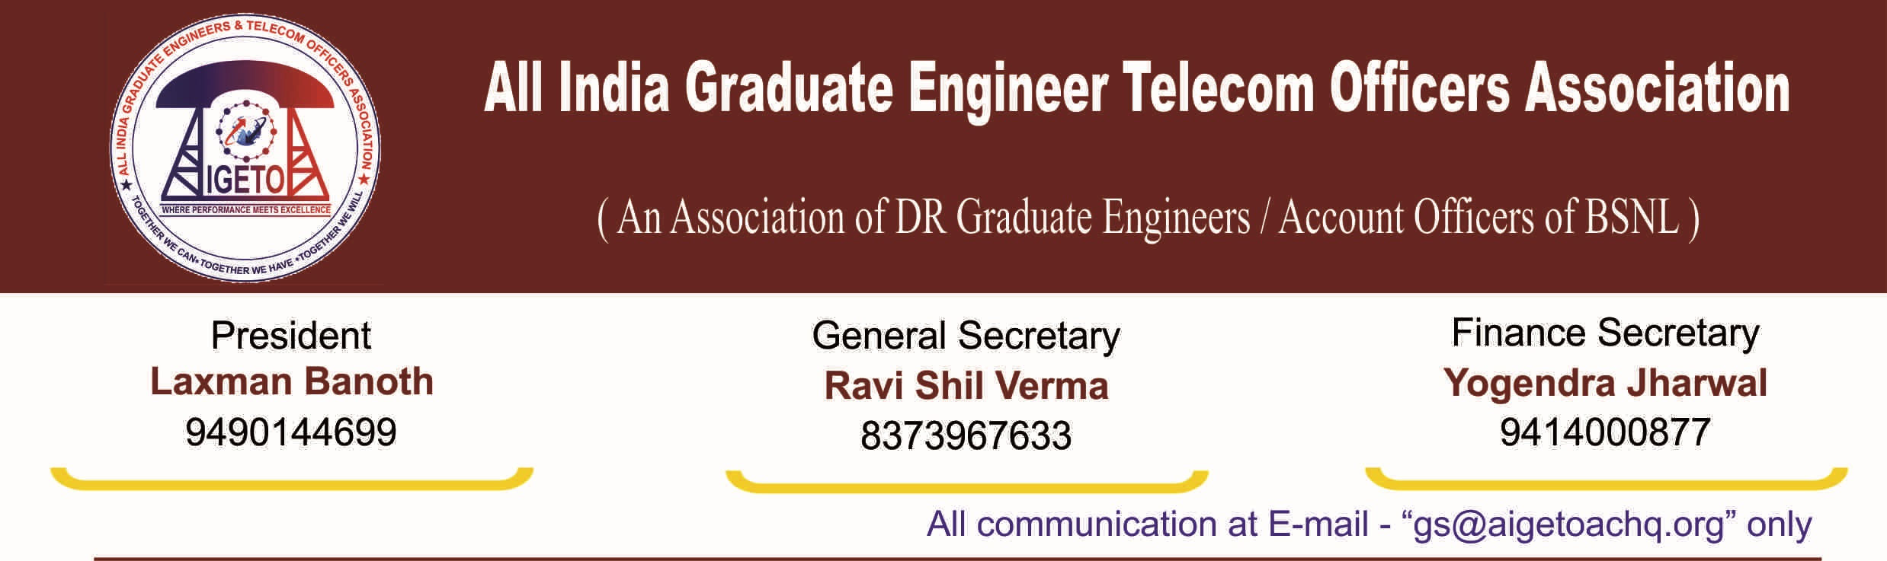
No. GS/AIGETOA/2016/26 Dated 15.11.2016

To,
Shri M. N. Punde
Sr. GM (CA)
BSNL CO
Janpath, New Delhi.
Subject: Creation of Superannuation Fund Rules/Trust Deeds, Regarding.
Dear Sir,
Kindly refer to the discussions held in the office of Director (HR) on dated 02.11.2016. It was decided that the superannuation fund will be in place by the end of November 2016 so that discussion on the enhancement of the quantum and date of effect can take place in first week of December 2016. We sincerely hope that the creation of trust for the purpose of administration of Superannuation benefits of BSNL recruited employees must be in advance stage of implementation.

In this connection, we would like to submit that the since the fund is of utmost importance for the much deprived BSNL recruited employees, the management of fund by a tried and tested agency should be ensured. For this purpose, a government owned/controlled fund manager which gives sovereign guarantee may be appointed as being done by LIC in the case of Gratuity Trust, Leave Encashment Trust etc.

With regards

[RAVI SHIL VERMA]
General Secretary
Copy to:
- Director (HR) for kind information please.
- GM (SR), BSNL CO.

