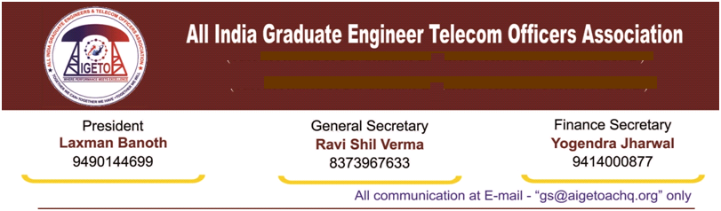

**No. GS/AIGETOA/2017/ 25 Dated 30.10.2017**

To,

**Director (HR)**

**BSNL Board,**

**Bharat Sanchar Nigam Limited**

**Janpath, New Delhi**

**Subject: - Request for immediate issuance of Promotion orders for JTO to SDE (T) under LDCE quota (Vacancy Year 2010-11) before implementation of CPSU Hierarchy.**

Respected Madam,

Kindly refer to our earlier letters on the long pending issue of promotion / posting of LDCE 2015 qualified candidates for the post of SDE (T) against vacancy year 2010-11. It is learnt that the amendment in SDE RR has been cleared in the last BSNL Board meeting held on 24.10.2017. We take this opportunity to express our heartfelt gratitude for your kind initiative for the same.

2. With the proposed approval of amendment in SDE RR, the restriction laid down by the Hon’ble CAT Chandigarh in the judgment dated 18.10.2016 with reference to the Inter-Se-seniority between Seniority cum Fitness quota and the LDCE quota candidates is settled.

3. It is also known that management is actively considering the promotions based on CPSU hierarchy. It is pertinent to mention that any move to implement CPSU hierarchy before posting of the LDCE qualified candidates will create legal hurdle as after qualifying the LDCE, the passed candidates are waiting for their promotion order as SDE since last one & half years. Non-issuance of their promotion order as SDE may create legal hurdles for smooth and hassle free implementation of CPSU Hierarchy Promotion Policy.

4. At present all the formalities have been completed and also there is no restriction or stay, legal or Administrative, to issue order for promotion of LDCE qualified candidates. In view of this, I humbly request your goodself to direct the concerned HR team to issue the promotion and posting orders. As stated above, this will avoid the legal complication in implementation of CPSU Hierarchy expected in the matter. It will also be pertinent to mention that any new policy should be intended to bring more durability, more ruggedness in the HR system.

***Contd…2***

5. In view of the above, it is once again requested that the pending LDCE promotion order should be issued before implementation of CPSU Hierarchy promotion policy and it should also be ensured that no executive irrespective of any stream is at disadvantageous position vis-a-vis the current BSNL MSRR, 2009 to avoid legal complexities.

With Warm Regards.

(**Ravi Shil Verma**)

**GS-AIGETOA**

Copy to:-

1. CMD, BSNL for kind information please.
2. CGM (Legal), BSNL CO for kind information please.
3. PGM (Pers.), BSNL Corporate Office – For kind information and necessary action.