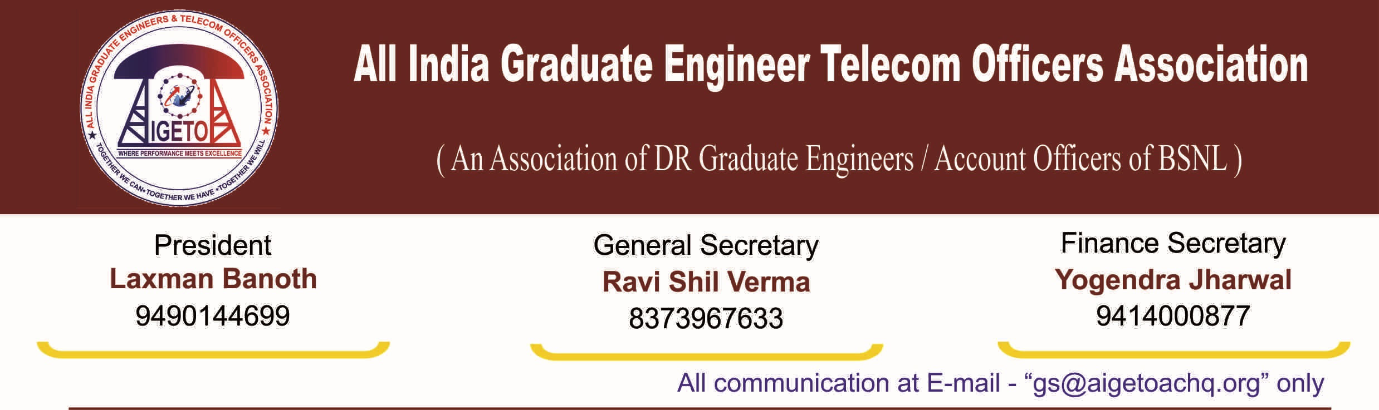
No. GS/AIGETOA/2016/23 Dated 22.09.2016
To,
Shri Anupam Srivastava
Chairman & Managing Director
BSNL, New Delhi
Subject: Implementation of “Death Relief Scheme”, “Group Corporate Term Insurance“ and “Superannuation Benefits Scheme” for the BSNL recruited employees, Regarding.
R/Sir
We seek your kind attention to the recent incidences of tragic and untimely death of Employees recruited directly by BSNL. In a span of 2-3 days, we have heard about untimely demise of 3 BSNL recruited employees. Earlier also, many DR employees’ families have suffered the untimely demise of their breadwinner. This has put them under great financial stress not to mention the mental agony. Many have been very badly affected & unable to cope of with their family expenditure and children education just after the sudden demise of their breadwinners. This situation is further aggravated due to non-availability of any post-retirement benefit & family pension for them unlike that of existing departmental employees. It is sad to mention that even while working in a company which is fully owned by Government of India, the BSNL recruits are devoid of sufficient terminal benefits owing to which the families of such deceased employees are made to suffer and live under extremely difficult circumstances.
Yourself being the father figure of this company, we hereby submit the following for your kind consideration:
- Implementation of Death Relief Scheme in BSNL: In almost all of the PSUs, a welfare scheme called “Death Relief Scheme” is implemented wherein a pre-defined amount is deducted from the salaries of all the employees who opt for it in the month on which such tragic incidences occur and the total amount collected this way with a pre-defined cap on the maximum amount is distributed amongst the families of the deceased employees. The amount left out from such collections is parked for future use.
We request your good-self to implement such scheme in BSNL also, wherein an amount of say Rs. 200-500 may be deducted from the salary of executives and Rs. 100-250 may be deducted from the salary of the non-executives. Even with a voluntary contribution of Rs. 200 from Executives and Rs. 100 from non-executives, a corpus of around Rs. 2.5 Cr to 3 Cr is created which can be distributed amongst the dependents of the employees’ facing untimely death in that particular month. A cap to the maximum amount can be decided and balance fund can be kept in benevolent funds for future use. Such schemes being a voluntary scheme, employees may be given option to opt out of this scheme. DRS should be made applicable to only those employees who opt for this scheme. The benefits of such scheme should be applicable to only those employees who face untimely death while in service.
- Implementation of Group corporate Term Insurance policy: Further, we request your kind attention to this association letter no. GS/AIGETOA/2016/3 Dated 27.06.2016, wherein we have requested for implementation of Group corporate term Insurance policy for Direct Recruit Employees of BSNL. (The copy of the letter is enclosed herewith as Annexure-II). Through the aforesaid letter, we have requested BSNL to consider the implementation of Group corporate Term Insurance policy in consultation with corporate life Insurance company to extend some basic minimum support to the family of DR executives in case of such unforeseen incidences. The annual premium for a term insurance of 20 lacs is estimated to be around Rs. 3000/- per Annum which is nothing for BSNL compared to benefits which it extends for the dependents of employees facing such tragic incidences.
- Increase in Quantum of BSNL contribution towards Superannuation/pension Fund – BSNL has proposed a meagre 3 percent contribution towards superannuation Fund due to administrative and financial constraints though at various platform and in various meetings with this association, BSNL management has agreed for a much higher contribution.
It is also learnt that BSNL management is moving ahead with extending PLI Bonus for all employees. It would be pertinent to quote here the methodology of implementation of benefits recommended by 2nd PRC committee wherein it is clearly mentioned that retiral benefits are to be covered in totality before extending perks and allowances. (The relevant portion of the recommendations are enclosed herewith as Annexure-I).
It is regret to mention that while BSNL is happy offering freebies to employees at a greater cost, even mandatory benefits with respect to the BSNL recruited executives and non-executives are not being considered citing financial burden. Therefore, it is requested to consider enhancing Superannuation benefit to the BSNL recruited employees in totality before extending any such freebies like PLI, perks etc. to all set of employees as the retiral and terminal benefits of BSNL recruited Executives has yet not been covered in totality. Accordingly, the rightful dues of the BSNL recruited employees which have been left out despite the provisions for same in 2nd PRC recommendations should be extended first.
Further, it was informed to us that the quantum of Superannuation Benefit shall be revisited once the actuarial analysis of the expenditure on account of covering post-retirement medical benefits is over. We are very much sure that by now, BSNL must have completed the actuarial analysis and henceforth we request your good-self to kindly direct the HR unit to increase the quantum of the contribution towards Superannuation/Pension Fund as agreed before.
Such unfortunate incidences of BSNL recruited employees dying while in service and left with no proper coverage to take care of their family gives us enough in sight to introspect that BSNL is lagging far behind in protecting its directly recruited employees in cases of such misfortune. In view of the above, we request you to kindly consider the above said proposals which will go a long way in protecting the benefits and livelihood of the dependents of the employees facing such tragic incidences.
With Regards
[Ravi Shil Verma]
General Secretary
Copy to:
- Director (HR), BSNL CO for kind consideration please.
- GM (Establishment), BSNL CO.
- GM (Admin), BSNL CO.
- GS AIBSNLEA/GS SNEA seeking support on the above.

