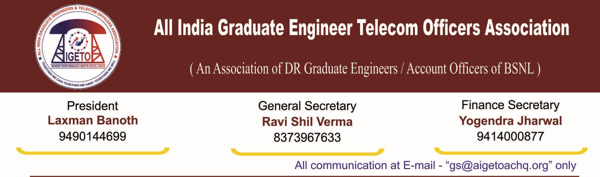

**No. GS/AIGETOA/2017/5 Dated 08.02.2017**

To,

**Chairman & Managing Director**

**Bharat Sanchar Nigam Limited**

**Janpath, New Delhi**

**Subject: - Request for immediate issuance of Promotion / Posting orders for JTO to SDE (T) under LDCE quota – result declared on 21.05.2016.**

Respected Sir,

I would like to draw your kind attention towards inordinate delay in issuing ofPromotion and Posting orders for JTO to SDE (T) under LDCE quota (33%) for which exam was conducted on 21.6.2015 and result was declared on 21.05.2016. Around 1800 qualified candidates are waiting for their first promotion in BSNL due to several administrative delays. Earlier, the promotions were delayed due to pending court cases. Now, the cases has been decided by Hon’ble court and there is no hindrance in issuance of promotion orders.

2. Earlier, court had stayed the promotion on the issue of seniority among the Seniority cum fitness quota (DPC) and the LDCE quota. The CAT Chandigarh vide judgment dated 18.10.2016 (copy enclosed), BSNL has been given directions to make promotions under LDCE quota for 2010-2011 after making proposed amendment in SDE-RRs i.e. inclusion of seniority clause from the vacancy year 2009-10 onwards.

3. It is a matter of fact that CAT Chandigarh has given judgment based on affidavit given by BSNL that the proposed amendment has already been approved by the Management Committee and the same will be approved by BSNL Board within three months. However, still after passage of 4 months, the said amendment has not been discussed by the Board till date.

4. Further, a committee has been constituted to examine the HR issues of BSNL and give recommendation to the Board on various HR issues. It is learnt that the issues are not being taken up due to non-finalization of HR plan. It is pertinent to mention that as per our understanding, the amendment in SDE RR for insertion of seniority clause is pending for a minor clarification on the date of effect of the said amendment. This minor clarification is holding the fate of around 1800 young executives’ awaiting their first promotion.

5. It is learnt that the next meeting of the HR committee shall be convened shortly. Your kind intervention is solicited to get the issue of SDE RR amendment delinked from the HR Plan so that the same can be notified and promotion order under LDCE quota can be issued immediately. This will enable BSNL Management to fill thousands of posts of SDE (Telecom) lying vacant for past many years and hampering the working for so long. These promotions will give a feeling of motivation and encouragement to JTO (T) cadre who are waiting for their first promotion for last many years despite being eligible for the same way back. Moreover, BSNL will get the vacancies filled by energetic and talented pool of executives to be assigned the responsible and challenging roles in BSNL operations.

With Kind regards

**[Ravi Shil Verma]**

**General Secretary**

**Enclosure:-** Hon’ble CAT,Chandigarh Judgement copy.

Copy to:-

1. The Dir (HR), BSNL for kind information pl.
2. Joint Secretary (Admin), Department of Telecom for kind information please.
3. The PGM(Pers.), BSNL Corporate Office – For kind information and necessary action.