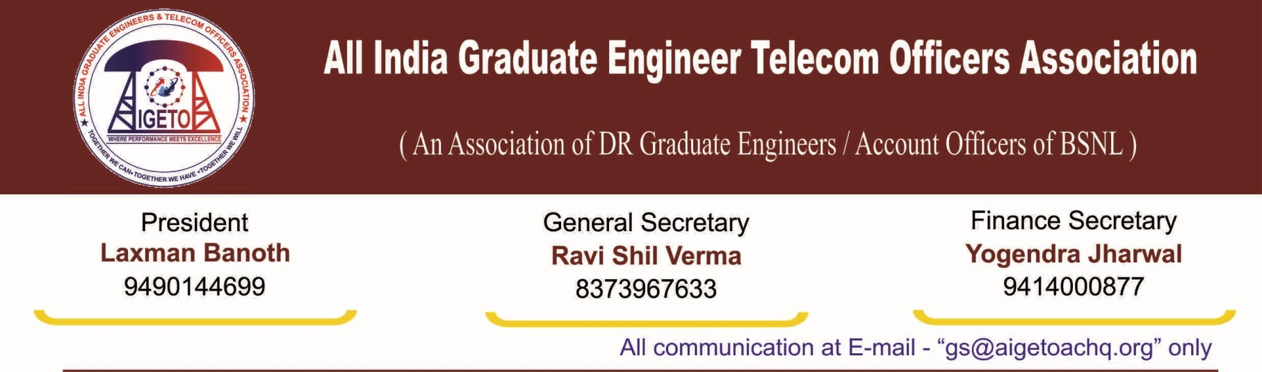

**No. GS/AIGETOA/2017/4 Dated 08.02.2017**

**To**

**The Director (HR)**

**Bharat Sanchar Nigam Limited**

**1, H.C Mathur Lane, Janpath**

**New Delhi 110001**

**Subject: Regarding extending the benefit of notional date of promotion with consequential benefit like increment on promotion, fixation of pay counting of experience for further promotions, annual increments etc. on promotion to SDE grade through 33% LDCE quota of SDE (T) held on 4th March 2012**

**Reference : 1. GS/AIGETOA/143 Dated 10.12.2015**

**Respected Madam,**

In continuation of our earlier request raised by this association for extending benefit of **notional date of promotion with consequential benefit like increment on promotion, fixation of pay counting of experience for further promotions, annual increments etc. on promotion to SDE grade through 33% LDCE quota held on 4th March 2012** vide our letters in reference above , attached as annexure to this letter, We once again request to extend all consequential benefit to LDCE passed executives held on 4th March 2012.

LDCE for SDE (T) against 33% quota for the vacancy year 2006-07 was due in year 2007-08. But Pers Cell of BSNL CO vide letter no:5.2/2009-DE dated 18.03.2010 notified the LDCE for SDE(T) against 33% quota to be held on 04/07/2010 including all the vacancies of four years i.e from 2006 - 2007 to 2009 - 2010. The examination was further postponed and finally held on 04/03/2012. However, the final result of the examination was declared on 2nd july-2013 and the promotion orders were issued accordingly on 4th July-2013 onwards.

The delay of about 5 years from the due date and delay of about 2 years in conducting LDCE and issuing promotion order from the date its initial notification was purely on either administrative or legal ground and candidates have nothing to do with that. Because of this delay in conducting examination, declaring result and issuing promotion order, the benefits of one increment on functional promotion to SDE (T) through LDCE is denied to those who have already been upgraded to E3 pay scale on 01.01.2012.

If LDCE for SDE(T) would have been conducted on 04/07/2010 as initially notified, candidates had not only got one additional increment on their regular promotion and then one another increment on financial upgradtion but also their service would have been counted for the next functional promotion.

In fact in the present circumstances , if financial upgradation in any respect of any candidate have been delayed beyond 05-07-2015 on account of his poor performance or due to some vigilance issue or delay in joining in the department then also he was entitled for one increment on his regular promotion to SDE(T) through LDCE and then one additional increment at the time of financial upgradation.

Candidates must not be forced to bear loss of one increment as well as loss of service because of administrative /legal delay in conducting LDCE on time and performing well to achieve the benchmark for financial upgradation on time.

Similar type of delay is happening in issuing posting orders of the executives who have passed in LDCE 2015. Their increments should also be protected as the delay in issuance of posting orders is due to administrative delay.

Hence we request your good self to kindly consider this request with compassion and sympathy and guide concerned section to reexamine the issue & take necessary step for immediate settlement of one increment **on promotion to SDE grade through 33% LDCE quota.**

Sincerely yours

(Ravi Shil Verma)

General Secretary

**Copy to:**

1. CMD, BSNL for kind information please.
2. GM (Pers.) BSNL for kind information and necessary action please.