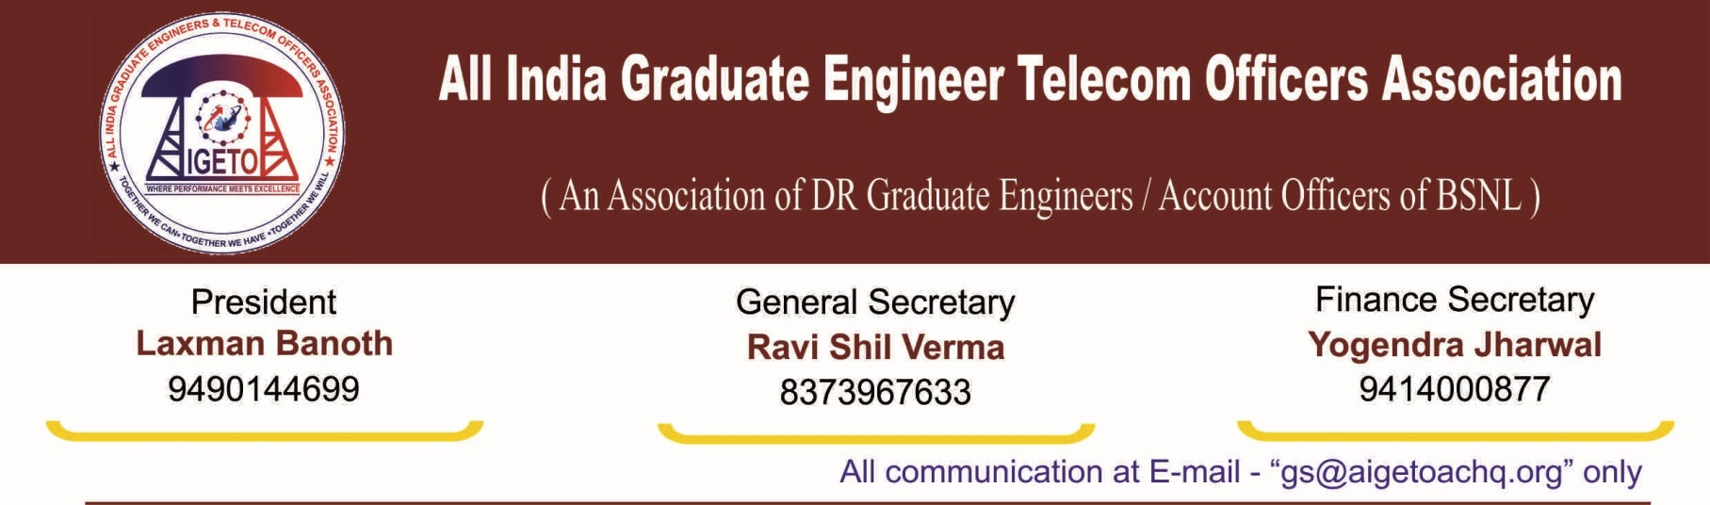

**No. GS/AIGETOA/2017/3 Dated 08.02.2017**

**To**

**The Director (HR)**

**Bharat Sanchar Nigam Limited**

**1, H.C Mathur Lane, Janpath**

**New Delhi 110001**

**Subject: Request to issue suitable instructions to all Circle Heads for immediate settlement of all the pending Rule-8 cases, especially considering rule -8 cases of tenure circle**

**Reference: 1) AIGETOA Letter No. GS/AIGETOA/155 Dated 22/06/16**

**2) AIGETOA Letter No. GS/AIGETOA/149 Dated 09/05/16**

**3) UF Letter no UF/CMD/16-17/ Dated 05/01/2017**

**Respected Madam,**

With reference to the subject cited above and the letter under reference, this association has written many letters & the same has been discussed with different authorities of BSNL CO HR wing, to issue suitable instruction to All Circle Heads for immediate settlement of pending JTO (T) Rule-8 cases. **In the meeting held on 6th January 2017 also, it was assured to association that the instructions in this regard shall be issued soon to the circles.** However, so far, no such instructions have been issued from BSNL CO HR wing to all circle heads to settle pending rule -8 Cases.

Despite this critical issue being taken up continuously by our association for release of these officers, the field units have shown reluctance to release these JTO praying for transfer under R-8 citing acute shortage of officers in this cadre.

**It is to inform you that, recently BSNL management conducted LICE (promotion of JEs to JTO (T)) and 1735, & 1906 numbers of TTAs qualified respectively for the vacancy year 2013-14, & 2014-15. Many qualified TTAs presently undergoing JTO training program at different RTTC. Similarly 2700 nos of external JEs selected recently.** Please find below details regarding Circle wise JTO Rule 8 pending list & LICE qualified TTAs for immediate necessary action at your end.

|  |  |  |  |
| --- | --- | --- | --- |
| **S/N** | **Circle** | **Circle wise JTO Rule 8 cases pending** | **LICE qualified TTAs**  **(Vacancy Yr 13-14 & 14-15)** |
| 1 | Assam | 115 | 81 |
| 2 | NE I | 59 | 13 |
| 3 | NE II | 22 | 35 |
| 4 | West Bengal | 117 | 247 |
| 5 | CTD | 15 |
| 6 | Tamil Nadu | 86 | 403 |
| 7 | Chennai | 16 |
| 8 | Gujarat | 272 | 354 |
| 9 | Maharashtra | 98 | 227 |
| 10 | Karnataka | 230 | 103 |
| 11 | Himachal Prasad | 36 | 60 |
| 12 | Odisha | 28 | 18 |
| 13 | Haryana | 23 | 97 |
| 14 | Uttaranchal | 3 | 52 |

**As per SDE RR one JTO is eligible for promotion to SDE in three years. But, in BSNL, these promotional aspects are at stalemate and executives are not getting promotion and getting a chance to go back to their home circle. This is the main reason of queuing up Rule 8 cases at circle.**

Further, it is to informed that JTOs, particularly those working in the hard tenure circles like Assam, NE-I, NE-II , and other circles like West Bengal Gujarat, Maharashtra , Tamil Nadu & Karnataka are feeling highly de-motivated as Circle administrations are showing their reluctance in initiating Rule -8 transfer request processes in a systematic & consistent way.

This is again to inform you that, many DR JTOs are waiting since long for their transfer to their home circle after completion of more than five years of service, and due to huge delay in consideration of their cases, it has already created frustration among this young work force of the company. In many cases even after completion of **ten to fifteen years of service in a particular circle**, the Rule-8 transfer is not being considered and which created huge unrest amongst the executives.

So, considering the above facts and finding it is requested before your kind self to immediately issue suitable instructions to all Circle Heads for the settlement of all the pending Rule-8 cases in true spirit in light of the recently qualified JE to JTO joining in almost all the circles.

With Warm Regards

Sincerely yours

(Ravi Shil Verma)

General Secretary

Copy to:

1. GM(Estt.) , BSNL CO for kind information and necessary action please
2. GM(SR) , BSNL CO for kind information and necessary action please