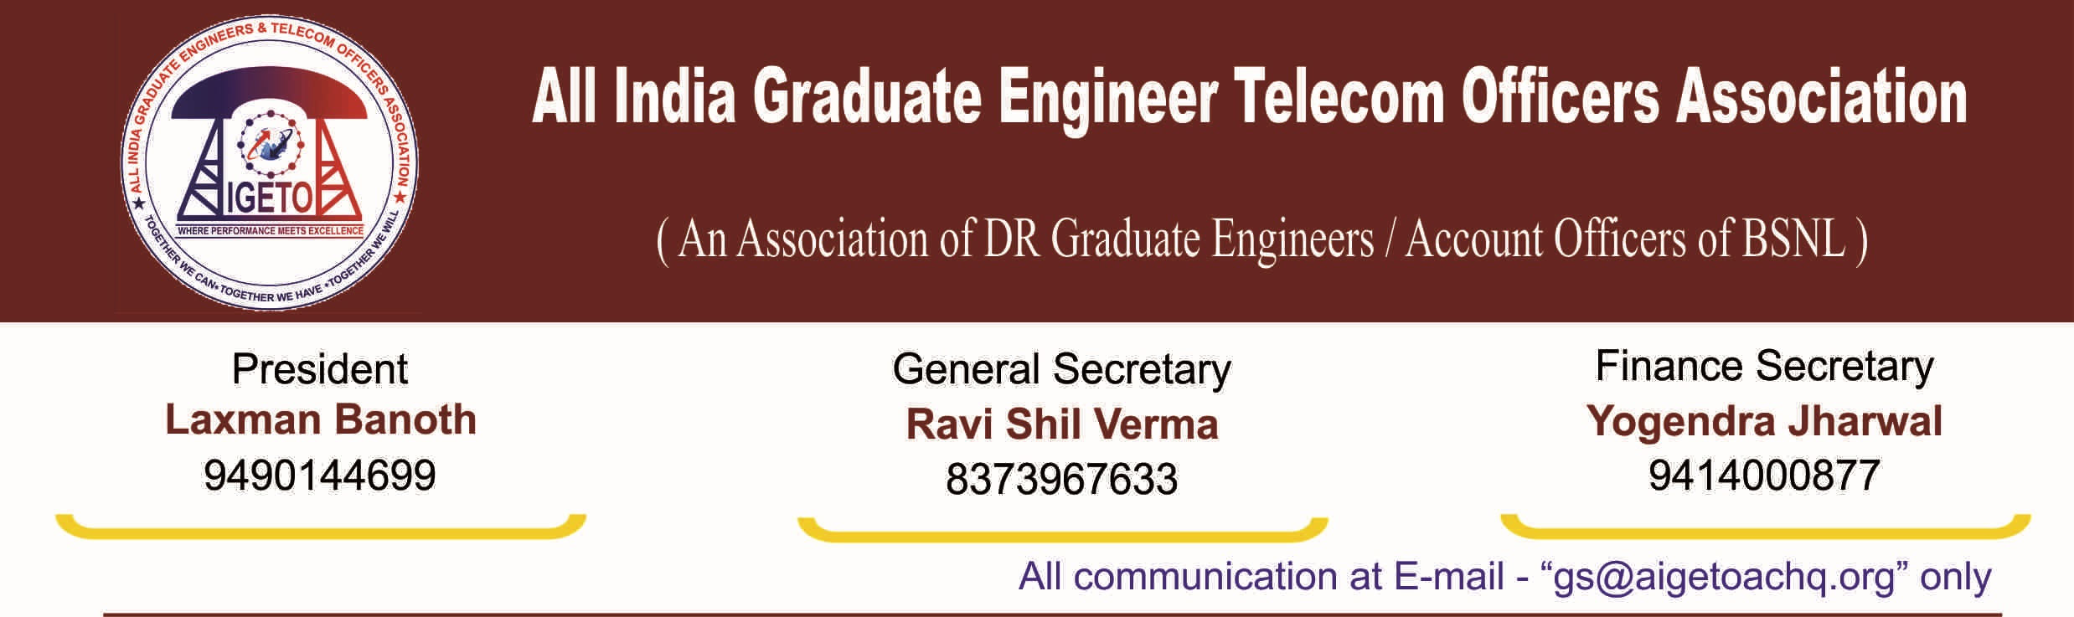
No. GS/AIGETOA/2017/1 Dated 16.01.2017
To
The Director (HR)
Bharat Sanchar Nigam Limited
1, H.C Mathur Lane, Janpath
New Delhi 110001

Subject : Implementation of Group Corporate Term Insurance Policy &
Death Relief Scheme for BSNL recruited employees of BSNL.

Reference : 1. GS/AIGETOA/2016/03 Dated 27.06.2016
2. GS/AIGETOA/2016/23 Dated 22.09.2016

Respected Madam,
In continuation of our earlier request raised by this association for social security of BSNL recruits in BSNL vide our letters in reference above, attached as annexure to this letter, We once again request for provision of Term Insurance and Death Relief Schemes for families of BSNL recruited employees who suffer untimely demise of their breadwinner and are completely left without any social security cover, putting them under great financial stress and mental agony.
Most of these families are very badly affected & unable to cope of with the responsibilities like expenses of children education after their sad untimely demise. This situation is further aggravated due to non-availability of any post-retirement benefit & family pension for them unlike that of existing departmental employees.
In this regard, recently this association met with different Corporate Banks & Life Insurance Corporations, searching for some solution which could provide meaningful relief to these bereaved families.
After due deliberations with them, it is suggested there should be Group corporate Term Insurance family policy for BSNL recruit executives, which will definitely help the employee’s family in case of any unforeseen incidents like untimely demise, permanent disability or critical illness .
The annual premium for a term insurance of 10 lacs is estimated to be around Rs. 1500/- per Annum. In addition Death Relief Scheme in line with other PSUs can also be implemented in BSNL, in which a pre-defined amount is contributed by each employee for a deceased co-worker and handed over to the bereaved family.
The modalities for implementation of Group corporate Term Insurance family policy & Death Relief Scheme in BSNL must be finalized to provide a better working environment and provision of organizational support to all its Employees at the earliest.
Our association has already provided inputs and is willing to provide further inputs for the above as and when required.

Sincerely yours
Sd/-
(Ravi Shil Verma)
General Secretary
Copy to:
- CMD, BSNL for kind information please.
- PGM (Estt.), BSNL CO for kind information and necessary action please.
- GM (Admin), BSNL CO for kind information and necessary action please

