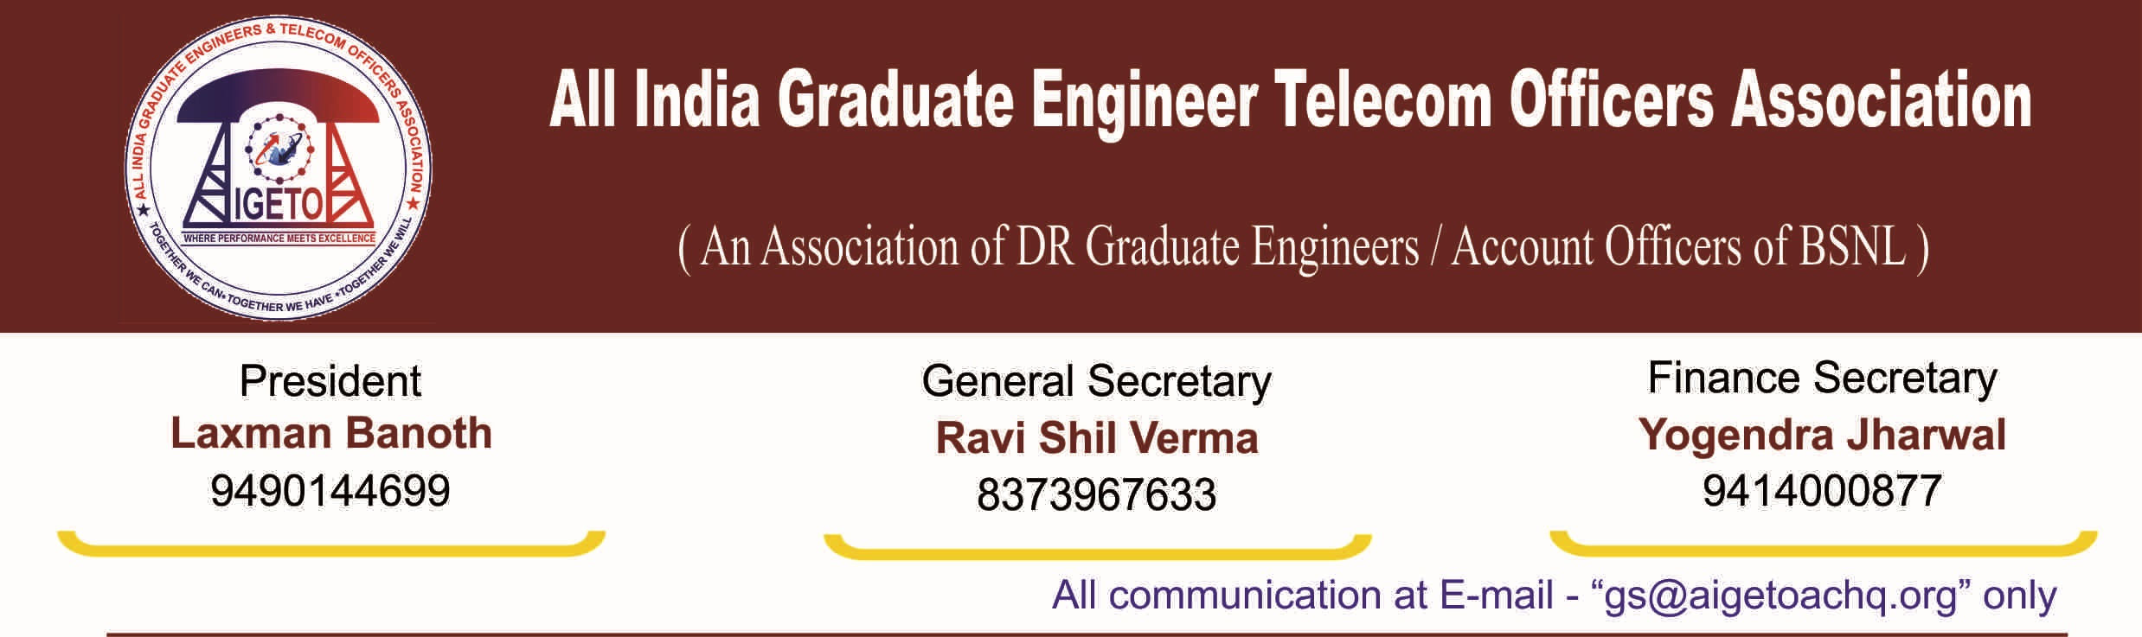
No. GS/AIGETOA/2016/16 Dated 02.08.2016

To,

GM (SR)
BSNL Corporate Office,
New Delhi

Subject: Recognition of majority representative association of serving executives in BSNL-Reg.

Reference:
- No. BSNL/9-1/SR/2016 dated 25/7/2016 of GM(SR), BSNL C.O. New Delhi
- No. BSNL/5-1/SR/2016 dated 28.07.2016 of GM(SR), BSNL C.O. New Delhi
- No-2/10/80-JCA of Department of Personnel & Training, Govt of India dt 31/01/1994
- No-2/10/80-JCA of Department of Personnel & Training, Govt of India dt 5/11/1993

Dear Sir,

This is in reference to letter cited above under reference [1] for separate representation to the BSNL recruited executives in the Membership Verification Process. In continuity of our letter No GS/AIGETOA/2016/7 dated 12/7/2016, it is once again requested to consider our submission for separate recognition of the association of Direct Recruited Executives of BSNL in the light of prevailing guidelines of the Govt. of India and our fundamental right to form the association of distinct category of executives to represent their common rights, issues and grievance before the management.

Kindly refer to para-3 of letter No. BSNL/9-1/SR/2016 dated 25/7/2016 of GM(SR), BSNL C.O. New Delhi, wherein it has been quoted as “It is left to each ministry/Department to define distinct category, keeping in view the functional/administrative/organizational set up” in reference to the Department of Personnel and Training OM No 2/10/80-JCA dated 31st January’1994. The interpretation given by SR Cell in reference to Department of Personnel and Training OM No 2/10/80-JCA dt 31st Jan’1994 seems to be misleading and erroneous of the facts. The details are as under:

- That the Department of Personnel and Training OM No 2/10/80-JCA dated 31st Jan’1994 is not meant to categorize the distinct category of executives in a department as claimed in para-3 of referred letter at [1] but deals with the procedure for verification of membership of Associations for the purpose of recognition under the Central Civil Services (Recognition of Service Associations) Rules, 1993.
- That the referred OM at [3] above states at para-3 that “The guidelines are by no means exhaustive and Ministries/Departments may make such changes as they deem fit provided the changes do not infringe any of the provisions of CCS (RSA) Rules, 1993”. Here, it clearly implies about procedure for verification of membership of Association and not the provisions.
- That the Para-5 of the CCS(RSA) Rules 1993 which deals with conditions for recognition of the Service Associations implies that the distinct category of executives can form a separate association to protect common interest of their members and the government has to recognize it.
- That on one side the BSNL Rules, 2014 in their para-2 says that, “the officers who have taken absorption in Group ‘A’ capacity have been allowed to form a separate Service Association” and the BSNL Rules, 2014 will not be applicable to them. But on other side the same facility has not been extended to the BSNL Recruited Executives, whose service benefits are also entirely different from the absorbed executives.
- That every citizen has got a fundamental right to form an association to protect their common interest under the Constitution of India.

This association has time and again been requesting for separate and formal recognition to the executives recruited after inception of BSNL, as their service conditions and hence some of the benefits are entirely different than other sets of absorbed executives. It is unfortunate to receive your reply vide letter mentioned under reference [1] denying the formal representation of direct recruit executives of BSNL merely on the ground of prerogative of the management not on the merit.
We request SR cell to inform us about the grounds on which our representation has been denied except for the prerogative factor which in our opinion should have been applied based on the merits and not on discretion. SR cell is also requested to inform us whether or not, the service conditions of BSNL recruited executives are different from those executives who have taken absorption in BSNL from DoT. SR cell is also requested to inform us the reasons for extending separate representation platform for the executives of BSNL who were absorbed in group-A capacity from DoT.
As your good self has already mentioned in the letter referred above that on the demand of AIGETOA, the committee constituted for the purpose had considered our submission for the recognition of two associations, one for absorbed officers and another for BSNL recruited officers in year 2009 and that the committee in its wisdom has not recommended for separate association for Direct Recruits. It is requested to kindly inform if the recommendation was based merely on the wisdom of the committee or upon the established facts and documents.
It is also requested to provide details of classification of Executives in distinct categories along with the justification. It is further requested to inform why direct recruits of BSNL has not been classified as a distinct category while group B and Group A absorbed officers are classified in different category, perhaps just on the basis of their induction in BSNL as absorbed from different cadres of DoT. You are requested to kindly inform why the similar treatment as distinct Category cannot be given to the BSNL recruited executives on the basis of their induction as recruited by BSNL, a PSU and accordingly with different service conditions.
It cannot be denied that executives recruited after inception of BSNL form distinct category of employees in terms of service conditions and their post-retirement benefits. It is highly required to remind that some statuary benefits of direct recruits like EPF, pension, post-retirement medical benefits etc. are entirely different from that of Group B executives absorbed in BSNL from DoT. All such issues were completely ignored by the existing associations and management of BSNL as the majority were not at all affected out of these benefits. Non-extension of 30 percent Superannuation Benefit to the executives directly recruited by BSNL till date despite extending perks and giving 30 percent fitment benefit to all set of employees is a glaring example of this. We would like to remind that on the cut-off date for implementation of 2nd PRC, BSNL was in profit. Despite provisions for doing so, as submitted by this association from time to time, the benefits which are exclusively for the set of employees recruited by BSNL after its inception have not seen the light of the day. It was only after the formation of AIGETOA as an association representing the executives directly recruited by BSNL, the issues pertaining to the directly recruited executives of BSNL started gaining significance and momentum. It was only when our association raised the issues, the importance of these issues were recognized by all including management and some action was visible on ground.
Now when referendum of executives association is notified wherein single and majority association will be in place to formally represent the issues of executives and there is no provision for separate representation of BSNL Direct recruits who are still in minority and hence there is no chance of getting representative association status in referendum. In this situation, denying separate representation to executives directly recruited by BSNL in forthcoming referendum process is nothing but denying the right of representation to a particular set of executives. The provision for exclusive representation for third distinct category of the executives in BSNL, i.e. “BSNL Recruited Executives” has not been made in the BSNL Rules, 2014. Hence in the light of the above facts, the existing BSNL Rules, 2014 is in contravention of the laid down rules and procedures of the Government of India. It is an encroachment of our right available under the constitution of India as well as through circulars and orders of the Government of India.
Therefore, we once again appeal you to consider our request for exclusive formal representation of BSNL Recruited Executives in the light of the provisions available to us under the constitution of India and prevailing rules and guidelines of the Government of India to ensure 360 degree representation of all category of executives in the company. It is worth to intimate here that the association will not hesitate to knock the door of law if BSNL Recruited Executives denied provisions of separate and exclusive representation. Your kindness in considering our above demand is not only in the interest of justice but also enhance the trust level between BSNL recruited executives and management.
In view of the above, we once again emphasize that our association has been formed to protect the rights and interests of the executives who have been recruited by BSNL after its inception and are governed by separate service conditions and benefits. Accordingly, undertaking has been given without prejudice to the rights of the association wherein it has represented for a separate recognition and formal representation for the association representing exclusively the third category of executives i.e. direct recruits executives recruited after inception of BSNL.
Thanking you,
[RAVISHIL VERMA]
General Secretary
Copy to:
- Director (HR) for kind information and with a request to intervene in the matter.

