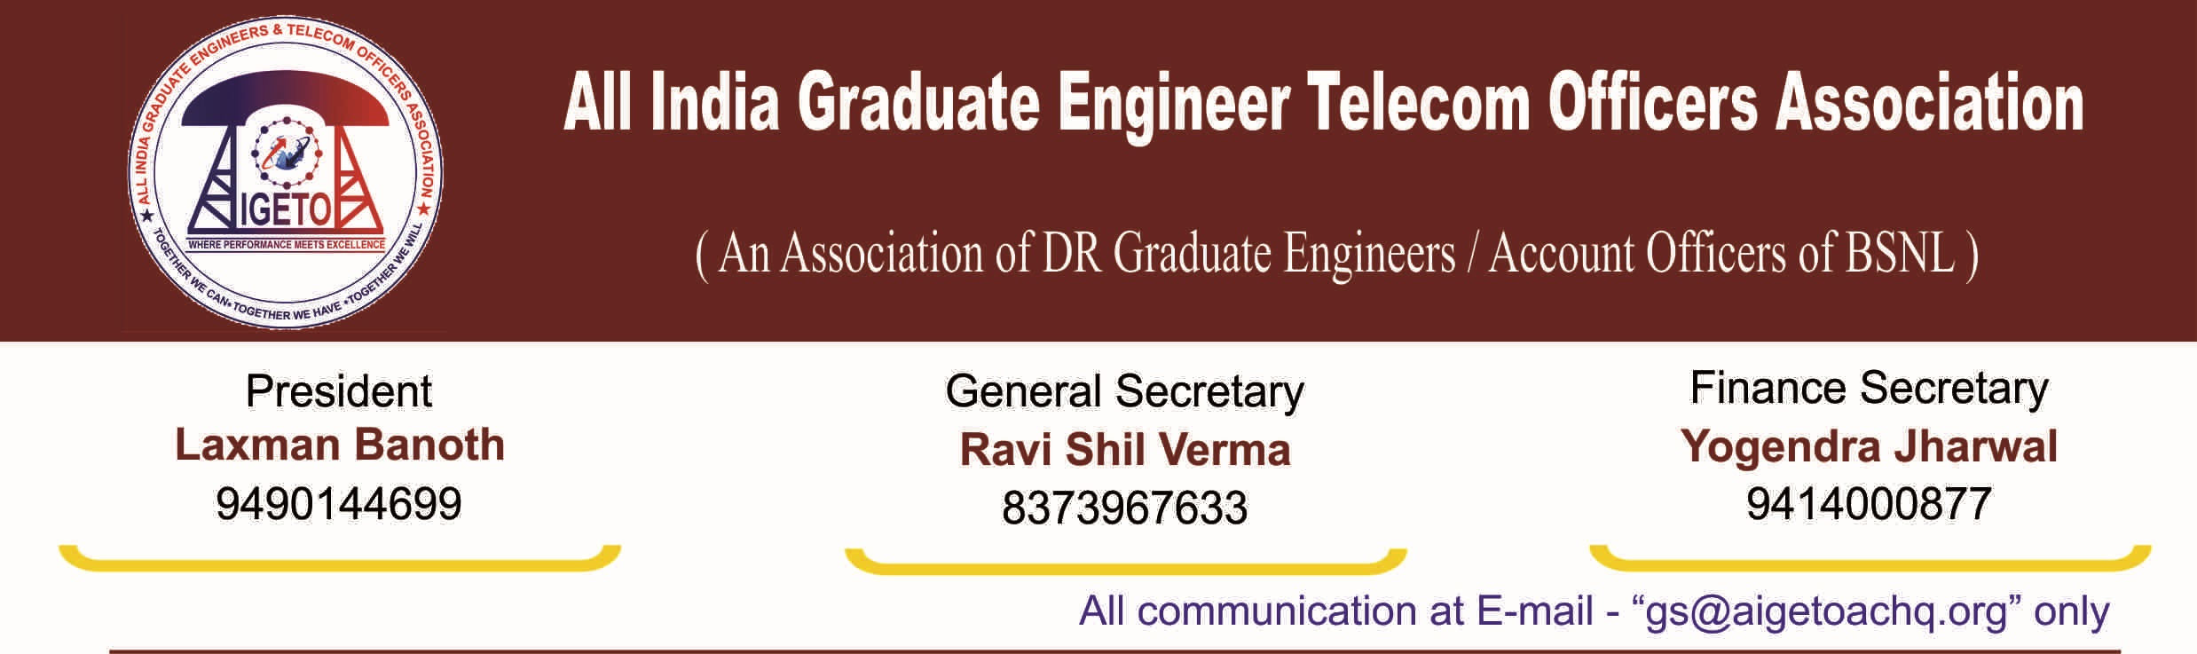
No. GS/AIGETOA/2016/15 Dated 01.08.2016

To,
Sri J. S. Deepak,
Secretary/DOT, Sanchar Bhavan,
New Delhi.

Subject: Our submission in respect of Replacement of Non-Standard Pay-Scales E1A & E2A pertaining to BSNL with E2 & E3 and extension of 30 percent Superannuation Benefits to the employees and executives recruited by BSNL, Regarding.

Respected Sir,
This is in respect to the proposals sent by BSNL for replacement of Non-standard Pay scales of E1A and E2A with standard E2 and E3 pay scales and extending 30 percent Superannuation Benefit to the employees Directly Recruited by BSNL.
Sir, we would like to submit before your good self that 2nd pay revision of board and below board level executives working in CPSEs was due on 01.01.2007 and henceforth pay revision committee headed by Justice Rao was constituted. After 18 months of extensive study, committee recommended the total compensation package of executives working in CPSEs based on category, affordability and profitability. The said recommendations of the 2nd PRC were put up before Committee of secretaries (CoS) for consideration and getting final approval of the Government. CoS has considered the recommendations of 2nd PRC and the same got approved by the government with some changes as suggested by CoS.
Consequent to the acceptance of the recommendations of 2nd Pay Revision Committee for CPSEs and suggestions of CoS, Government of India through the Department of Public Enterprise has issued various orders on employee’s benefits. These orders perspicuously states that all the employee’s benefits will be on IDA pattern and inter-alia provides for the following benefits to the employees of CPSEs.
- Basic or serving Benefits (Basic + IDA + HRA);
- Retiral Benefits (EPF + Gratuity + Post-Retirement Medical + Pension) with the ceiling of 30% of Basic + IDA;
- Perks & Allowances with the ceiling 50% of Basic
- PRP/Variable Pay up to 40 to 200% of Basic

Of the above benefits, the most important being the first two which deal with the Pay and Retiral benefits of the executive. However, despite clear-cut provisions stipulated by DPE in this regard, BSNL has yet not implemented the recommendations in respect of the Basic or serving benefits (Sl. No.-i) and Retiral Benefits (ii) in totality especially for the executives recruited by BSNL.

Still the initial two scales in BSNL have not been finalized and the standard scale has not yet been extended to the first two level of executives. Similarly the provision of 30% Superannuation Benefits in respect of the Direct Recruits has also yet not been implemented by BSNL. We would like to highlight that in the meeting of Joint Action Committee of BSNL unions and associations held on 1st May 2015, the leaders were informed by Hon’ble Secretary DoT that for Superannuation Benefits and Pay related issues of BSNL recruits, they should speak to BSNL management as these issues are well within the domain of BSNL and DoT has nothing to do with it. After our continuous persuasion, BSNL management has now taken some corrective measures and have sent the proposal for the above two issues to DoT for approval. The same is now pending at DoT and it is our humble appeal for expediting the decision on the same.

On behalf of around 14,000 professionally qualified executives who have been directly recruited by BSNL after its inception in year 2000, we are hereby submitting the facts and details along with our submissions in respect of the above two issues. The detail in regard to the above are enclosed herewith. The supporting documents are also attached herewith as Annexure to the enclosure.

Despite of passage of 9 years and now when the 3rd PRC is also on the anvil, still the executives in BSNL are devoid of the recommendations of second PRC in respect of the very basic issues of Pay and Retiral Benefits. We seek your kind intervention and direction in resolving the issues of Pay and Retiral Benefits pertaining to the professionally qualified and youngest executives of BSNL.

Enclosure: The details of the issues along with the necessary supporting documents.

With regards

[RAVI SHIL VERMA]
General Secretary
Copy to:

- Sri. N. Sivasailam, Addl Secretary, DoT for information please.
- Smt Annie Moraes, Member (Finance), DoT for information please.
- Sri. Anupam Shrivastava, CMD/BSNL for information and necessary action please.
- Smt Sujata T Ray, DIR(HR) for information and necessary action please.
- Sri. Amit Yadav, Jt Secretary (A), DoT for information and necessary action please.

