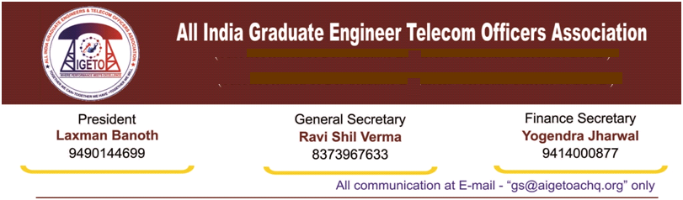

**No. GS/AIGETOA/2017/14 Dated 05.04.2017**

To,

**Shri Anupam Shrivastava**

**Chairman & Managing Director**

**Bharat Sanchar Nigam Limited**

**Janpath, New Delhi**

**Subject: - Immediate stoppage of DR- DGM Recruitment process and instituting a suitable enquiry into the recruitment process - Regarding.**

Respected Sir,

I would like to draw your kind attention towards the letter no. 29-1/2015-Rectt dated 03.04.2017 issued by recruitment cell to PGM (Pers) wherein the merit list for 41 candidates for appointment as DR-DGM has been forwarded to Personnel section for further necessary actions like verification of documents by Personnel section.

**In the letter, it is mentioned that even the documents of the candidates have not been verified completely**. It is quite amusing to know that before issuance of interview call letters, even the document verification has not been done properly. In any recruitment process, interview is conducted only after the proper verification of documents. **We fail to understand the compulsive reasons behind the hasty approach by the concerned authorities to conduct the interview without following the proper procedure.** We fail to find any convincing reasons for this lapse on the part of personnel and recruitment section. How the candidates were allowed to be interviewed without verifying the documents. What was the compulsive reasons behind the hurried approach of the authorities that they even did not waited for proper and complete verification of documents. What is the compulsive reason to keep this recruitment alive even after passage of so many years.

Time and again we have been raising the issue of irregularity in the DR-DGM recruitment process and have been requesting for a thorough enquiry into the whole recruitment process of DR-DGMs. We have always been requesting for scrapping the DR-DGM RRs since its notification as it is completely discriminatory with the internal executives of BSNL. **Herein, we would like to emphasize that in various meetings, it was assured to us that the DR-DGM RR will be scrapped and the ongoing recruitment process will be put on hold and association side shall be informed before moving further.** However, suddenly the recruitment process have been restarted without any discussion with the association.

In view of the circumstances as mentioned above, we hereby request you to put the whole recruitment process of DR-DGMs on hold and scrap the ongoing recruitment process including the DR-DGM RR. We also request your good self to conduct a thorough enquiry into the whole recruitment process to identify the involvement of any malaise intent. This association once again reaffirms its commitment to oppose this arbitrary and unjustified recruitment process which is going to ignite a huge resentment and organizational unrest in BSNL especially the BSNL recruited executives. We sincerely believe that necessary & prompt corrective action shall be taken by HR team to maintain industrial peace.

With Kind regards

With Warm Regards

(**Ravi Shil Verma**)

**GS-AIGETOA**

Copy to:-

1. Dir (HR), BSNL for kind information please.
2. PGM (Pers.), BSNL Corporate Office – For kind information and necessary action.
3. GM (Recruitment), BSNL CO.
4. GM (SR.), BSNL Corporate Office for kind information and necessary intervention   
    with reference to SR cell letter no. BSNL/7-3/SR/2015 dated – 14.12.2015.