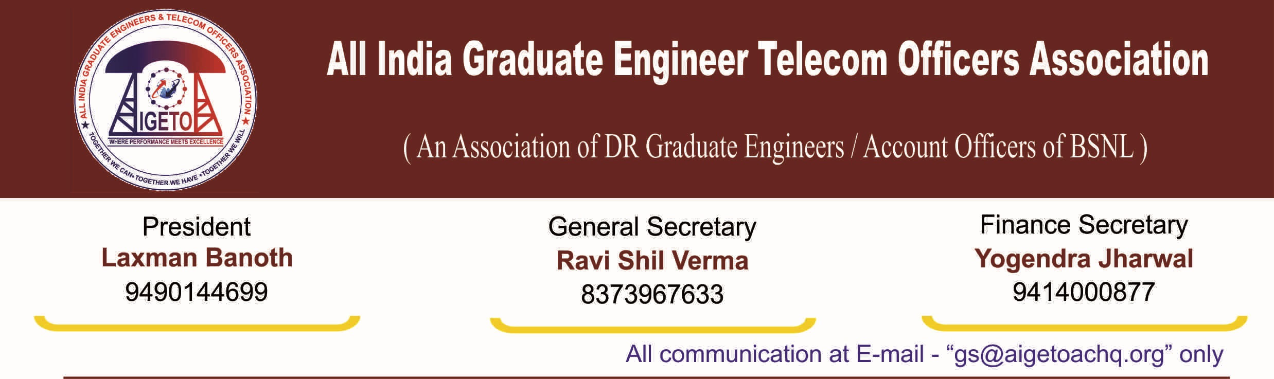
No. GS/AIGETOA/2016/13 Dated 29.07.2016

To,
GM (Recruitment)
BSNL CO, New Delhi

Subject: Holding of the training for the JTOs qualified through LICE conducted for Promotion to JTO from TTA, regarding.
R/Madam
TTA to JTO LICE was conducted on 22.05.2016 and subsequently the results were declared on 8th July 2016. However, vide letter no. 12-1/2016-Rectt dated 22.07.2016, the circles have been directed to not to take any action on the provisionally declared list apparently due to discrepancies in the result.
It has come to our notice that the so called discrepancies were observed in HRMS number and the same was corrected by the CGMs of the respective circles and even training letters were dispatched to concerned RTTCs in respect of the qualified candidates with copy of the aforesaid letters marked to BSNL CO for information. Instead of proceeding with the much awaited promotions for these TTAs (Junior Engineers), BSNL has moved ahead with creating obstacles in the careers of thousands of qualified candidates for the no fault of theirs.
We fail to understand that how come such discrepancies occurred and instead of taking punitive action against the authorities concerned, the candidates are being penalized by withholding their training which may result in unnecessary delay in their promotion as well as may result into financial losses owing to this delay. Already, when in BSNL, the promotions have been marred with various type of litigations and court cases, creating such type of anomalies may prove quite costly for the qualified candidates. This delay may result into the loss of fitment benefit, loss in qualifying period, loss in service length etc. for which only and only BSNL shall be responsible.
In view of the above, it is my humble request to kindly ensure that all the candidates who have qualified in the LICE may immediately be sent for their training and the orders issued on 22.07.2016 may be withdrawn.

(Ravi Shil Verma)
General Secretary

Copy to:
- Director (HR) for kind information and with a request for intervention in the matter please.

