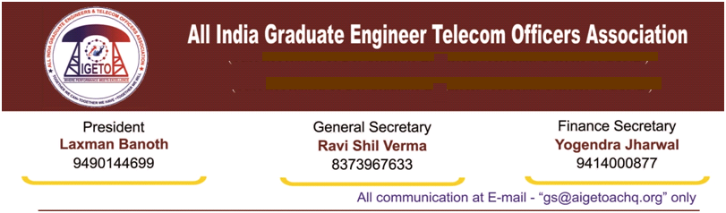

**No. GS/AIGETOA/2017/12 Dated 05.04.2017**

To,

**Shri Anupam Shrivastava**

**Chairman & Managing Director**

**Bharat Sanchar Nigam Limited**

**Janpath, New Delhi**

**Subject: - Request for immediate issuance of Promotion / Posting orders for JTO to SDE (T) under LDCE quota (2010-11).**

Respected Sir,

I would like to draw your kind attention towards inordinate delay in issuing ofPromotion and Posting orders for JTO to SDE (T) under LDCE quota (33%) for which exam was conducted on 21.6.2015 and result was declared on 21.05.2016. Around 1800 qualified candidates are waiting for their first promotion in BSNL due to several administrative delays. Earlier, the promotions were delayed due to pending court cases. Now, the cases have been decided by Hon’ble court in Oct-2016 and since then there is no hindrance in issuance of promotion orders.

The CAT Chandigarh vide judgment dated 18.10.2016 given directions to BSNL to make promotions under LDCE quota for 2010-2011 after making proposed amendment in SDE-RRs, based on the affidavit given by BSNL that the proposed amendment will be approved by BSNL Board within three months. However, even after passage of more than 5 months, the said amendment has not been approved by BSNL Board till date.

It is learnt that the issues are not being taken up by Board due to non-finalization of HR plan. It was informed to us that HR plan will be finalized in March and after that SDE RR amendment will be approved in board meeting. However, the Board meeting held on 30-03-2017 did not consider the proposal for amendment in SDE RR. HR plan finalization is pending since long time and it appears that approval of HR plan is being deliberately ignored. It is imperative on part of BSNL management to finalize the SDR RR amendment urgently as the fate of around 1800 young executives’ first promotion is entirely linked with this amendment.

It is also known that management has already started discussion for implementation of CPSU hierarchy with the recognized Association. It is pertinent to mention that any move to implement CPSU hierarchy before posting of these LDCE qualified candidates will create legal hurdle as after qualification of LDCE examination these candidate are equivalent to SDE (T). Therefore, posting of LDCE candidates will also be necessary to avoid legal hurdle in CPSU hierarchy implementation. **Our association will not allow any injustice to the candidates who have already become eligible to become SDE (Either through LDCE mode or through Seniority-cum-Fitness Mode) and any move to suppress their promotions and career prospects in the name of CPSU hierarchy shall be opposed by this association through legal as well as organizational route.**

Our association has raised this issue various times but on the assurance of management our members have been requested to keep patience and faith in your good office and to concentrate on improving the health of BSNL. But, even after lapse of several months’, candidates are highly demotivated and depressed for their future prospects.

Considering the above facts, we are humbly requesting yourself to intervene in matter and direct the HR team to complete the posting to LDCE qualified candidates immediately to avoid any unrest and demotivation amongst the candidates waiting for their promotion since long.

With Kind regards

With Warm Regards

(**Ravi Shil Verma**)

**GS-AIGETOA**

Copy to:-

1. Dir (HR), BSNL for kind information please.
2. CGM (Legal), BSNL CO for kind information please.
3. PGM (Pers.), BSNL Corporate Office – For kind information and necessary action.
4. GM (WS& Rest.), BSNL Corporate Office- For kind information and necessary action.