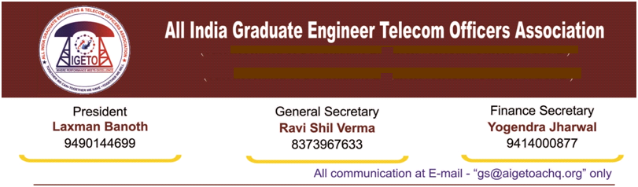

**No. GS/AIGETOA/2017/11 Dated 31.03.2017**

To,

Shri K. Sebastin

General Secretary, SNEA CHQ

New Delhi

Reference: SNEA/CHQ/Assns/2015-18/01 dt 30/03/2017

Dear Sir

I appreciate your gesture shown through referred letter and I do believe that the individual approach of associations for the cadre issues can’t yield desired result except satisfaction of egos. The recent order of the DoT on Pay Scale issued vides No 61-2/2016-SU dated 28th March’2017 is nothing but a hard slap on the faces of all of us. It shows us that how a divided house can harm our interest and benefits. Although, the time is less and LHD decision is individualistic of SNEA but we acknowledge your request and decided to extend support for the today’s call in the larger interest of the JTO/JAO Cadre, which is our Symbol of Pride.

Herein we would like to emphasize that had associations would have resorted to protest the scale degradation in JTO RR 2014 well in time; the current situation would have never arisen. Just to seek a short time benefit, the careers of thousands and thousands DRs were pushed on to the danger. AIGETOA was protesting against this right from the beginning and in fact have challenged the degradation in court also. However, its better to be late than never. The same situationis being created for Jaos also and we need to protest that.

You will also agree that a simple agitation program may not be sufficient to resolve the decade long crisis of standard pay scale issue of E2-E3 for JTO-SDE equivalent and other burning issues, e.g. Pay loss to post 2K7 batches (Rs. 22820/-), Long pending promotion of JTO to SDE through DPC/LDCE, Non extension of 30% SAB to BSNL Recruits, which are seriously affecting the health of our basic cadre of JTO/JAO.

Contd to…….

I am of the firm opinion that a joint and decisive battle is need of the hour to resolve the above crisis which is hanging in balance through years due to lackluster attitude of the BSNL Management and DoT. So, let us come forward by burying all differences among major factions, discuss and decide for a revolutionary call for all the pending HR issues especially the Pay Parity of Executives recruited post 01.01.2007, Replacement of non-standard pay scales of E1A and E2A by E2 and E3 , Promotion of JTO(T) to SDE(T) through LDCE/DPC, Clearance of Pending HR issues by BSNL Board, 30 Percent SAB and change in date of implementation, Extension of one extra increment to LDCE 2012 and LDCE 2015 passed executives including other similarly placed executives, 1st Time bound Up gradation in 4 years etc. to take these issues for a final solution. Fight on a single issue may not be a good idea as a decisive battle cannot be fought every now and then. We are ready to fight shoulder to shoulder for the cause of the cadre to any extent. We do hope for a serious discussion on the above within all stakeholder representatives very soon.

With Warm Regards

(**Ravi Shil Verma**)

**GS-AIGETOA**