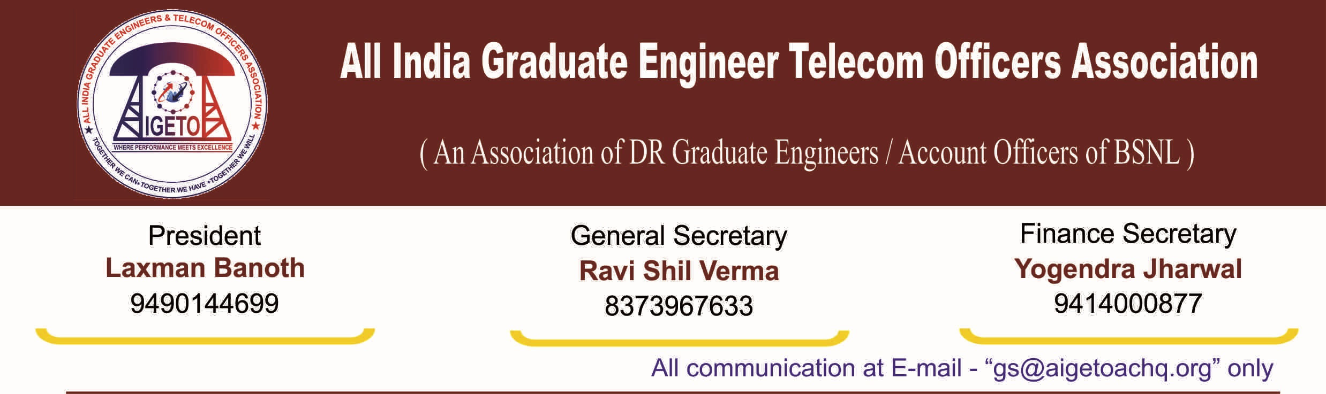
No. GS/AIGETOA/2016/11 Dated 22.07.2016

To,
Director (HR)
Bharat Sanchar Nigam Limited
Janpath, New Delhi
Subject: Appeal and Advisory to BSNL Officers and Executives, Regarding.
Ref- 101-01/2016-Pers. Policy dated 19th July 2016.

Respected Madam,
First of all I would like to take this opportunity to thank you for your gesture shown by appealing to the executives and officers to desist from filing the court cases through the letter under reference. This is a first step in right direction with many more steps to be taken by HR wing for settling the grievances of the executives of the company.
However, in this regard, we would like to suggest that your aforesaid appeal shall be taken more as a warning then an advice, if the similar type of advisory is not issued to the persons dealing with HR and administration issues at BSNL CO, Circles and SSAs. They should be advised to follow the well-defined and written rules and norms in a more scrupulous manner then to exercise their discretionary powers. Further, a grievance redressal mechanism should be in place at all levels wherein the individual employee of the company can raise his grievance and the disposing the grievances should be made mandatory. The provisions for creating the grievance cell exists as per DPE guidelines. This small step will result in minimization of many court cases which will save a lot of money of BSNL as well as the employees.
The need for issuing the advisory to all the persons dealing with HR and administration issues at BSNL CO, Circles and SSAs also becomes necessitated by following facts:
- In most of the cases, the employee find no other option then to reach court as his rights are being compromised in the name of discretionary powers of administration especially in the cases of transfers. This issue has been raised by this association in past also but instead of enquiring the root cause, our ex-GS was penalized with various charges. We once again request you to enquire on the issue of transfers raised by this association which will give an insight on to the level to which the discretionary powers are being misused.
- The disciplinary cases pertaining to various employees are kept pending at various levels without any action for years together which leaves employees with no other option but to reach the court of law. At this point, it would be pertinent to mention that the disciplinary cases pertaining to our ex-GS Shri R.P. Shahu has been kept pending without any further action at MP circle. Similarly, one of his review appeals has been pending at BSNL CO level without any further action despite hearing on the same has taken place on 12th April 2016.

- Similarly discretionary powers are being used in settlement of genuine HR issues pertaining to the employees. One live example is that of extension of 30% Superannuation Benefit to the Direct Recruits. While this association has established without any doubt that 30 percent Superannuation benefit should be given to the Direct Recruits and accordingly Superannuation fund for the balance 12 percent should be created. However, despite the ruling and logics submitted by this association, the discretionary powers have been used by limiting the amount to 3%. On this issue, it was learnt that Finance Wing has calculated the Post-Retirement Medical Benefits for Direct Recruits as more than 13%. Despite seeking the name of the fund and details where this amount has been spent, there has not been any response from HR side on the issue and nor any action has been taken against the person if the calculations were done arbitrarily.
Similar was the case with extension of EPF Contribution for the training period for the Direct Recruits. Despite our repeated pleas that the issue is genuine and have merits, the same was not extended and ultimately the case was settled through court of law which resulted into unnecessary expenditure for BSNL. The responsibility should be fixed in such cases.
- Similar type of negligence was being visible in issues like replacement of non-standard Pay scales, extension of CPSU Promotion Policy, submitting the reply in various court cases in time. The Pay Scale issue was dragged just on the pretext of sending letters and raising the matter again and again while knowing fully well that DPE is not going to accept the Intermediary Pay Scales. Many cases were filed by the employees in this regard. Similar is the case with CPSU Hierarchy also. Decision taken at highest level are not being followed. Scrapping of DGM RRs have also not been done yet despite clear-cut directions.
- In the Much Hyped matter of DPC from JTO to SDE (T), the promotions have been withheld just for the want of correct All India Eligibility List. An impression has been made that the same has been pending because of court case. Timely submission of the Eligibility list would have made the promotions much earlier.3

Above are some examples which normally forces the employee to reach the court. Similar type of instances may be prevalent everywhere which needs to be discouraged. In view of the above, we request you to issue a similar type of advisory to the various persons dealing with the HR issues and administration issues and also arrange for proper grievance redressal mechanism for employees of the company with strict directions for their timely disposition.

With regards

[RAVI SHIL VERMA]
General Secretary
Copy to:
- CMD BSNL for kind information please.
- Sr. GM (Pers) for kind information please.
- GM (Estt.) for kind information and n/a please.

