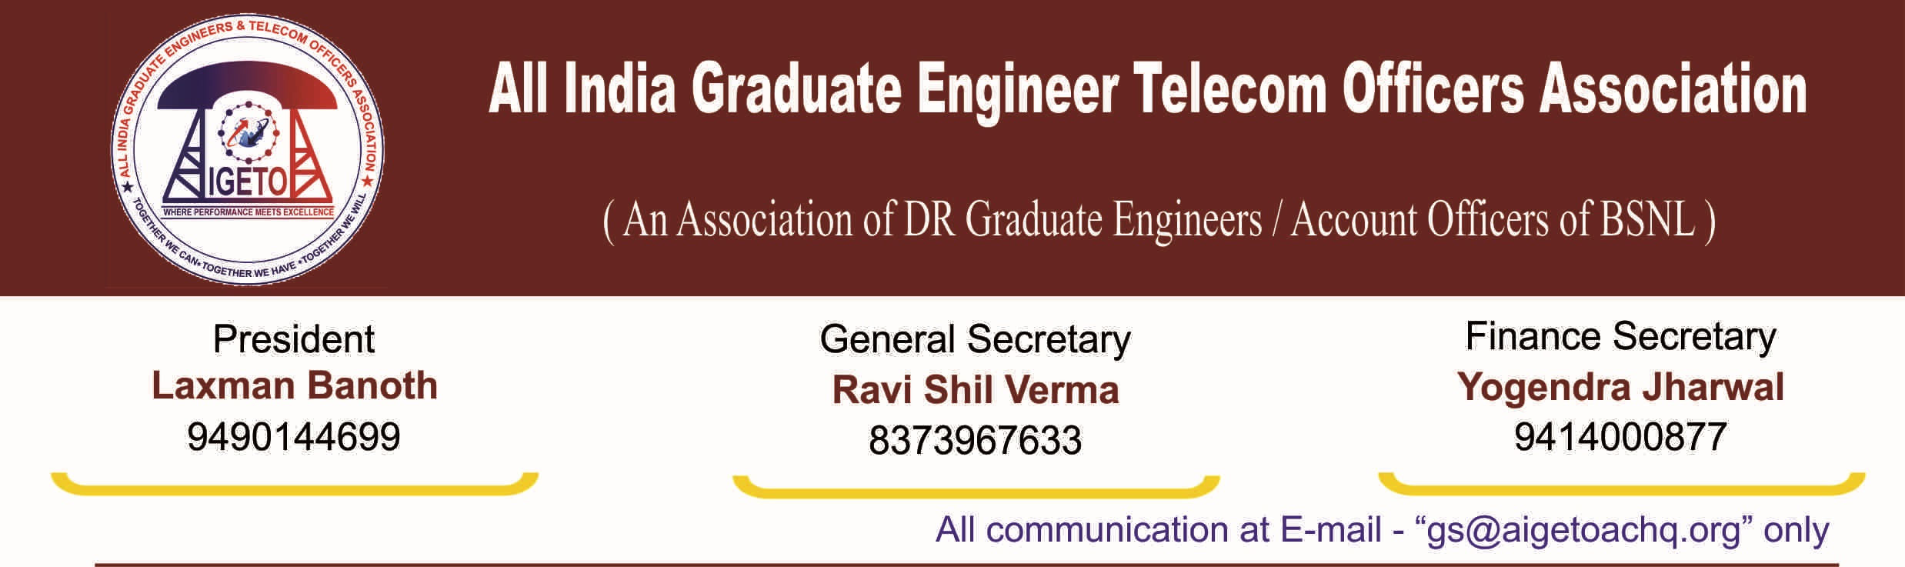
No. GS/AIGETOA/2016/10 Dated 22.07.2016

To,
Director (HR)
Bharat Sanchar Nigam Limited
Janpath, New Delhi
Subject: Seniority fixation in JTO cadre & Promotion to SDE cadre under 67% Seniority cum Fitness Quota, Regarding.
Ref-1 :- BSNL Corp Ltr No 2-18/2007 Pers-II (Pt.1) dated 20-02-2015
2:- BSNL Corp Ltr No . 2-18/2007-PersII (Pt.I) Dated 17-05-2012

Respected Madam,
Your kind intervention is sought regarding the case at Hon High Court of Kerala, in connection with fixation of seniority in JTO cadre and further promotion to SDE under seniority cum fitness quota. An impression has been made that the applicants have stalled the whole process of promotion through Seniority-cum-Fitness. However, the actual scenario of the case is something else. In this regard, we would like to submit the following for your kind information and further necessary action:
- The case is still badly affected, mainly due to non-submission of a correct seniority list in the cadre of JTOs before Honorable High court of Kerala. This is against the popular belief that the DPC is pending because of the stay, the fact is that the DPC has been pending for the want of correct and finalized eligibility list.
- The case at the court is being handled in a wrong method without considering the actual merit, which has led to the stalling of the whole process since year 2012.
Non-submission/ Publishing of a correct seniority list in JTO cadre
Honorable court has not stayed the promotions to the SDE cadre under seniority quota as such. Hon Court has directed BSNL to submit a final eligibility / seniority list in JTO cadre as per guidelines available, on which BSNL management still not submitted a list which is without anomalies and is as per DoPT guidelines. All India Eligibility / Seniority list in JTO cadre (which is the basis for issuance of promotion to TES Group B SDET) has to be prepared by BSNL Corporate office. The list circulated vide letter dated 17-05-2012/ 30-10-2012 and further submitted on 20-02-2015 (refer 1 & 2) are almost of the same inputs & type and it can be seen that the anomalies/ discrepancies which were available earlier are still appearing in the list even after passage of almost four years.
Anomalies like, the list contains people who retired, absconding, not in service, already promoted, supernumerary, date of appointment not available, date of joining not available etc. and the list can’t be termed as a final one too. This means that without incorporating the basic corrections in the list to be submitted by BSNL, the situation may remain the same which will further delay the promotions. We request your good self to direct the concerned unit for early submission of a correct all India Eligibility list without these anomalies/ discrepancies.
In addition, BSNL is yet to publish an All India seniority list in JTO cadre, which includes JTOs recruited from 2002 onwards and owing to this, almost more than ten thousand JTOs are working in BSNL without knowing their relative seniority. We would like to take this opportunity to request your good self to direct concerned section for preparation and publishing of an All India seniority list which includes all working JTOs in BSNL with a cutoff date like 31-3-2016. This is much easy as, we already have a centralized ERP software in place.
Consider the actual merit of seniority fixation & clearance of wrong method
It may be noted that applicants have mainly challenged the method of seniority fixation between direct recruited JTOs and Promoted JTOs in the All India seniority list, which is not in line with DoPT guidelines / GOI, and consequent any provisional list which has followed the wrong method. The fixation of seniority among Promoted & Direct recruits in the combined seniority list should be based on the rule & guidelines and as envisaged in the JTO RRs, DoPT, DoT guidelines on the subject i.e. since the provisions are there for 50%-50% Promote Vs Direct recruitment in BSNL JTO cadre, the seniority in the cadre should also be fixed in 1:1 ratio amongst Promotees & DRs (as 50 % mentioned in above all) by following Rota Quota Principle. As the Rota-Quota of 1:1 ratio between Promoted & Direct recruited JTOs in JTO cadre has not been followed, many promotional vacancies have been lost for DR JTOs in the previous DPCs too.
As a result of the method followed by BSNL like arbitrary award of backdated year of recruitment to Promoted JTOs, non followance of Rotation of Quota & 1:1 ratio for JTOs, the promoted JTOs, whose Date of Appointment in JTO cadre is at least three to four years later than that of direct recruits, have found a place much above the Direct Recruits even in the latest circulated AEL dated 20-02-2015. The above list itself shows that the list has not been prepared scrupulously.
We fail to understand, instead of focusing on the root cause of the problem i.e. preparation of a corrected eligibility list and submitting that in court, the attention is being diverted towards Hon’ble Court without rectifying the actual error. It appears that the entire JTO Community has not been provided with actual picture either by administration or by those groups who have been supposedly championing this cause, which in the process has been resulting into unnecessary heart burn amongst the JTOs thinking each other to be responsible for their misery.
The entire JTO cadre are being deprived off their legitimate right and seniority as per prevailing rules and guidelines. It may be noted that a DR executive who got into BSNL corporate even in the year 2001 still to get his / her first functional promotion through this mode and same is the case with promoted JTOs. We strongly feel that the issue can be well taken care of by BSNL by making a correct AEL/ All India seniority / All India Gradation List in JTO cadre and submission of same to honorable high court.
Hence we request you to kindly go through the facts and merits of the case and do the needful to extend the justified and legitimate right for the entire JTO cadre (DRs as well as Promotees) and take them out from this unfortunate situation.
With regards

[RAVI SHIL VERMA]
General Secretary
Copy to:
- CMD BSNL for kind information and with a request to intervene in the matter so that legitimate rights of the thousands and thousands of JTOs of BSNL can be protected.
- Sr. GM (Pers) for kind information please.
- GM (Estt.) for kind information and n/a please.

