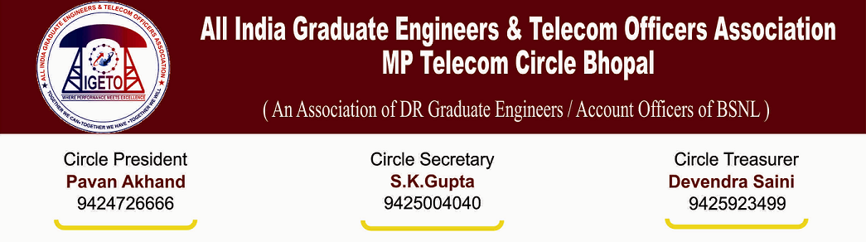
AIGETOA/MP/13-14/46 Date: 05/03/2014

To,
Shri N K Yadav
Chief General Manager
M.P. Telecom Circle.

Subject: Request for Agenda meeting.
Respected Sir,
With due respect, I would like to draw your kind attention towards long pending and very critical issues in respect of direct recruits executives which are adversely affecting their survival and social security. Despite of continuous persuasions by this association and assurance by the management issues remain unaddressed since long time. We seek your valuable time for agenda meeting to appraise your kind so that issues can be resolved amicably.
Agenda points:
- Random deduction of salary, HRA, perks allowances and less contribution towards EPF in respect of direct recruit’s executives for the month of July-Aug-2013 and Feb-2014 without any prior or post communication.

- Resolution of EPF anomalies and compliances of various orders in this regard issued by BSNL CO time to time.

- EPF Anomaly case of Shri P N Gautam SDE Baiora: This association has been continuously pointing out the details of anomalies in the EPF of Shri P N Gautam SDE Baiora where a serious lapses has been committed by the DDO by not submitting monthly challans to EPFO Gwalior causing a huge shortfall of Rs. 4.5 Lakhs in his EPF Accounts with annual interest loss of Rs 36000/- and non-issuance of Annual EPF Slips for the Fin Year 2007-08, 2010-11, 2011-12, 2012-13.
- Intra circle transfer issues and execution of longest stay in respect of executives. Timely operation of request transfer cases in view of commencement of educational session of children of executives.

- Action taken on complaints made by this association against wrongful act by GMTD Jabalpur and TDM Panna in respect of transfer and relieving of direct recruits executives.

- Various Transfer & Posting in the cadre of JTO/SDE has been issued by the C.O. Bhopal but that is not being operated/relieved by the field units.

Some of the issues mentioned above are very critical in nature adversely affecting the survival of executives and their social securities. Non-resolution of these issues before the end of the financial year may create further complication hence we are quite hopeful that considering the seriousness of the issues, your goodself will spare some of your valuable time at the earliest for the said agenda meeting.

Thanking You,

(S K Gupta)
Circle Secretary, AIGETOA MP

Copy to:

- The Sr. GM (Admin/HR), MP Telecom Circle
- The GM (Finance) MP Telecom Circle.
- General Secretary, CHQ AIGETOA with request for persuasion in BSNL CO New Delhi

